### 18.3 Electronic Structure

The p



orbitals in benzene are partially filled and there is an energy gap between HOMO and LUMO (Fig. [2.​11](The_Physics_of_Semiconductors00001.docx#u116076_4_En_2_Chapter-Fig11)). A similar consideration is valid for polymers. The coupling of orbitals along the polymer chain leads to broadening of the

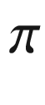

and

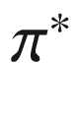

states into a (filled) valence and an (empty) conduction band, respectively (Fig. [18.5](#u116076_4_En_18_Chapter-Fig5)).Table 18.1

Properties of oligoacene crystals. Melting point and unit cell parameters. Data from [1559]

| Property | Naphtalene | Anthracene | Tetracene | Pentacene |
| --- | --- | --- | --- | --- |
| Melting point (  $$^{\circ }$$  C) | 80 | 217 | 357 | $$&gt;300~^{\circ }$$  C |
| Crystal system | Monoclinic | Monoclinic | Triclinic | Triclinic |
| a (nm) | 0.824 | 0.856 | 0.798 | 0.793 |
| b (nm) | 0.600 | 0.604 | 0.614 | 0.614 |
| c (nm) | 0.866 | 1.116 | 1.357 | 1.603 |
| $$\alpha $$  (  $$^{\circ }$$  ) | 90 | 90 | 101.3 | 101.9 |
| $$\beta $$  (  $$^{\circ }$$  ) | 122.9 | 124.7 | 113.2 | 112.6 |
| $$\gamma $$  (  $$^{\circ }$$  ) | 90 | 90 | 87.5 | 85.8 |

The HOMO and LUMO positions of various organic semiconductors are shown in Fig. [18.6](#u116076_4_En_18_Chapter-Fig6) relativ to the vacuum level (cmp. Fig. [12.​21](The_Physics_of_Semiconductors00005.docx#u116076_4_En_12_Chapter-Fig21) for inorganic semiconductors). The HOMO is also known as *ionization energy* (IE), the LUMO as *electron affinity* (EA). With layered organic semiconductors heterostructures can be built, e.g. to design recombination pathways (recombination layer, electron blocking layers (EBL) and hole blocking layers (HBL)). For electron injection and electron extraction (hole injection) contacts, metals with appropriate work function (in connection with a possible interface dipole layer) have to be used. More details on injection and extraction contacts to organic semiconductors are discussed in Sect. [21.​2.​7](#u116076_4_En_21_Chapter).

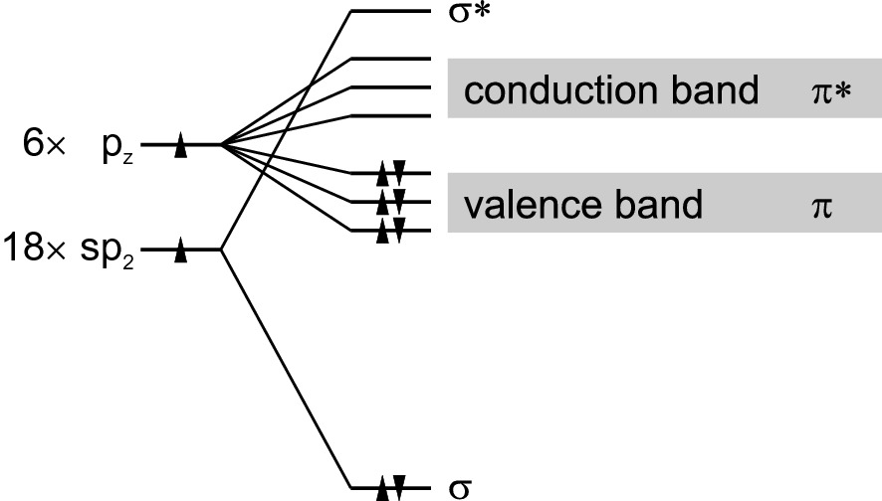

Fig. 18.5

Schematic band structure of a polymer originating from the states of the benzene molecule (see Fig. [2.​11](The_Physics_of_Semiconductors00001.docx#u116076_4_En_2_Chapter-Fig11))

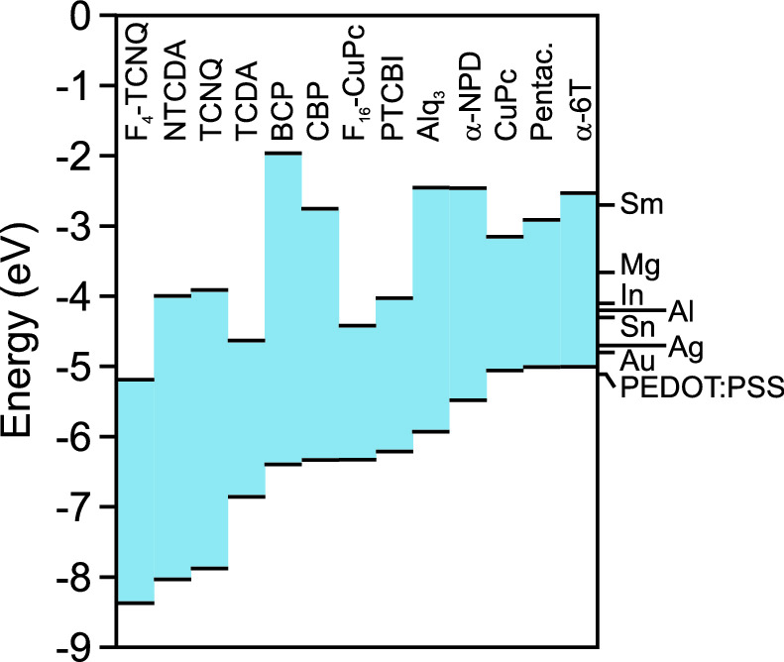

Fig. 18.6

Position of HOMO and LUMO for a variety of organic semiconductors (relative to a common vacuum level at

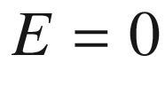

 eV). Based on values from [1567]. On the right hand side the work functions of several metals are shown for comparison

### 18.4 Doping

The doping of organic semiconductors can be achieved by

partial oxidation or reduction of the organic molecule,

substitution of atoms in the organic molecule,

mixing of the matrix with ‘dopant’ molecules.

The systematic shift of the Fermi level with dopant concentration has been reported in [1568]. Typically, the conductivity increases superlinearly with the doping concentration (Fig. [18.7](#u116076_4_En_18_Chapter-Fig7)a), an effect discussed in detail in [1569]. While the mobility remains constant, the thermal activation energy

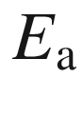

for carriers decreases with increasing doping (Fig. [18.7](#u116076_4_En_18_Chapter-Fig7)b) due to electrostatic interaction [594, 1570], an effect already discussed in Sect. [7.​5.​7](The_Physics_of_Semiconductors00003.docx#u116076_4_En_7_Chapter). The activation energy in the dilute limit

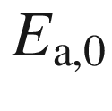

is modified to (cmp. ([7.​52](The_Physics_of_Semiconductors00003.docx#u116076_4_En_7_Chapter)))

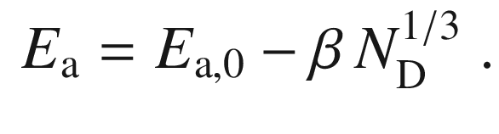

(18.1)

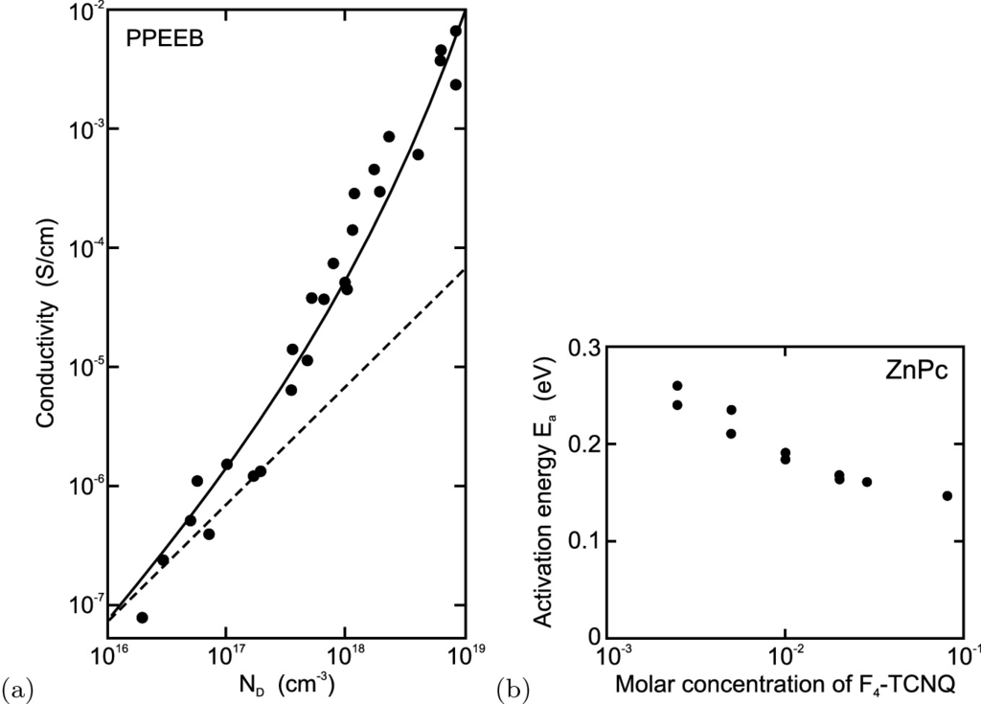

Fig. 18.7

**a** Conductivity (at 0.9 V/

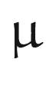

m) versus dopant concentration

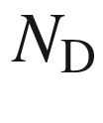

for PPEEB films. Experimental data (*circles*) and fit (*solid line*) according to ([18.1](#u116076_4_En_18_Chapter-Equ1)) with activation energy

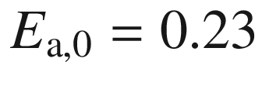

 eV and

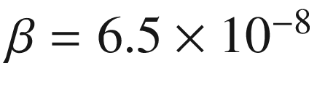

 eV cm (

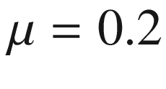

 cm

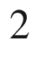

/Vs). *Dashed line* denotes linear relation between conductivity and

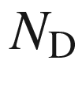

. Adapted from [1571]. **b** Thermal activation energy



of carriers (holes) in ZnPc:F



-TCNQ as a function of the molar dopant concentration.

Adapted from [1568]

### 18.5 Transport Properties

Transport in organic semiconductors is characterized by

strong polaronic effects,

hopping conduction,

low mobility, low drift saturation velocity.

The interaction of charges with lattice deformations leads to the formation of polarons [1572]. In organic materials these are often ’small‘, i.e. the extension of the deformation is on atomic scale. Such self-trapping of charges reduces their mobility. Two charges can share the same deformation (bipolaron) or oppositely charged polarons can attract (similar to an exciton). If these charges are on the same (neighboring) polymer chain, the polaron is called intrachain (interchain).

The conductivity within a molecule, e.g. a long polymer chain, and the conductivity between different molecules have to be distinguished. The conduction between different molecules occurs via *hopping*. Typically, the conductivity is thermally activated according to

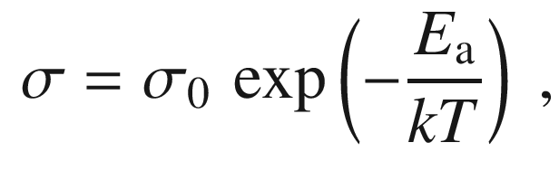

(18.2)

where



is an energy of the order of 1 eV. Such activation also pertains to the mobility alone, e.g.

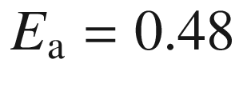

 eV for PPV [1573].

The maximum low-field mobility of many crystalline organic semiconductors at room temperature is around 1 cm

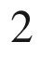

/Vs with a weak temperature dependence [1574]. Such mobility is much smaller than that of crystalline silicon and rather comparable to that of amorphous silicon. Improved purity and handling of organic semiconductors has allowed to achieve intrinsic material properties (Fig. [18.8](#u116076_4_En_18_Chapter-Fig8)). The mobility increases at low temperatures, e.g. below 100 K in naphtalene [1575]. This has been attributed to the freeze-out of phonons and the transition from hopping to band transport.

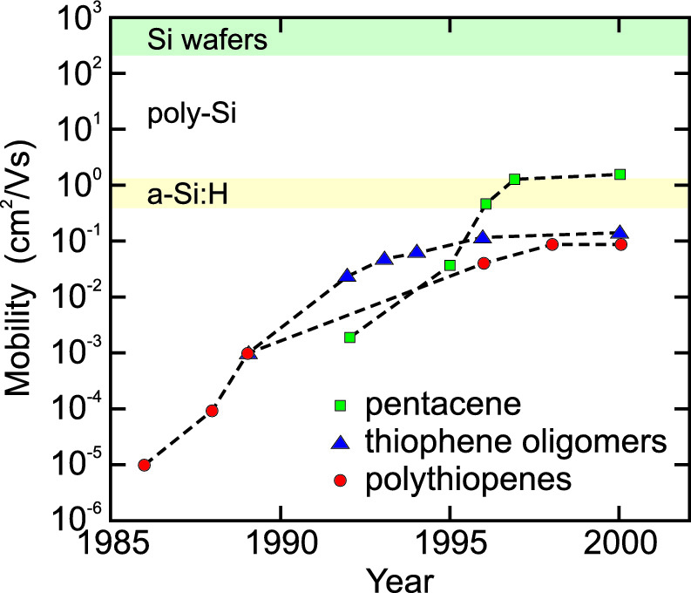

Fig. 18.8

Historic development of the experimentally achieved mobility of organic semiconductors at room temperature

The drift velocity at higher fields shows saturation but the values, even at low temperature, are much smaller than in silicon (Fig. [18.9](#u116076_4_En_18_Chapter-Fig9)). An analytical model for the described main features of transport in organic semiconductors has been given in [1576].

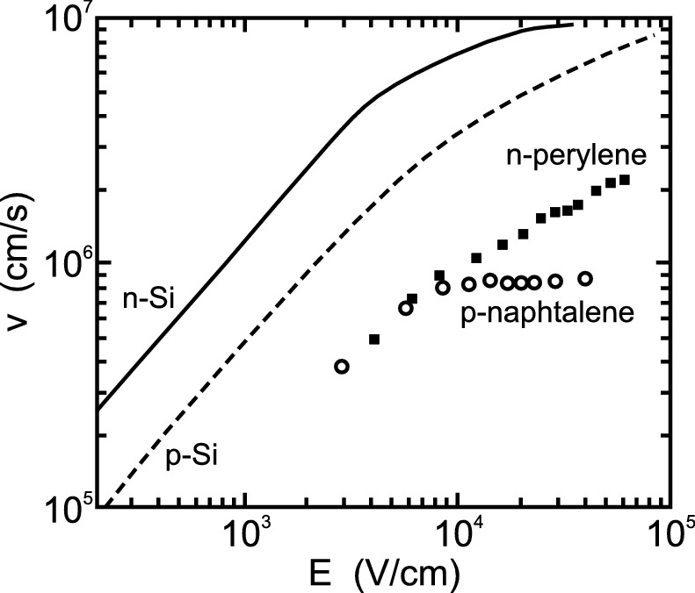

Fig. 18.9

Carrier velocity in ultrapure and highly perfect single crystals of (n-conducting) perylene at

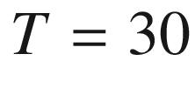

 K and (p-conducting) naphtalene at

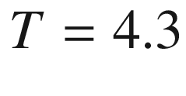

 K. For comparison electron (hole) velocity in silicon at room temperature is shown as *solid* (*dashed*) line.

Adapted from [1561]

### 18.6 Optical Properties

Organic molecules can emit light efficiently and are thus useful for light emitters. For the photo-physics of organic materials it is essential to recall the molecular physics of singlet and triplet states. In the singlet (triplet) state, the total spin quantum number of the unpaired electrons is

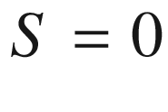

(

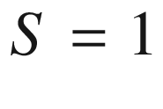

). A simple energy scheme includes a ground state

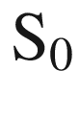

and excited singlet (

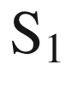

) and triplet (

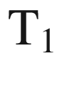

) states. The recombination transition

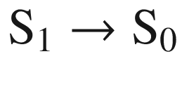

is allowed and its lifetime short. Such luminescence is termend ‘fluorescence’. Recombination from the triplet state is forbidden or at least very slow (‘phosphorescence’).

As an example for a small organic molecule, the fluorescence lifetime of Alq



is about 12 ns [1577]. The triplet lifetime is in the 10

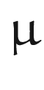

s range [1578]. Luminescence and absorption spectra of Alq



are shown in Fig. [18.10](#u116076_4_En_18_Chapter-Fig10). The luminescence peak is redshifted with respect to the absorption edge due to the Frank-Condon principle (Fig. [10.​21](The_Physics_of_Semiconductors00005.docx#u116076_4_En_10_Chapter-Fig21)). The density of excited (empty) states of the Alq



molecule is shown in Fig. [18.11](#u116076_4_En_18_Chapter-Fig11) together with the orbitals associated with the four prominent states. The lowest orbital is the LUMO and leads to the visible luminescence of the Alq



in the red.

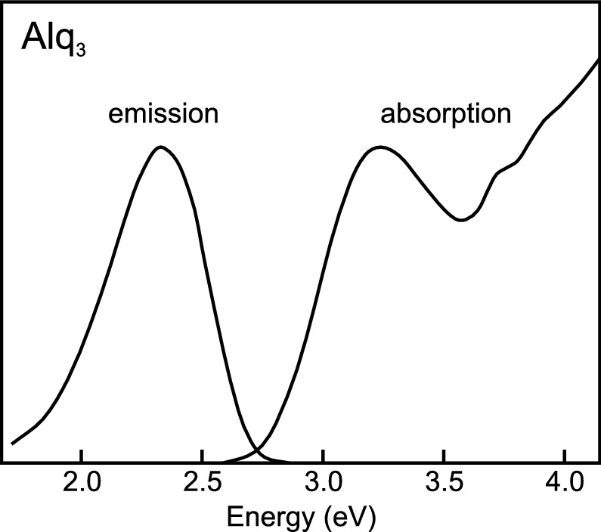

Fig. 18.10

Luminescence and absorption spectra of Alq



(vapor-deposited 150 nm thin film on a quartz substrate) at room temperature.

Adapted from [1579]

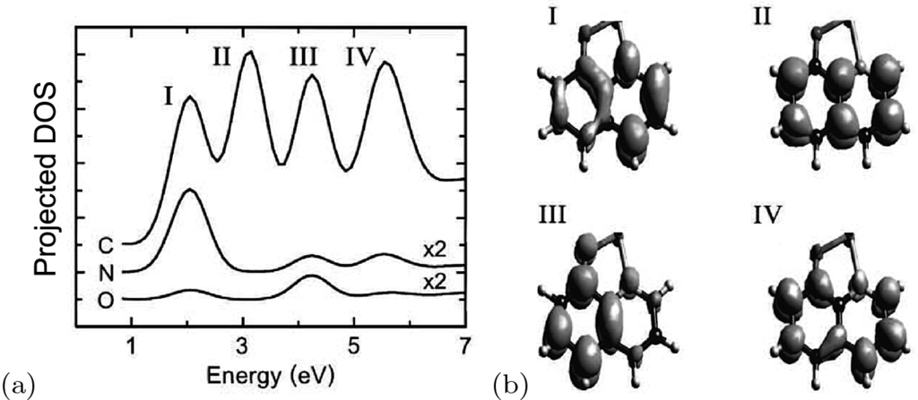

Fig. 18.11

**a** Projected density of states (for C, N, and O) of excited states in an Alq



molecule. The origin of the energy axis is the HOMO level. **b** Orbitals for the four states labeled I–IV in (**a**).

Reprinted with permission from [1556], ©1998 AIP

In Fig. [18.12](#u116076_4_En_18_Chapter-Fig12), the photoluminescence (PL) and absorption of a polymer, poly-thiophene are shown. The recombination is below the band gap of 2.1–2.3 eV on an excitonic level at 1.95 eV. There are several phonon replica whose separation of 180 meV corresponds to the C–C stretching mode. The PL excitation (PLE) spectrum of poly-thiophene demonstrates that the PL at 1.83 eV can be excited via the exciton level.

The theoretical band structure of poly-thiophene is shown in Fig. [18.13](#u116076_4_En_18_Chapter-Fig13)a. The Brillouin zone is one-dimensional. The situation I corresponds to a single molecular chain, the situation II pertains to the chain embedded in a medium with a dielectric constant

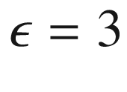

. The predicted band gaps are 3.6 eV and 2.5 eV, respectively. The exciton binding energy is about 0.5 eV. The exciton is a Frenkel exciton that has a small extension and is localized. The high binding energy is favorable for radiative recombination since the exciton is stable at room temperature. For photovoltaic applications, it is unfavorable since it has to be overcome in order to separate electrons and holes (after absorption). Generally, intrachain excitons (as here) and interchain excitons, where electron and the hole are localized on different chains, are distinguished.

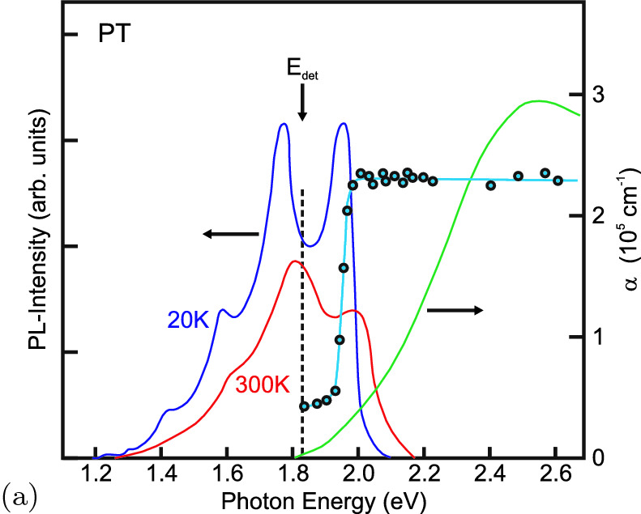

Fig. 18.12

Photoluminescence (PL) spectra at

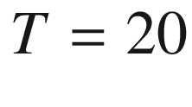

and 300 K and absorption spectrum (*green line*) of poly-thiophene. The *vertical dashed line* denotes the detection energy (

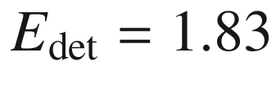

 eV) of the PL excitation (PLE) spectrum (*blue circles*) (

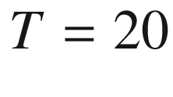

 K).

Adapted from [1580]

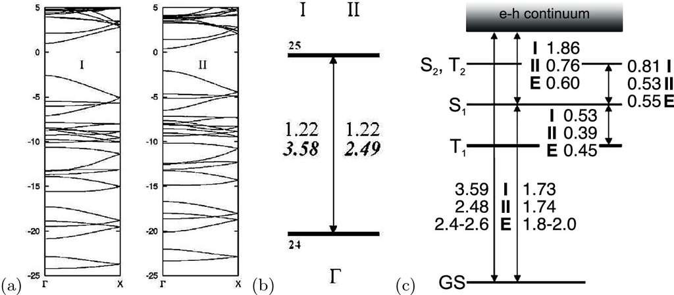

Fig. 18.13

**a** Band structure of poly-thiophene (‘I’: naked chain, ‘II’: chain in a dielectric medium (



)), **b** single-particle energies and band gap, **c** exciton levels (’E’: experimental values).

Reprinted with permission from [1581], ©2002 APS

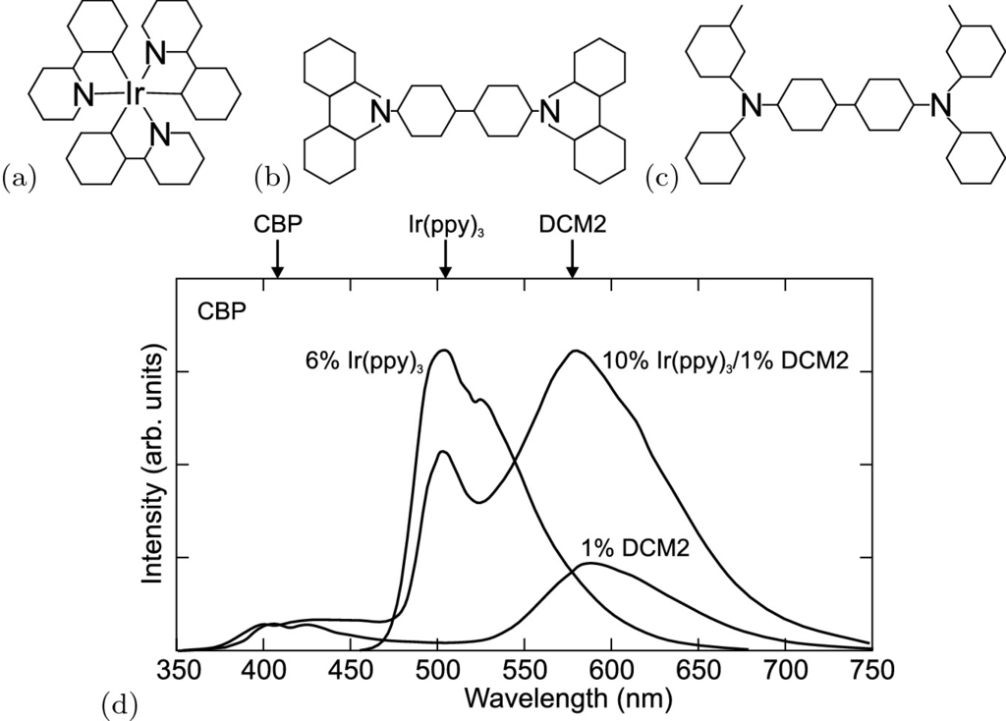

Fig. 18.14

Molecular structure of **a** Ir(ppy)



, **b** CBP and **c** TDP (see text). **d** Electroluminescence spectra (at room temperature) of CBP:6% Ir(ppy)



, CBP:10% Ir(ppy)



/1%DCM2 and CBP:2%DCM2.

Based on data from [1585, 1586]

Collection of carriers in the ‘dark’ triplet state poses a problem limiting the quantum efficiency to 25% in a simple model [1582]. Harvesting luminescence from *all* exciton states would yield significantly higher efficiencies than is possible in purely fluorescent materials (or devices).

A successful route is the use of a phosphorescent guest material. Radiative transitions from triplet states become partially allowed when the excited singlet and triplet states are mixed. This is typically achieved in metalorganic molecules with heavy metal atoms, providing large spin-orbit interaction effects [1583, 1584]. Most prominently Ru-, Pt- and Ir-containing compounds are used, e.g. *fac* tris(2-phenylpyridine) iridium [Ir(ppy)



] in 4,4’-N,N’-dicarbazole-biphenyl [CBP] (Fig. [18.14](#u116076_4_En_18_Chapter-Fig14)a,b) [1585]. The luminescence spectrum of Ir(ppy)



is shown in Fig. [18.14](#u116076_4_En_18_Chapter-Fig14)d. The radiative decay constant of the Ir(ppy)



triplet state is about 800 ns and observable if energy transfer from the host triplet state is exotherm (

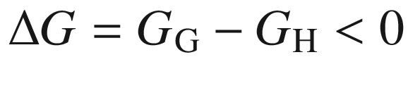

[1578], see Fig. [18.15](#u116076_4_En_18_Chapter-Fig15)a) and fast. This is the case for CBP:Ir(ppy)



(Fig. [18.15](#u116076_4_En_18_Chapter-Fig15)b),

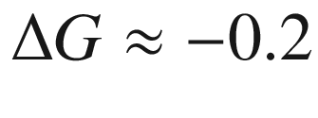

 eV. Actually, reverse transfer from Ir(ppy)



to CBP seems responsible for some loss in luminescence efficiency and the decrease in phosphorescent lifetime from 800 ns to 400 ns.

In the case of N,N’-diphenyl-N,N’-bis(3-methylphenyl)-[1,1’-biphenyl]-4,4’-diamine [TDP] (Fig. [18.14](#u116076_4_En_18_Chapter-Fig14)c) host, the triplet energy transfer to the phosphorent Ir(ppy)



guest is endotherm (

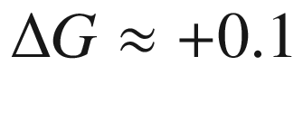

 eV) and represents the rate limiting step [1578]. In this case the recombination of Ir(ppy)



has a decay constant of about 15

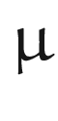

s (Fig. [18.15](#u116076_4_En_18_Chapter-Fig15)b). The thermal activation character is confirmed by even longer decay times at low temperatures (

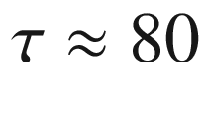



s at

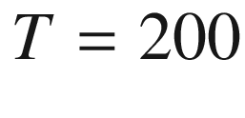

 K) [1578]. Endothermic transfer allows to pump a blue guest phosphor without a blue host material.

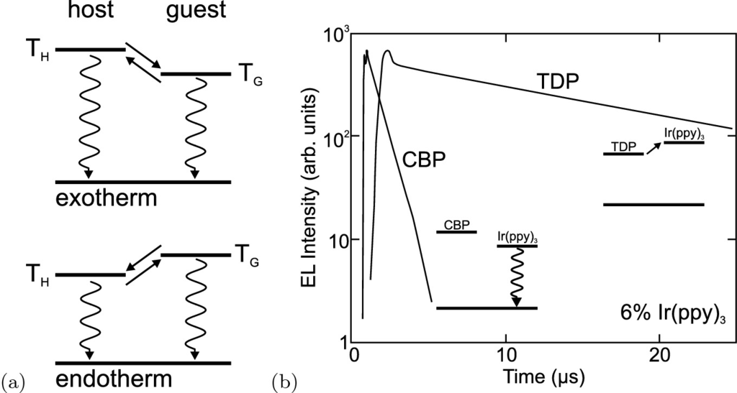

Fig. 18.15

**a** Schematic term diagram of host (T

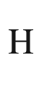

) and guest (T

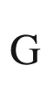

) triplet states. *Straight arrows* denote energy transfer between triplet states, *wiggly arrows* denote radiative transitions to the (singlet) ground state. **b** Electroluminescence transients (at room temperature, detected in the range 500–560 nm [cmp. Fig. [18.14](#u116076_4_En_18_Chapter-Fig14)b]) of CBP:6% Ir(ppy)



(

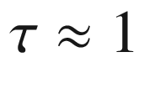



s) and TDP:6% Ir(ppy)



(

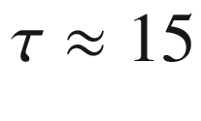



s). *Insets*: term schemes with arrow denoting the rate limiting step.

Based on data from [1578]

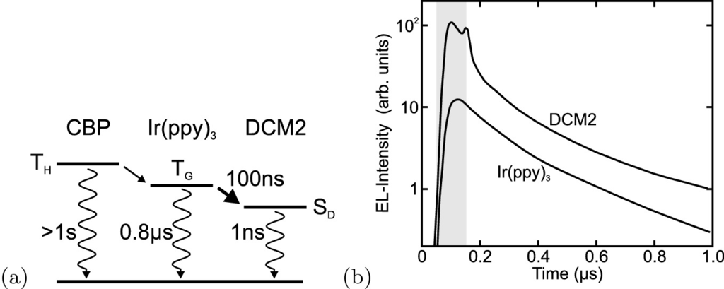

Fig. 18.16

**a** Schematic term scheme of CBP:Ir(ppy)



/DCM2 and energy transfer and recombination paths (cmp. spectrum in Fig. [18.14](#u116076_4_En_18_Chapter-Fig14)). The rate constants are shown for various processes, the rate limiting step is shown with a *bold arrow*. **b** Electroluminescence transients after 100 ns excitation pulse (*grey area*) of Ir(ppy)



and DCM2 luminescence from CBP:10% Ir(ppy)



/1% DCM2.

Based on data from [1586]

Further, subsequent Förster energy transfer [1587] from the guest triplet state to a fast and efficient singlet state (S

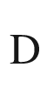

) of a fluorescent dye is possible, e.g. from CBP:Ir(ppy)



to DCM2 [1586]. The transient lifetime of pure DCM2 is about 1 ns. In a mixture of CBP:10% Ir(ppy)



/1% DCM2 the luminescence of DCM2 appears with the same 100 ns decay constant as that of Ir(ppy)



(Fig. [18.16](#u116076_4_En_18_Chapter-Fig16)b). This decay constant (rate limiting step, see Fig. [18.16](#u116076_4_En_18_Chapter-Fig16)a) corresponds to the energy transfer depleting the triplet state of Ir(ppy)



to DCM2 and is much faster than the pure Ir(ppy)



radiative lifetime.

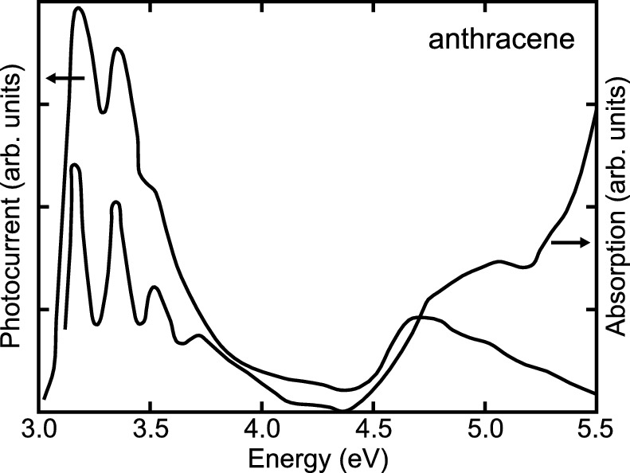

Fig. 18.17

Photoconductivity and absorption spectrum of anthracene

The photoconductivity of organic semiconductors is typically related to their absorption spectrum as shown for anthracene in Fig. [18.17](#u116076_4_En_18_Chapter-Fig17).

Footnotes

[1](The_Physics_of_Semiconductors00006.docx#u116076_4_En_18_Chapter-Fn1_source)

2-ethoxy,5-(2’-ethyl-hexyloxy)-1,4-phenylene vinylene.

© Springer Nature Switzerland AG 2021

M. Grundmann

The Physics of Semiconductors

Graduate Texts in Physics

<https://doi.org/10.1007/978-3-030-51569-0_19>

## 19. Dielectric Structures

Marius Grundmann[1](#u116076_4_En_19_Chapter-Aff11)

(1)

Felix Bloch Institute for Solid State Physics, Universität Leipzig, Leipzig, Germany

Marius Grundmann

Email:

[grundmann@physik.uni-leipzig.de](mailto:grundmann@physik.uni-leipzig.de)

## Abstract

Dielectric structures, in particular periodic dielectric structures are treated. A general one-dimensional model is developed describing Bragg mirrors. Examples for photonic band gap materials in one, two and three dimensions are given. Different types of dielectric cavities and microscopic resonators including Fabry-Pérot and whispering gallery resonators are treated. Quantum electrodynamic physical effects from light matter coupling such as Purcell effect and strong coupling are treated.

### 19.1 Photonic Band Gap Materials

Layered structures of dielectric  materials with different index of refraction are used as optical elements such as filters or reflection and anti-reflection coatings [1588]. In this section we discuss the use of such concepts in one-, two- and three-dimensional photonic band gap materials.

#### 19.1.1 Introduction

A structure with a so-called *photonic* band gap (PBG) exhibits an energy range (color range) in which photons cannot propagate in any direction. In the photonic band gap, there are no optical modes, no spontaneous emission and no vacuum (zero-field) fluctuations. We recollect that spontaneous emission is not a necessary occurrence: Looking at Fermi’s golden rule ([9.​30](The_Physics_of_Semiconductors00004.docx#u116076_4_En_9_Chapter)) for the transition probability integrated over all final states

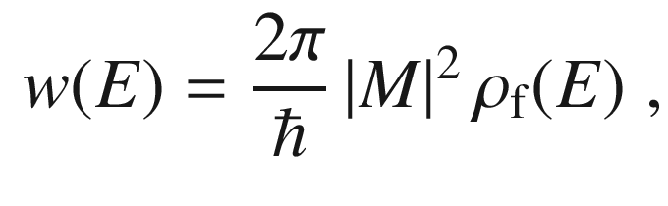

(19.1)

we see that the decay rate depends on the density

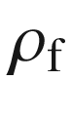

of final states at energy *E*. In the case of spontaneous emission, this is the (vacuum) density

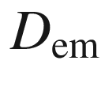

of electromagnetic modes (per energy per volume) that varies

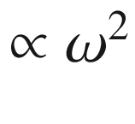

:

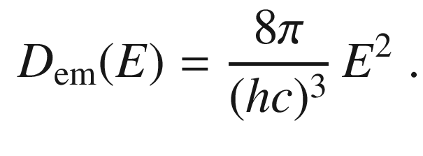

(19.2)

In a homogeneous optical medium *c* must be replaced with *c*/*n* (cmp. Sect. [10.​2.​3](The_Physics_of_Semiconductors00005.docx#u116076_4_En_10_Chapter)).

If the band gap of a PBG is tuned to the electronic gap of a semiconductor, the spontaneous emission, and also induced emission, can be suppressed. Thus, one mode has to be left by ‘doping’ the structure. In this mode all emission will disappear and an efficient single-mode (monochromatic) LED or ‘zero-threshold’ laser could be built. A schematic comparison of the band structure of electrons and photons is given in Fig. [19.1](#u116076_4_En_19_Chapter-Fig1).

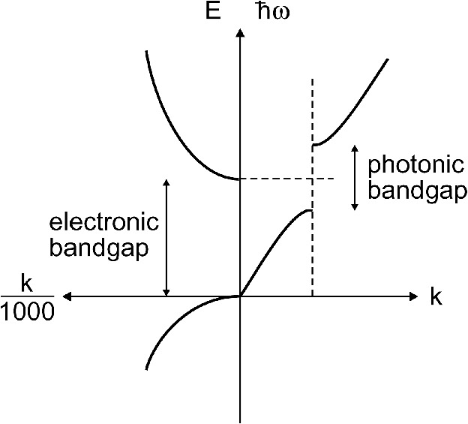

Fig. 19.1

*Right*: electromagnetic dispersion with a forbidden gap at the wavevector of the periodicity. *Left*: Electron-wave dispersion typical of a direct-gap semiconductor. When the photonic band gap straddles the electronic band gap, electron–hole recombination into photons is inhibited since the photons have no place to go (zero final density of states)

#### 19.1.2 General 1D Scattering Theory

The formation of a photonic band gap in a one-dimensional dielectric can be calculated to a large extent analytically and thus with direct insight. Let *n*(*x*) be the spatially varying index of refraction (no losses or nonlinear optical effects). The one-dimensional wave equation (Helmholtz equation) reads for the electric field *E*

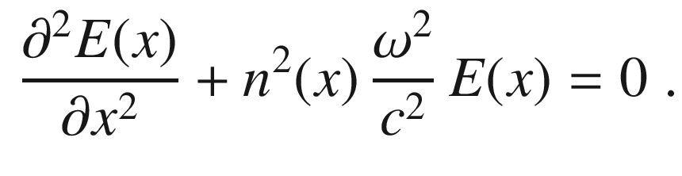

(19.3)

A comparison with a one-dimensional Schrödinger equation

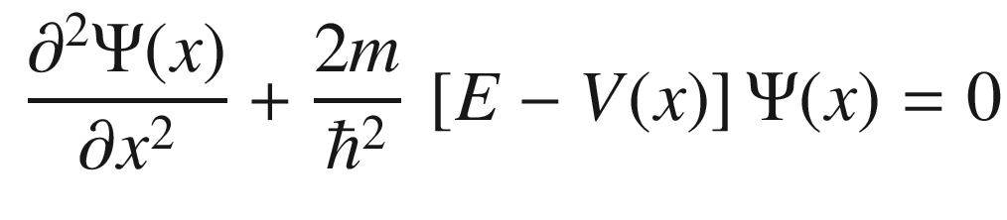

(19.4)

shows that the Helmholtz equation corresponds to the quantum-mechanical wave equation of zero external potential *V* and a spatially modulated mass, i.e. a case that is usually not considered.

Let us consider now the amplitude

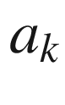

of the *k* eigenvector. The eigenvalue is then

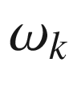

. The one-dimensional mode density

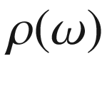

(per energy and per unit length) is

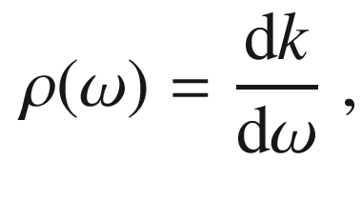

(19.5)

which is the inverse of the group velocity.

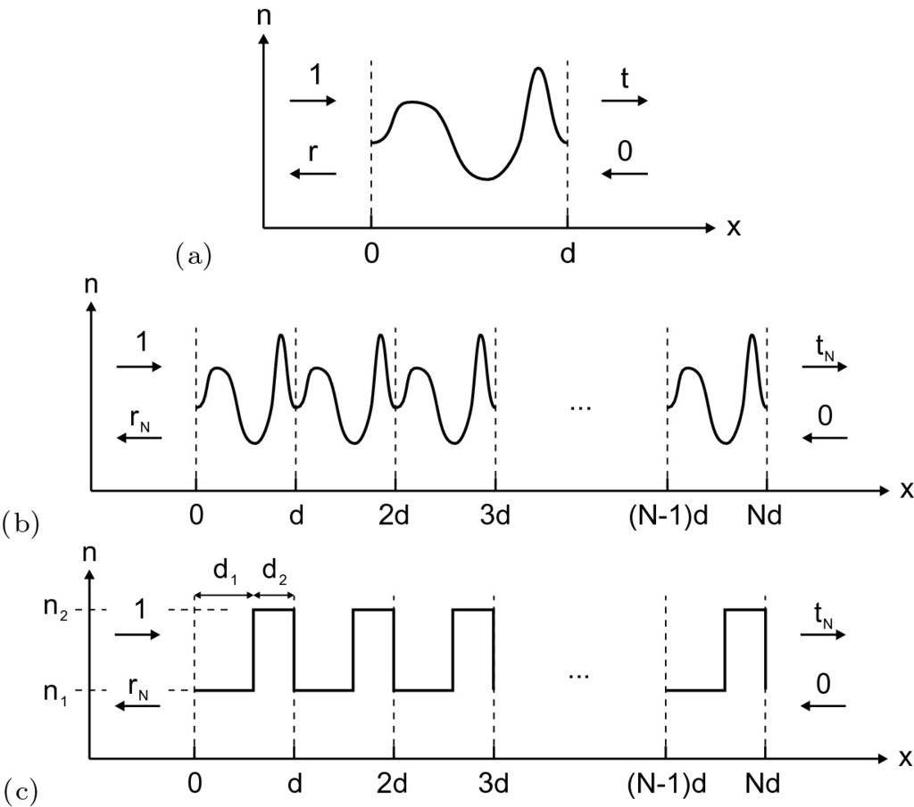

Fig. 19.2

1D scattering problem: **a** General scattering of an index of refraction distribution, **b** *N*-period stack, **c** two-layer (quarter-wave) stack

We follow one-dimensional scattering theory as presented in [1589]. At this point we do not rely on any specific form of *n*(*x*) (Fig. [19.2](#u116076_4_En_19_Chapter-Fig2)a). The (complex) transmission coefficient *t* for any index structure is

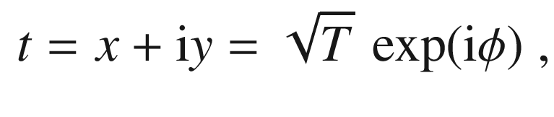

(19.6)

where

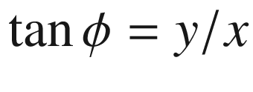

.

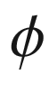

is the total phase accumulated during propagation through the structure. It can be written as the product of the physical thickness of the structure *d* and the effective wave number *k*. Hence we have the dispersion relation

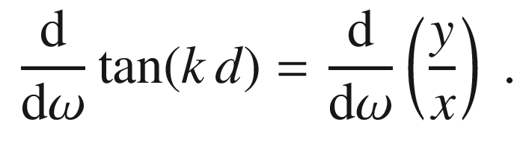

(19.7)

Evaluating the derivative we find

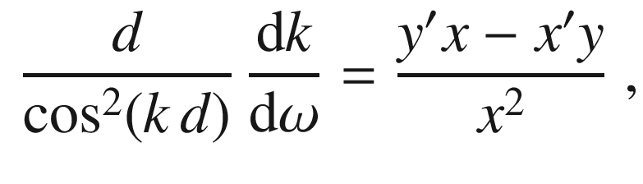

(19.8)

where the prime denotes derivation with respect to

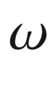

. Using the relation

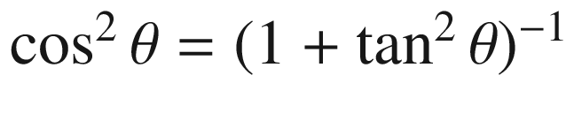

, we obtain the general expression

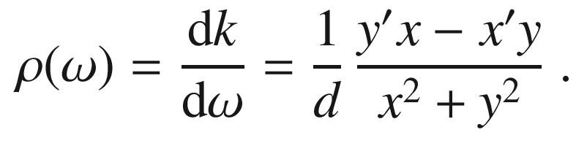

(19.9)

#### 19.1.3 Transmission of an N-Period Potential

Now, the behavior of *N* periods of a given index distribution *n*(*x*) within a thickness *d* of one period (Fig. [19.2](#u116076_4_En_19_Chapter-Fig2)b) is investigated. The scattering matrix



connects the intensity at

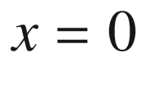

with that at

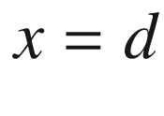

. We use the column vector

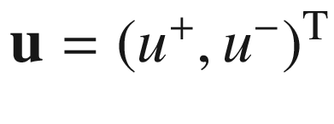

containing the right- and left-going waves (labeled ‘

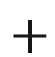

’ and ‘−’, respectively),

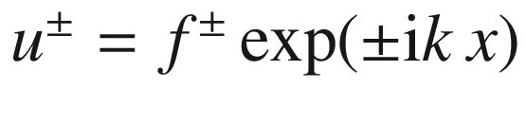

,

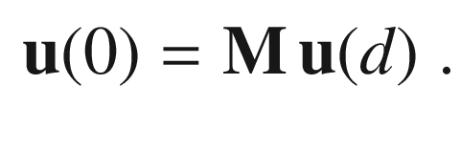

(19.10)

Using the boundary conditions

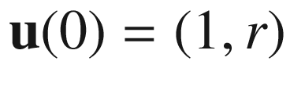

and

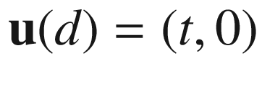

, we find that



has the structure

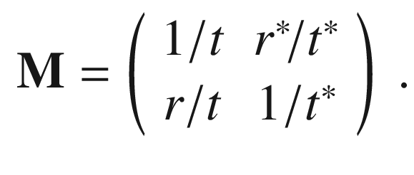

(19.11)

The conservation of energy requires that

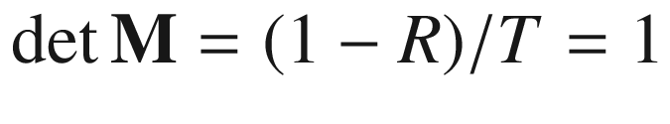

. The eigenvalue equation for



 is

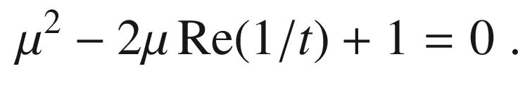

(19.12)

The two eigenvalues

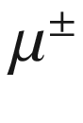

are related by

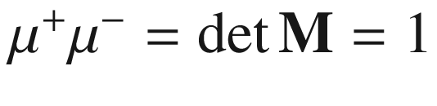

. If we consider an infinite, periodic structure, we know from Bloch’s theorem (cf. Sect. [6.​2.​1](The_Physics_of_Semiconductors00003.docx#u116076_4_En_6_Chapter)) that the eigenvector varies between unit cells only via a phase factor, i.e.

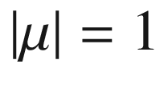

. Therefore, the eigenvalues can be written as

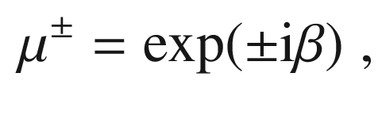

(19.13)

where

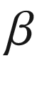

corresponds to the Bloch phase of a hypothetical infinite periodic structure. This phase

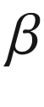

should not be confused with



defined earlier, which is associated with the unit cell transmission. We find the condition

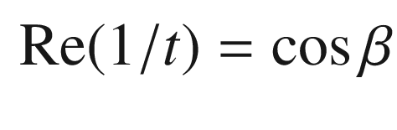

(19.14)

for the Bloch phase. Since every matrix obeys its own eigenvalue equation, we have also (

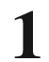

being the unity matrix)

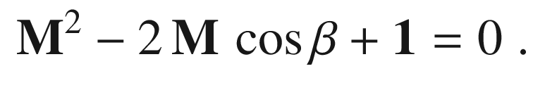

(19.15)

By induction one can show that the *N*-period case has the scattering matrix

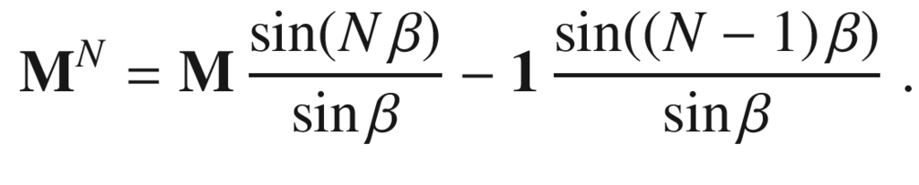

(19.16)

The solution for the finite period case can be written in terms of the Bloch phase of the infinite potential. The transmission and reflection of the *N*-period system are given by

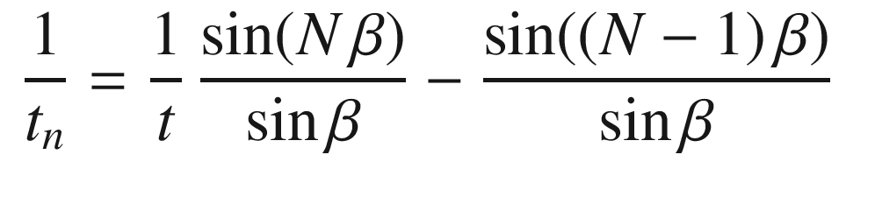

(19.17a)

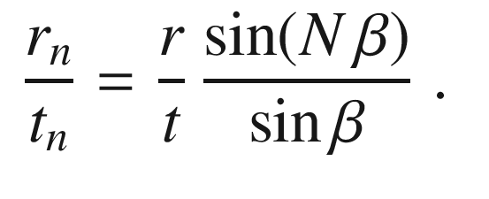

(19.17b)

The transmission of intensity can be written as (

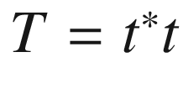

)

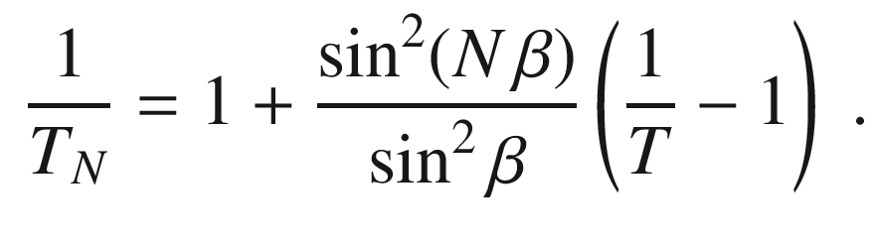

(19.18)

Again, up to this point no specific distribution of the index of refraction within the unit cell has been specified.

From ([19.17a](#u116076_4_En_19_Chapter-Equ17)), a general formula for the mode density

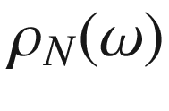

of the *N*-stack can be obtained as [1589]

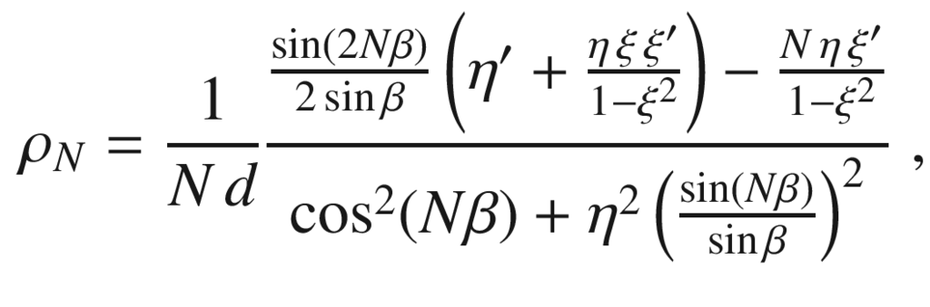

(19.19)

where

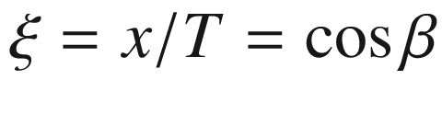

and

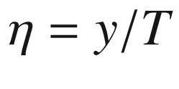

.

#### 19.1.4 The Quarter-Wave Stack

A quarter-wave stack, also known as a Bragg mirror, exhibits a one-dimensional photonic band gap. One period consists of two regions with thickness and index of refraction

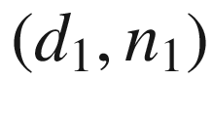

and

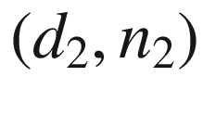

, respectively (Fig. [19.2](#u116076_4_En_19_Chapter-Fig2)c). In the quarter-wave stack each region has an optical thickness of

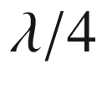

(the wave accumulates in each region a phase of

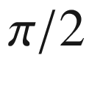

) for a particular wavelength

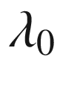

or (midgap) frequency

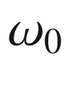

. Thus, the condition reads

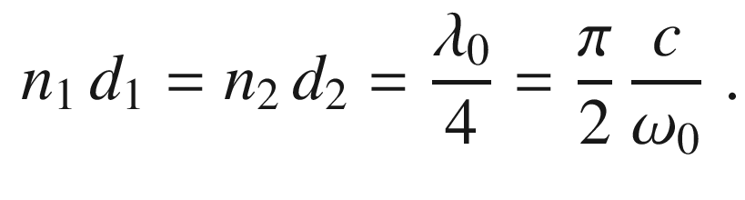

(19.20)

Using the Fresnel formulas, the transmission of an arbitrary two-layer cell is

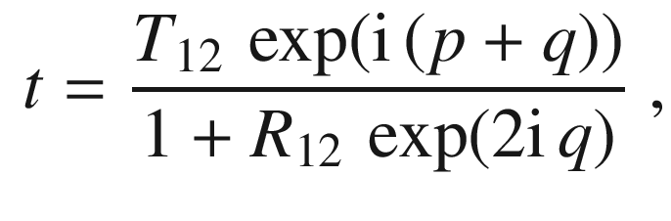

(19.21)

where

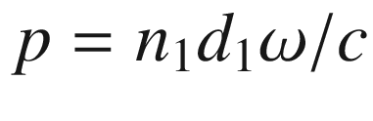

and

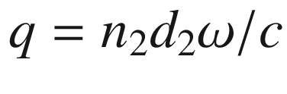

are the phases accumulated in the two layers, respectively. The values of

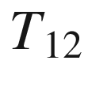

and

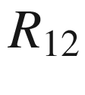

are given as

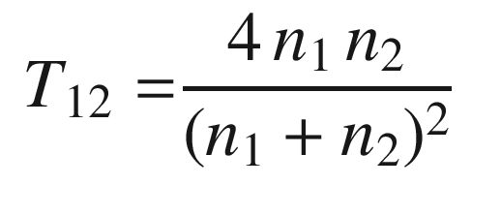

(19.22)

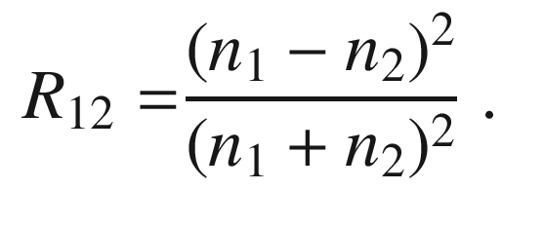

(19.23)

For the quarter-wave stack (

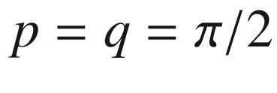

), we obtain for ([19.21](#u116076_4_En_19_Chapter-Equ22))

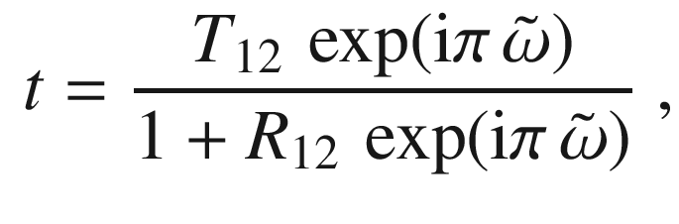

(19.24)

where

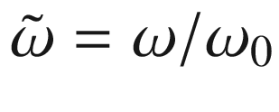

is the frequency scaled to the midgap value.

The transmission of a single two-layer cell is

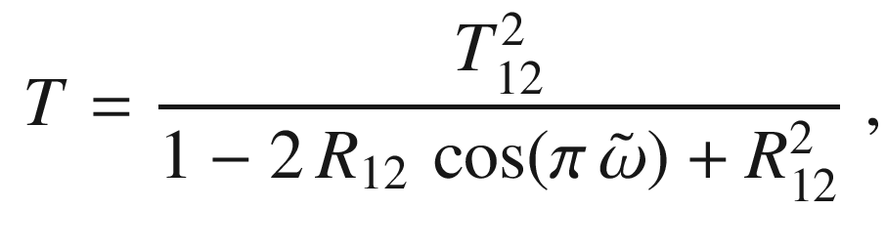

(19.25)

and the Bloch phase is given by

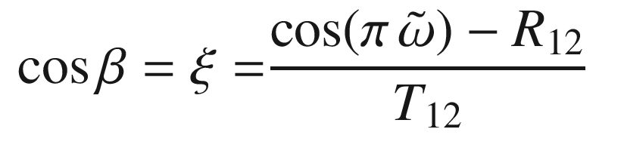

(19.26)

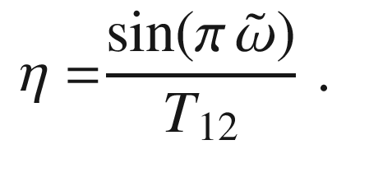

(19.27)

For the *N*-period quarter-wave stack the transmission is given by

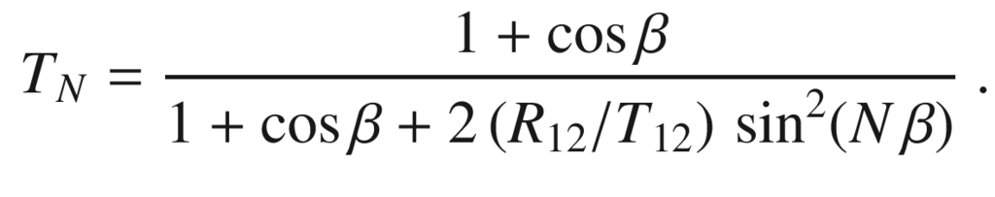

(19.28)

A band gap forms. Within the band gap, the density of modes is lowered, at the edges it is enhanced (Figs. [19.3](#u116076_4_En_19_Chapter-Fig3) and [19.4](#u116076_4_En_19_Chapter-Fig4)). The transmission at midgap decreases

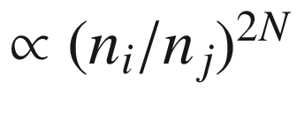

, where

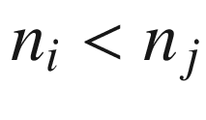

.

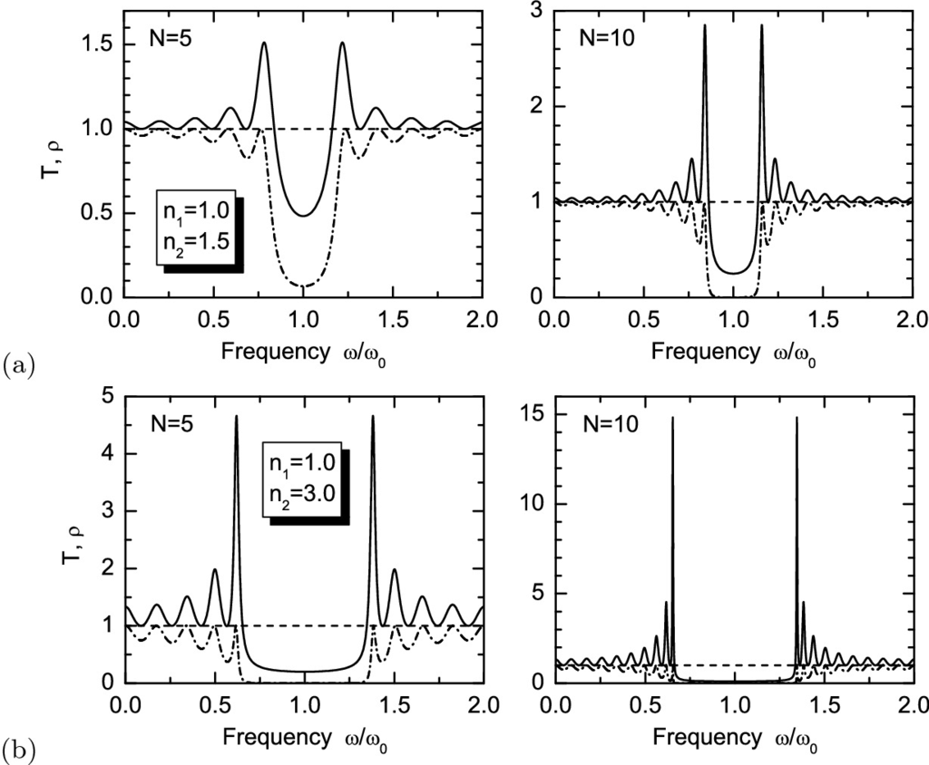

Fig. 19.3

Quarter-wave stack with indices of refraction **a**

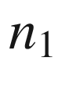

,

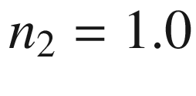

, 1.5 and **b** 1.0, 3.0. *Solid lines*: dimensionless density of modes

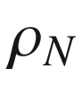

([19.19](#u116076_4_En_19_Chapter-Equ20)), *dashed lines*: transmission

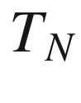

([19.28](#u116076_4_En_19_Chapter-Equ29)) for two different numbers of pairs

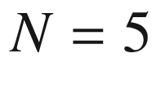

(*left panels*) and 10 (*right panels*) versus the dimensionless frequency

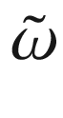

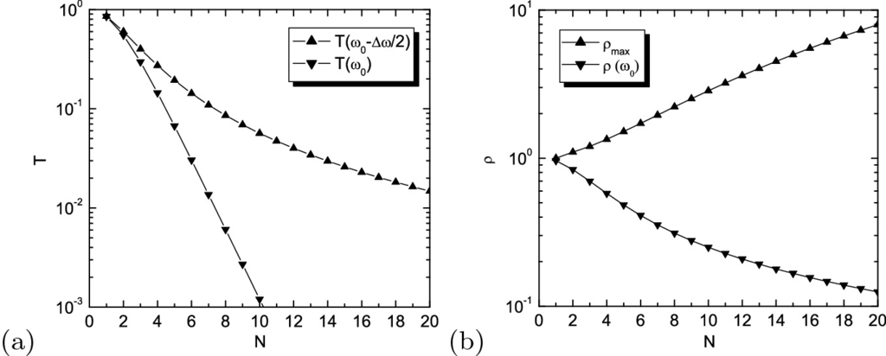

Fig. 19.4

Quarter-wave stack with indices of refraction

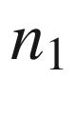

,

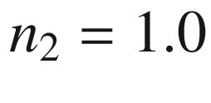

, 1.5: **a** Transmission

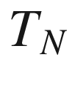

at midgap (

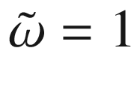

, *down triangles*) and at the band edge (

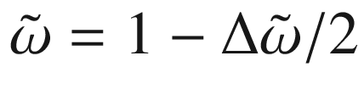

, *up triangles*) versus number of pairs *N*. **b** Dimensionless density of modes

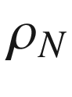

at maximum near the band edge and at midgap versus number of pairs *N*

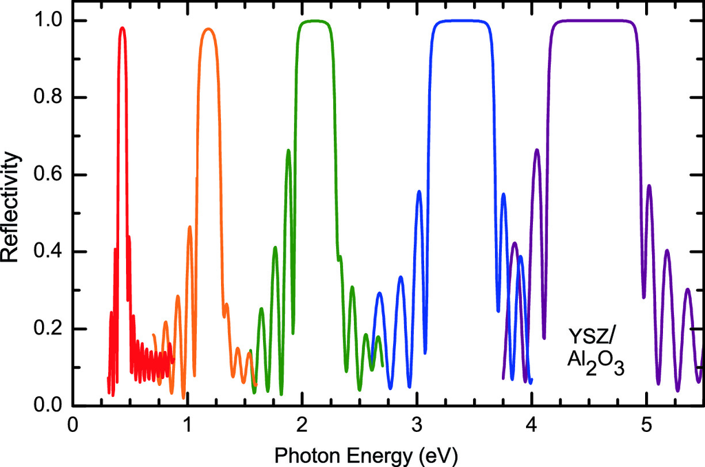

Fig. 19.5

Reflectance of various Bragg mirrors from YSZ/Al



O



grown by pulsed laser deposition on sapphire. The different layer thicknesses result in the design energies 0.43 eV (

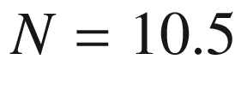

,

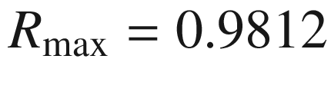

, *red*), 1.19 eV (

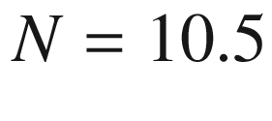

,

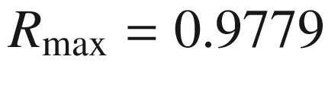

, *orange*), 2.11 eV (

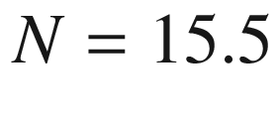

,

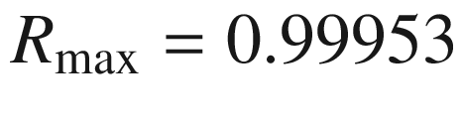

, *green*), 3.39 eV (

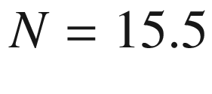

,

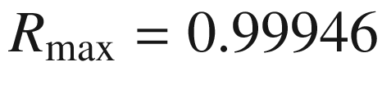

, *blue*) and 4.54 eV (

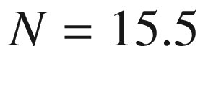

,

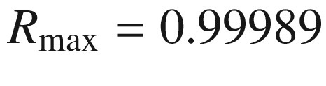

, *purple*)

In the limit of large *N* the complete width

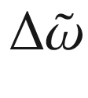

of the band gap is implicitly given by

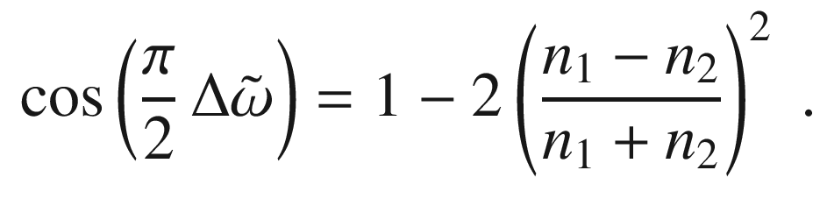

(19.29)

If

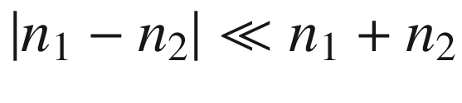

, we find

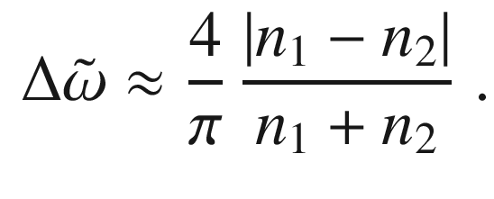

(19.30)

The principle of the quarter-wave stack is scalable to frequencies other than visible light.[1](#u116076_4_En_19_Chapter-Fn1) In Fig. [19.5](#u116076_4_En_19_Chapter-Fig5) the reflectance of various quarter-wave stacks from yttria-stabilized zirconia (YSZ [1590], high index material, Fig. [19.6](#u116076_4_En_19_Chapter-Fig6)a) and Al



O



are shown [1591]. The different design wavelengths have been achieved solely by varying the layer thicknesses.

In Fig. [19.6](#u116076_4_En_19_Chapter-Fig6)b the three Bragg mirrors from Fig. [19.5](#u116076_4_En_19_Chapter-Fig5) with



pairs are replotted in relative frequency units



. The spectra look very similar; subtle differences in the width of the reflectance band are due to slightly larger index contrast at higher design energy (cmp. Fig. [19.6](#u116076_4_En_19_Chapter-Fig6)a). The width of the gap is approximately

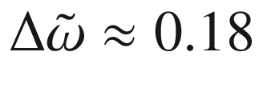

in agreement with ([19.30](#u116076_4_En_19_Chapter-Equ31)).

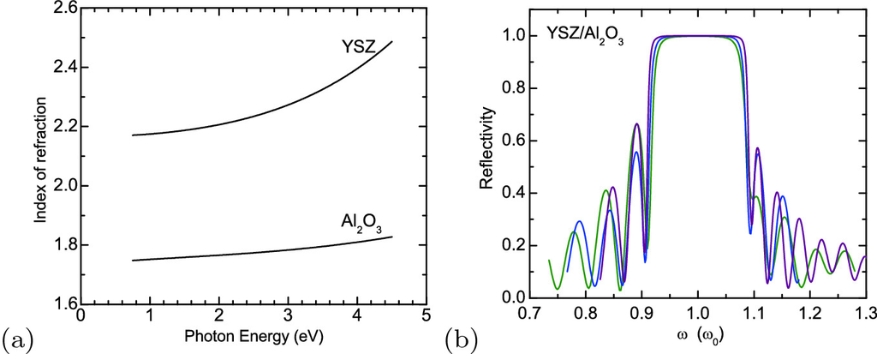

Fig. 19.6

**a** Index of refraction of YSZ and Al



O



as a function of photon energy. **b** Reflectance spectra of the 2.11 eV (*green*), 3.39 eV (*blue*) and 4.54 eV (*purple*) Bragg mirrors of Fig. [19.5](#u116076_4_En_19_Chapter-Fig5) replotted as a function of the scaled frequency

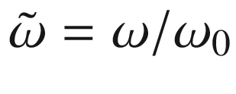

As further example, a Mo/Si Bragg mirror with a period of 6.7 nm is shown in Fig. [19.7](#u116076_4_En_19_Chapter-Fig7). Such a mirror works in the extreme UV and is used for soft X-ray optics, possibly in advanced lithography systems. Dielectric thin films can also be designed for anti-reflection coatings, edge filters or pass and stop band filters as detailed in [1588].

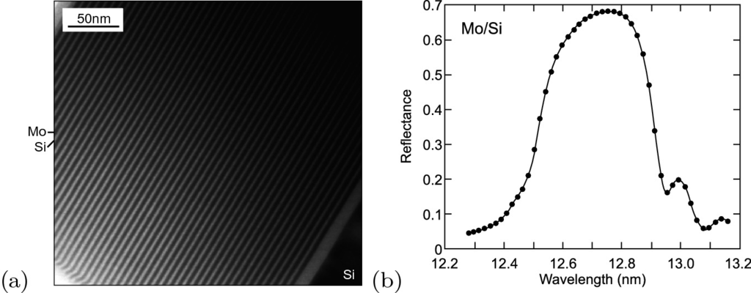

Fig. 19.7

**a** Cross-sectional TEM of Mo/Si superlattice with 2.7 nm Mo (*dark*) and 4.0 nm Si (*bright*) layers on Si(001) substrate. From [1592]. **b** Reflection spectrum for a SL with nominal period of 6.5 nm and 88.5

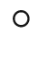

angle of incidence. Data points are shown as *circles*, the *solid line* is a fit with a period of 6.45 nm.

Adapted from [1593]

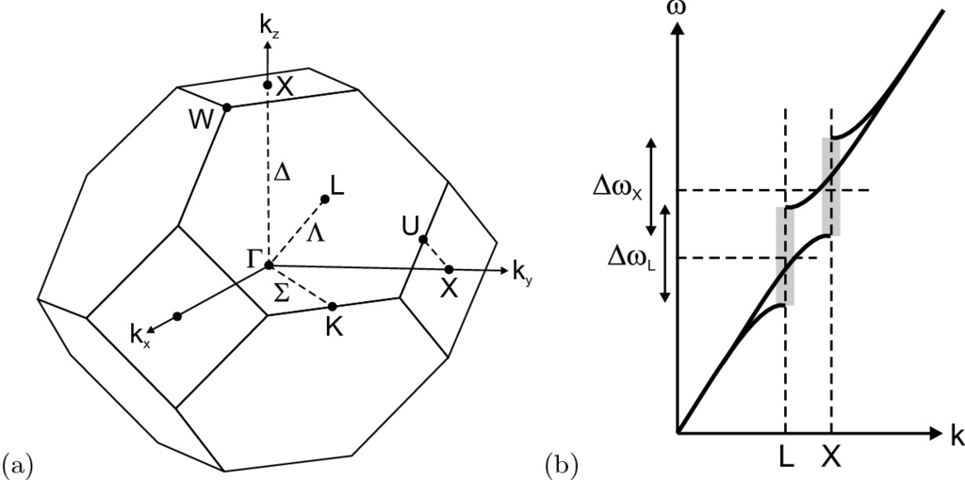

Fig. 19.8

**a** The Brillouin zone of the fcc lattice. **b** Schematic forbidden gaps at the L- and X-points

#### 19.1.5 Formation of a 3D Band Structure

For other applications, e.g. waveguides with minimized footprint, 3D (or at least 2D) photonic band gap structures are needed. Details can be found in dedicated textbooks [1594–1596]. In [1597] planar, cylindrical and spherical Bragg mirrors are discussed.

Since we want a photonic band gap that is present for *all* directions of propagation, a Brillouin zone with a shape close to a sphere is preferable. Then, the main directions are at similar *k*-values (Fig. [19.8](#u116076_4_En_19_Chapter-Fig8)). One of the best suited is the fcc lattice. Since the L-point is centered at



14% lower frequency than the X-point, the forbidden gaps for different directions must be, however, sufficiently wide to create a forbidden frequency band overlapping at all points along the surface of the Brillouin zone. For example, the bcc lattice has a Brillouin zone that is less symmetric than that of the fcc lattice (see Fig. [3.​38](The_Physics_of_Semiconductors00002.docx#u116076_4_En_3_Chapter-Fig38)) and thus is less suited for the creation of an omnidirectional photonic band gap. However, the photonic band gap must not arise above the first band, relaxing problems due to asymmetry of the Brillouin zone (cf. Table [19.1](#u116076_4_En_19_Chapter-Tab1)).Table 19.1

Various photonic band gap structures and some of their properties. The band gap is between the *n*-th and (

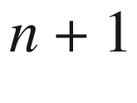

)th band,



is given for air/silicon (

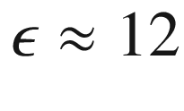

)

| Name | Crystal type | *n* | $$\Delta \tilde{\omega }$$  (%) | Refs. |
| --- | --- | --- | --- | --- |
| Diamond | diamond | 2 | 29 | [1598] |
| Yablonovite | fcc | 2 | 19 | [1602] |
| Woodpile | fc tetragonal | 2 | 20 | [1603] |
| Spirals | sc | 4 | 17 | [1604] |
| Square-spirals | tetragonal | 4 | 24 | [1599] |
| Layered 3D | bc orthorhombic | 4 | 23 | [1605] |
| Inverted scaffold | sc | 5 | 7 | [1606] |
| Inverse opal | fcc | 8 | 4.25 | [1607] |
| Inverse hcp | hcp | 16 | 2.8 | [1608] |

Maxwell’s equations (zero charge density) for monochromatic waves

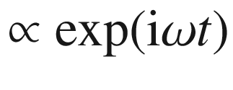

(and isotropic dielectric function)

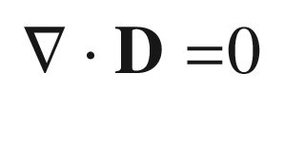

(19.31)

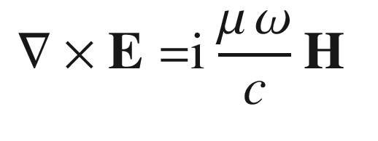

(19.32)

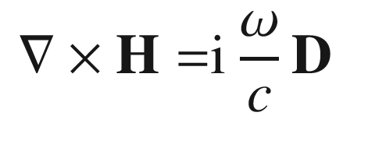

(19.33)

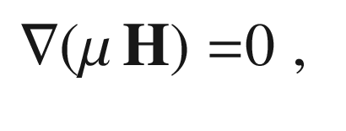

(19.34)

together with

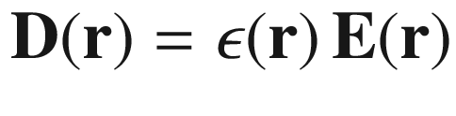

and

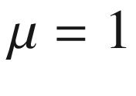

they are combined into the wave equation

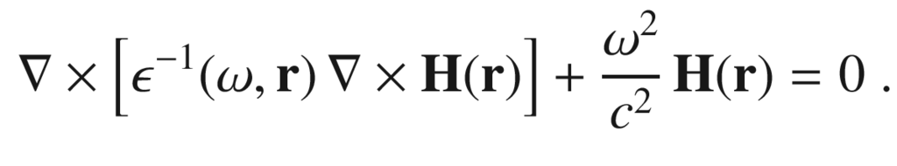

(19.35)

This equation is numerically solved for planar waves with wavevector



.

In the following, results are shown for various structures. In a fcc lattice of air spheres in a dielectric medium with

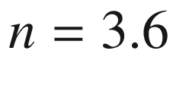

(a typical semiconductor), no band gap can be achieved (Fig. [19.9](#u116076_4_En_19_Chapter-Fig9)a), only a pseudogap (Fig. [19.9](#u116076_4_En_19_Chapter-Fig9)b) appears.

In a diamond lattice (imagine as two fcc lattices shifted by

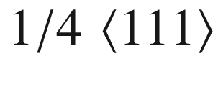

), a complete photonic band gap is possible [1598] (Fig. [19.10](#u116076_4_En_19_Chapter-Fig10)). Recently, a periodic array of spirals (Fig. [19.11](#u116076_4_En_19_Chapter-Fig11)) has been predicted to exhibit a large photonic band gap [1599]. Glancing-angle deposition [1600] (GLAD) is a way to realize such structures. Another method to fabricate structures with arbitrary geometry within a material is two-photon lithography or two-photon holography. Another path to PBG structures are so-called inverted opals. First, a close-packed structure of spheres, e.g. monodisperse silica spheres, is fabricated by sedimentation or self-assembly. The gaps are filled with a high-index medium and the template is subsequently removed, e.g. by etching or dissolving. The resulting structure is shown in Fig. [19.12](#u116076_4_En_19_Chapter-Fig12)a. Such a structure has a photonic band gap (Fig. [19.12](#u116076_4_En_19_Chapter-Fig12)b) if the refractive index is sufficiently high (

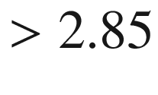

) [1601]. The band gap in this case is between the 4th and 5th band. Table [19.1](#u116076_4_En_19_Chapter-Tab1) offers a compilation of various PBG structures and their properties.

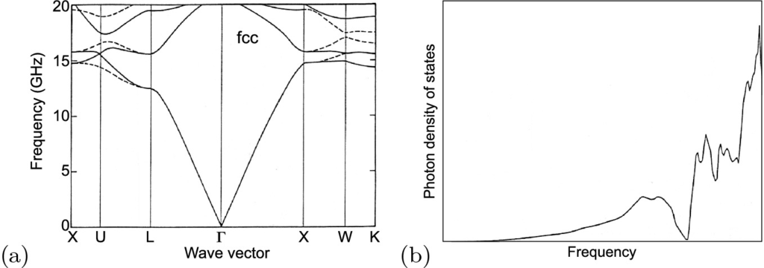

Fig. 19.9

**a** Calculated photonic band gap structure of a fcc dielectric structure composed of air spheres in a dielectric background of refractive index

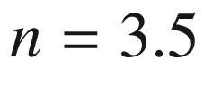

. The filling ratio is 86% air and 14% dielectric material. *Dotted* and *solid lines* represent coupling to s- and p-polarized light, respectively. **b** Density of states for the band structure of part (**a**).

Reprinted from [1598] with permission, ©1990 APS

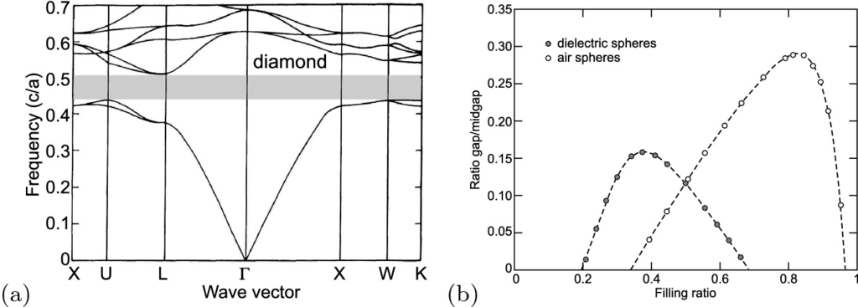

Fig. 19.10

**a** Calculated photonic band structure for a diamond dielectric structure consisting of overlapping air spheres in a dielectric material with

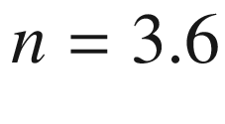

. Filling ratio of air is 81%. The frequency is given in units of *c*/*a*, *a* being the cubic lattice constant of the diamond lattice and *c* being the velocity of light. The gap is indicated as *grayed rectangle*. **b** Gap-to-midgap frequency ratio for the diamond structure as a function of filling ratio for dielectric spheres



in air (*solid circles*) and air spheres in dielectric *n* (*open circles*). Optimal case: air spheres with 82% filling ratio.

Adapted from [1598], reprinted with permission, ©1990 APS

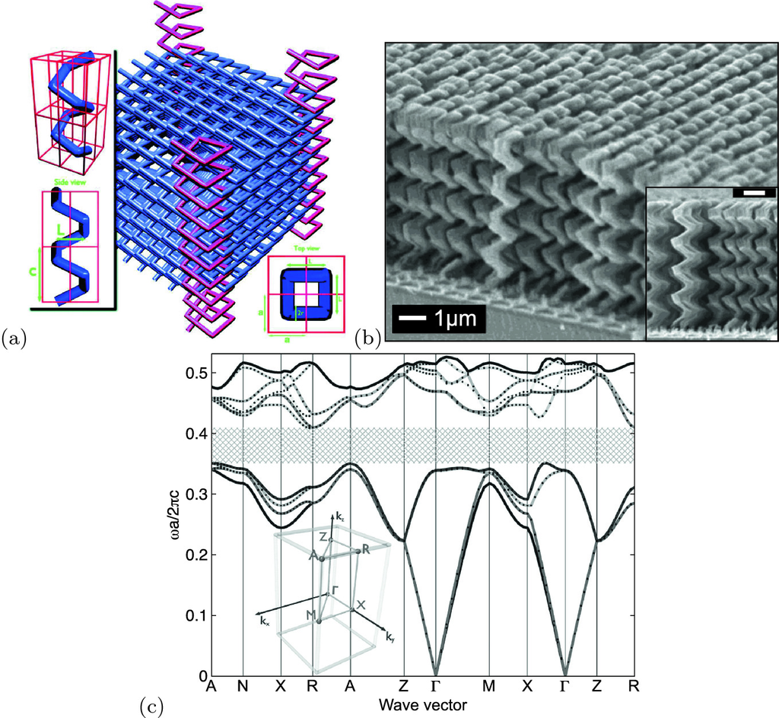

Fig. 19.11

**a** Tetragonal square-spiral photonic crystal. The crystal shown here has a solid filling fraction of 30%. For clarity, spirals at the corners of the crystal are highlighted with a different shade and height. The tetragonal lattice is characterized by lattice constants *a* and *b*. The geometry of the square spiral is illustrated in the *insets* and is characterized by its width, *L*, cylinder radius, *r*, and pitch, *c*. The *top left inset* shows a single spiral coiling around four unit cells. **b** Oblique and edge views of a tetragonal square spiral structure grown using the GLAD (glancing-angle deposition) process. Both markers are 1

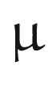

m. **c** Band structure for the direct structure crystal characterized by [*L*,*C*,*r*]=[1.6,1.2,0.14] and a spiral filling factor of 30%. The lengths are given in units of *a*, the lattice constant. The width of the PBG is 15.2% relative to the center frequency for background dielectric constant of 1 and spiral material dielectric constant of 11.9. The positions of high-symmetry points of the BZ are illustrated in the *inset*. Panel (**a**) reprinted and panel (**c**) adapted and reprinted from [1599], with permission, ©2001 AAAS. Panel (**b**) reprinted from [1600] with permission, ©2002 ACS

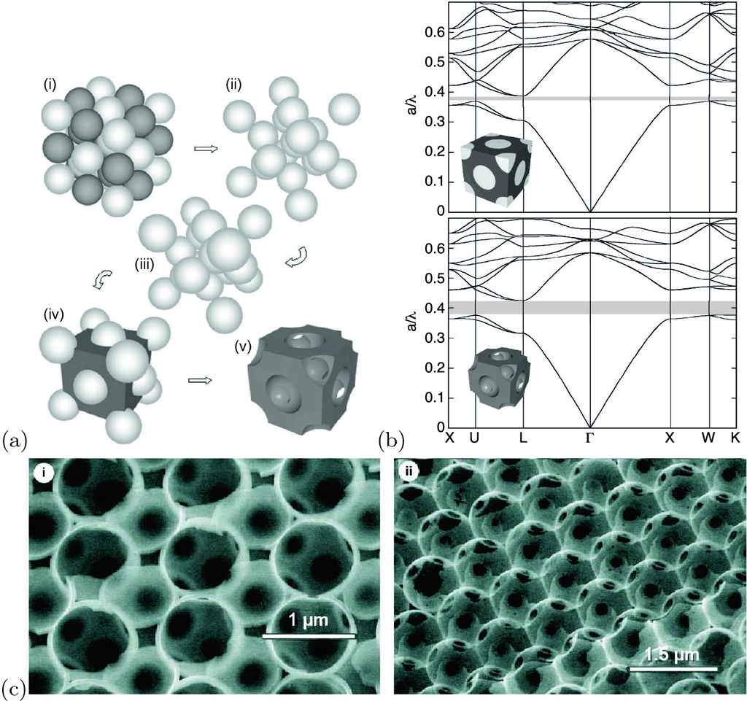

Fig. 19.12

**a** Cartoon showing, in five steps, the fabrication of an inverse diamond structure with a full photonic band gap. First, (i) a mixed body-centered cubic lattice is assembled (ii) after which the latex sublattice is removed; (iii) then the structure is sintered to a filling fraction of

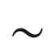

50% after that (iv) silicon or germanium infiltration takes place and finally (v) silica elimination. **b** Photonic band diagrams of (upper panel) a silicon/silica composite diamond opal and (lower panel) made of air spheres in silicon resulting from the removal of the silica spheres from the former. The filling fraction for silicon is 50%. The inset shows the corresponding real space structures. Adapted from [1609], reprinted with permission, ©2001 AIP. **c** SEM images of internal facets of silicon inverse opal: (i) (110) facet, (ii) (111) facet.

Adapted from [1610], reprinted with permission, ©2000, Springer Nature

#### 19.1.6 Disorder

A real photonic band gap structure deviates from the ideal, perfectly periodic system by slight variations of the position and possibly also the size of the dielectric ‘atoms’. This is schematically shown in Fig. [19.13](#u116076_4_En_19_Chapter-Fig13)a. The difference between the real and ideal structure is a (bipolar) spatial distribution of

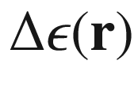

which acts as a source of scattering and hence exponential attenuation of coherent beams propagating through photonic crystals over lengths *l*, named the ‘(extinction) mean free path’. After propagating over such distance *l*, a light beam is converted to a diffuse glow that corrupts the functionality of any photonic integrated circuit. Experimentally for opals a mean free path consistent with 5% fabrication accuracy has been found (Fig. [19.13](#u116076_4_En_19_Chapter-Fig13)b). For such disorder and a lattice constant

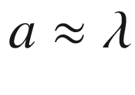

, the mean free path is about only 10 wavelengths,

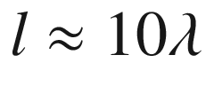

.

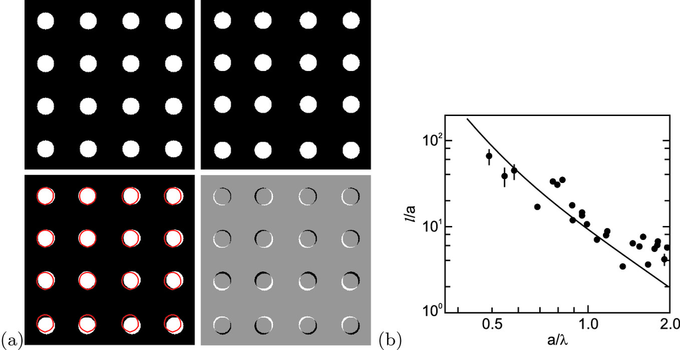

Fig. 19.13

**a** Schematic photonic band gap structure with perfect (*upper left*) and disordered (*upper right*) periodicity. In the *lower left* panel the disordered structure is overlayed with the ideal structure (*red circles*). In the *lower right* panel, the difference between ideal and disordered structure is shown. **b** Optical mean free path in an opal photonic band gap structure for various lattice constants. *Solid line* is theory for 5% fabrication accuracy.

Adapted from [1611], reprinted with permission, ©2005 APS

#### 19.1.7 Defect Modes

Similar to a perfect periodic atomic arrangement leading to the formation of the electronic band structure, a perfectly periodic dielectric structure leads to the photonic band structure. As we know from semiconductor physics, much of the interesting physics and numerous applications lie in defect modes, i.e. localized electronic states due to doping and recombination at such centers. The equivalent in PBG structures are point defects (one unit missing) or line defects (a line of units, straight, bend or with sharp angles, missing). Such defects create localized states, i.e. regions for light localization. In the case of line defects we deal with waveguides that can be conveniently designed and could help to reduce the size of photonic and optoelectronic integrated circuits.

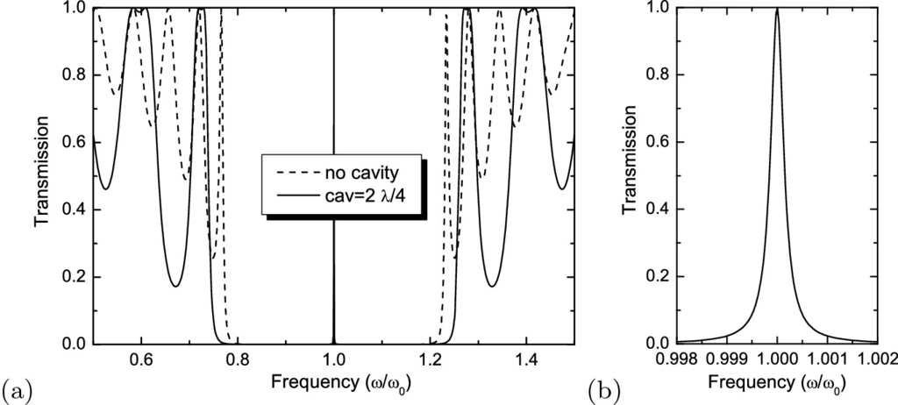

Fig. 19.14

Defect mode in 1D photonic band gap: **a** Transmission of

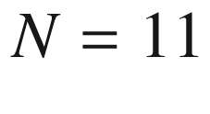

quarter-wave stack exhibiting a photonic band gap (

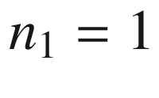

,

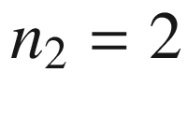

) (*dashed line*) and of microcavity (*solid line*) with center

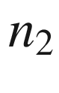

-region of width

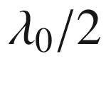

(instead of

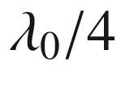

). **b** Relative width of mode is about

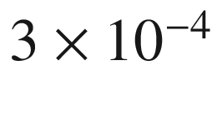

**1D Model**

We revisit our 1D scattering theory and create now a ‘defect’. A simple defect is the change of the width of the center

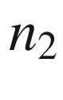

-region in a quarter-wave stack. For the numerical example, we choose

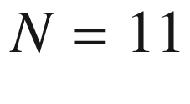

,

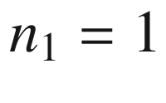

,

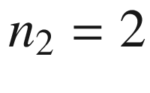

.

In Fig. [19.14](#u116076_4_En_19_Chapter-Fig14), the transmission curves are shown for the undisturbed quarter-wave stack and the microcavity with

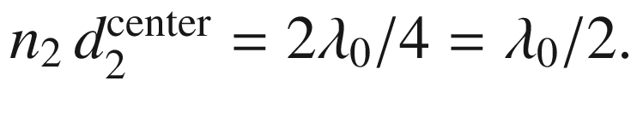

A highly transmissive mode at

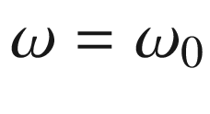

arises that is quite sharp with

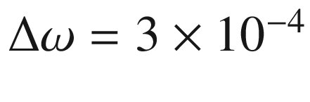

. Thus, the quality factor *Q*, also called the *Q*-factor or finesse,

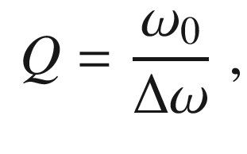

(19.36)

with

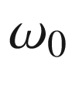

being the resonance frequency and

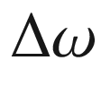

being the linewidth, is

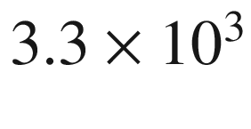

in this case.

If the thickness is varied (Fig. [19.15](#u116076_4_En_19_Chapter-Fig15)), the mode shifts away from the center. A similar scenario arises for higher-order

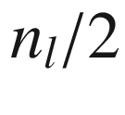

-cavities, e.g.

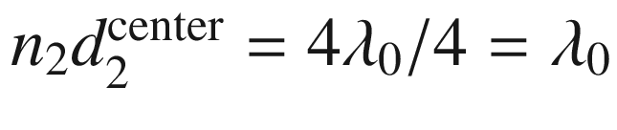

(Fig. [19.16](#u116076_4_En_19_Chapter-Fig16)).

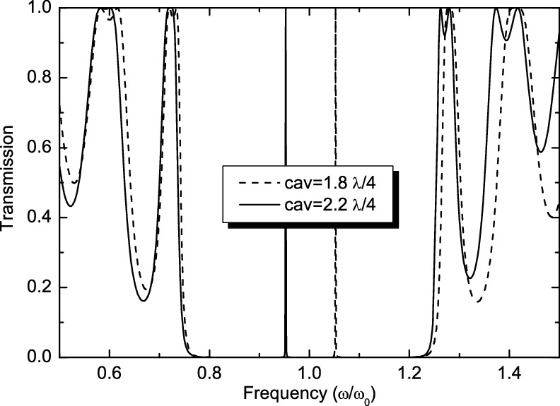

Fig. 19.15

Transmission of

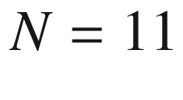

quarter-wave stack (

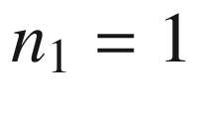

,

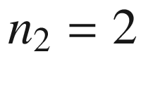

) with center

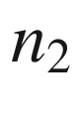

-region of widths 1.8



(*dashed line*) and 2.2

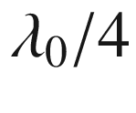

(*solid line*)

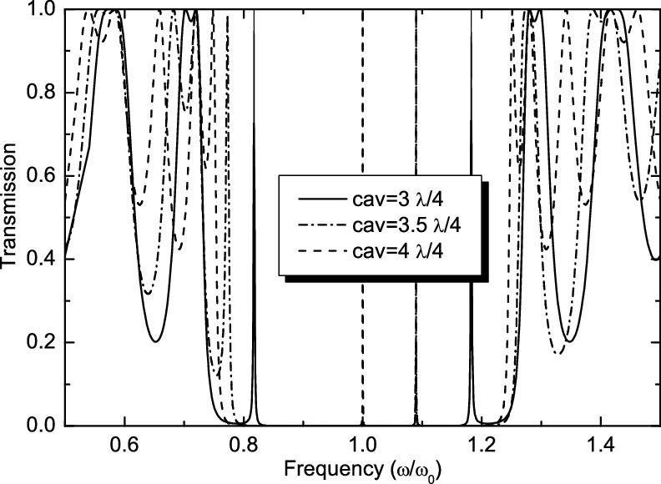

Fig. 19.16

Transmission of

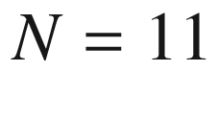

quarter-wave stack (

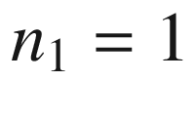

,



) with center



-regions of widths 3

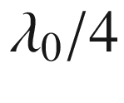

(*solid line*), 3.5

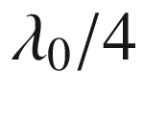

(*dash-dotted line*) and 4

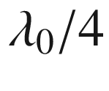

(*dashed line*)

**2D or 3D Defect Modes**

An example of 2D waveguiding is shown in Fig. [19.17](#u116076_4_En_19_Chapter-Fig17). Point defects can be used for high-finesse wavelength filtering. Emitters surrounded by a photonic band gap material with a defect mode can emit into the defect mode only, leading to spectrally filtered, highly directional emission.

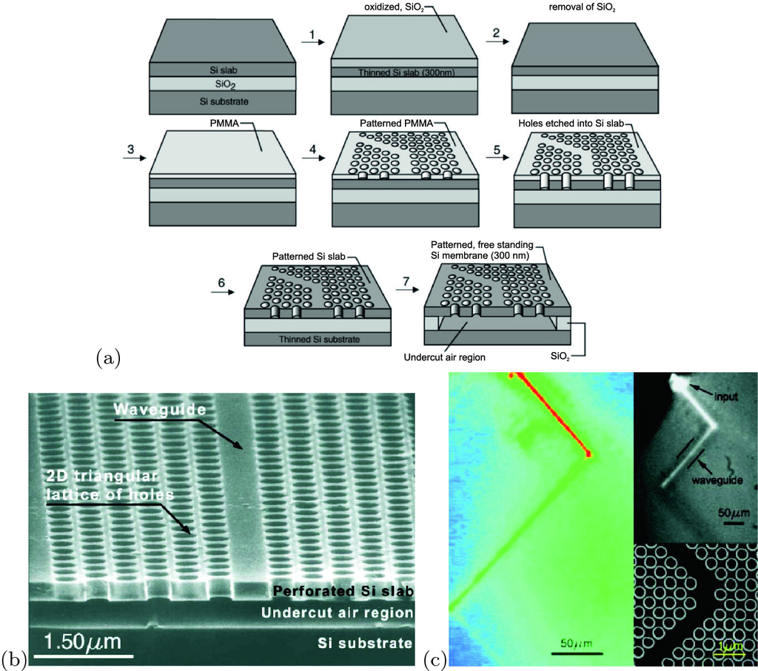

Fig. 19.17

2D photonic band gap waveguide structure. **a** Fabrication principle, **b** SEM image of the structure, **c** light guiding at a 90

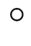

bend.

Reprinted with permission from [1612], ©2000 AIP

#### 19.1.8 Topological Photonic Band Structures

A review of two-dimensional topological photonics can be found in [1613]. The idea of topologically non-trivial 2D photonic band structures has been put forward in [1614] theoretically, employing a Faraday-effect medium breaking time-reversal symmetry. The system is a two-dimensional photonic crystals with an external magnetic field perpendicular to the plane of light propagation. A hexagonal array of dielectric cylindrical rods is modeled. The degeneracy of the Dirac points (at the K-points) is lifted by introducing the Faraday medium outside the rods. The bands close to the gap obtain non-zero Chern numbers

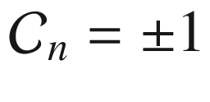

(breaking inversion symmetry only creates a gap but does not lead to non-zero Chern number). Reversal of the magnetic field inverts the bands to

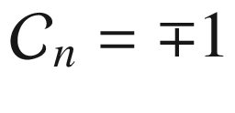

. The Berry curvature of the photonic bands plays a role analogous to that of the magnetic field in the QHE. The calculations show the existence of unidirectionally propagating photonic edge states between media with up and down magnetic fields. An experimental system similar to this is based on yttrium iron garnet (YIG) as gyrotropic material for breaking time reversal symmetry and exhibits topological edge modes [1615].

A non-magnetic version which is much more desirable in terms of fabrication and choice of materials is based on the idea of the Haldane model put forward in [1616]. A next-nearest neighbor coupling

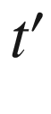

in the honeycomb lattice is considered and produces topological states if the phase

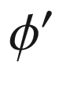

of the (complex) hopping parameter



is not zero or

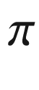

. Further theoretical considerations and modeling of such non-magnetic, fully dielectric topological resonators were reported in [1617, 1618]. Such resonators have been realized and investigated in [1619]. The system consists of a square lattice of ring resonators, which are coupled to each other through link rings. These intermediary links are spatially shifted with respect to the ring resonators, to introduce an asymmetric set of hopping phases controlling whether the structure results in topologically trivial

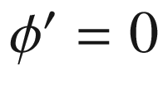

or non-trivial

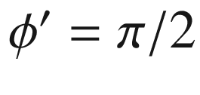

situation. Lasing in edge modes and light transport at the circumference of a

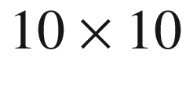

field of resonators have been demonstrated [1619].

A similar concept, also playing with the different hopping parameters to create topologically trivial and non-trivial two-dimensional photonic band structures has been reported in [1620] (Fig. [19.18](#u116076_4_En_19_Chapter-Fig18)). The dipole (odd parity) and quadrupole (even parity) character of the states changes (does not change) within a band for the topologically non-trivial (trivial) parts. The optically pumped laser emission stems from the topologically non-trivial 2D bulk area [1620]. This is attributed to the fact that the band-inversion around the

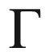

point leads to a topology-induced mode selection with lower threshold, due to limitation of the number of cavity modes with efficient confinement; also the mode closer to the band edge has a higher quality factor.

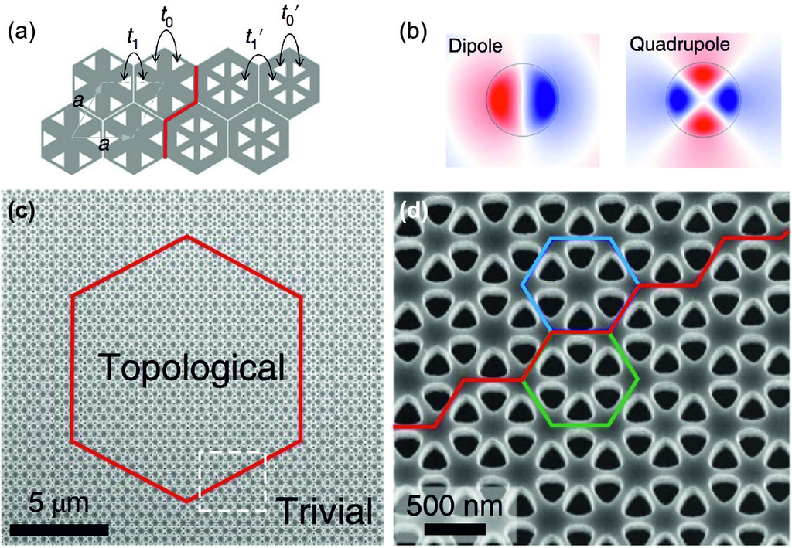

Fig. 19.18

**a** Schematic different hopping parameters for hexagonal dielectric structures with different aspect ratios of medium and air. The boundary between the two parts is highlighted in *red*. **b** Visualization of the odd (even) parity dipole (quadrupole) mode. **c** SEM image of the structure with the boundary between topologically trivial and non-trivial parts highlighted in *red*. A magnified view of the area indicated with the *dashed white rectangle* is depicted in panel **d**. A topologically trivial (non-trivial) hexagon is highlighted in *green* (*blue*).

Adapted from [1620]

#### 19.1.9 Coupling to an Electronic Resonance

In a vertical-cavity surface-emitting laser (cf. Sect. [23.​4.​14](The_Physics_of_Semiconductors00008.docx#u116076_4_En_23_Chapter)), an optical defect mode in a 1D dielectric structure is coupled to an electronic excitation, such as an exciton in a quantum well or dot. In the simplest picture, the oscillator must emit its radiation into the cavity mode since other modes do not exist in the Bragg band. Thus, the emission energy is given and fixed by the cavity mode. However, the photon mode (field oscillator) and the electronic oscillator form a coupled system that generally must be described using quantum electrodynamics. Energy is periodically exchanged between the two oscillators with the Rabi frequency. An analogous phenomenon is investigated in the field of atom–cavity interactions. A necessary condition for the observation of such an oscillation is that the radiation energy remains long enough in the cavity that can be expressed as [1621, 1622] (cf. ([19.42](#u116076_4_En_19_Chapter-Equ43)))

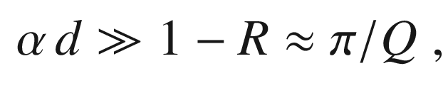

(19.37)

where

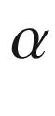

is the absorption coefficient of the electronic transition, *d* is the length of the absorbing medium, *R* is the reflectance of the cavity mirror and *Q* is the finesse of the cavity given in ([19.36](#u116076_4_En_19_Chapter-Equ37)). This situation is called the *strong coupling* regime since it leads to anticrossing behavior of the cavity mode and electronic resonance. In the *weak coupling* regime for small absorption, the resonances cross (within their linewidth). For resonance, the emission intensity of the oscillator into the cavity mode is enhanced and its lifetime is reduced (Purcell effect, cf. Sect. [19.2.2](#u116076_4_En_19_Chapter-Sec14)).

The transmission *T* of a Fabry–Perot cavity with two (equal and lossless) mirrors of transmission

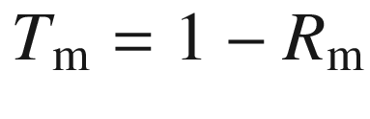

is given by

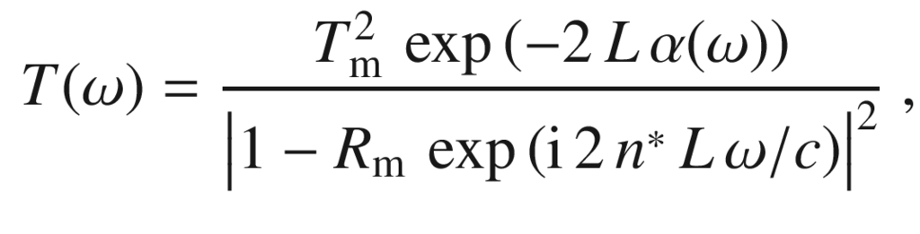

(19.38)

with the complex index of refraction

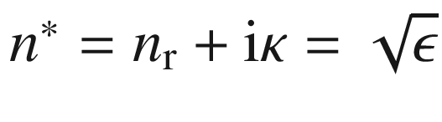

and

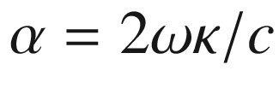

(cf. ([9.​9](The_Physics_of_Semiconductors00004.docx#u116076_4_En_9_Chapter))). For an empty cavity, i.e. a (small) background absorption

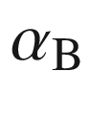

and a background index of refraction

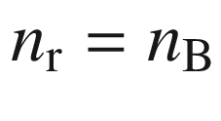

, the resonances occur when the phase shift

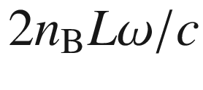

is an integer multiple of

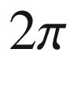

, i.e. for

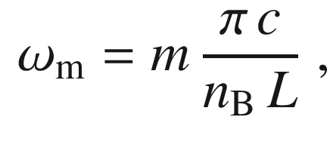

(19.39)

with

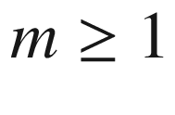

being a natural number. In the vicinity of the resonance, i.e. for

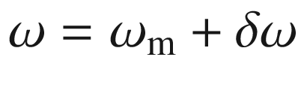

, we can expand

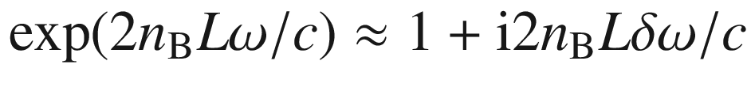

and obtain from ([19.38](#u116076_4_En_19_Chapter-Equ39)) a Lorentzian for the transmission

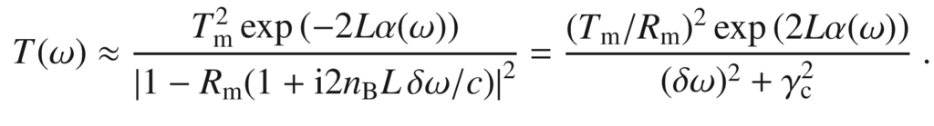

(19.40)

The frequency width (HWHM)

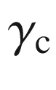

of the empty-cavity resonance is given by

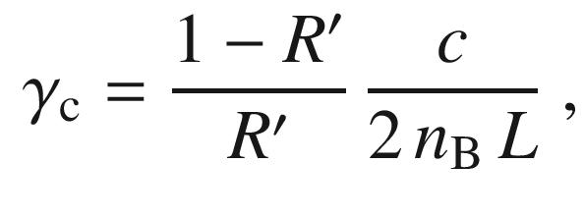

(19.41)

where

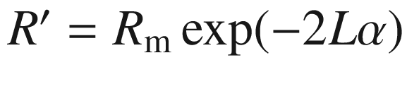

. Thus, the decay rate (photon loss from the cavity) is proportional to

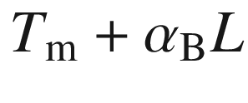

if both terms are small. The quality factor of the cavity resonance *m* is given by

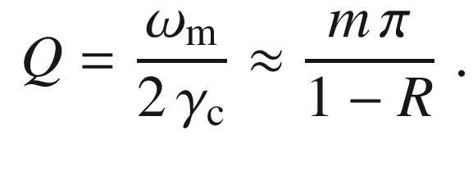

(19.42)

Now, the electronic resonance is put into the cavity leading to a change in the dielectric function to (cf. (D.11))

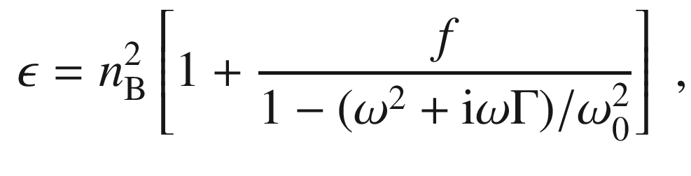

(19.43)

where the index of refraction due to the electronic resonance is given by

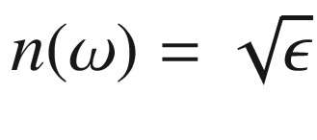

and (D.13a,b). For resonance of the cavity mode and the electronic oscillator, i.e.

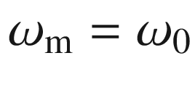

, the solution for the cavity resonance condition

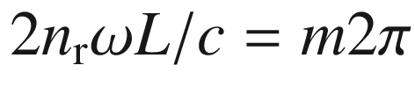

is obtained, using ([19.39](#u116076_4_En_19_Chapter-Equ40)), from

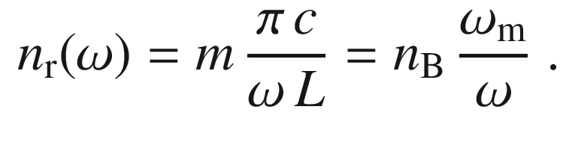

(19.44)

A graphical solution (Fig. [19.19](#u116076_4_En_19_Chapter-Fig19)a) yields three intersections of the left and right hands of ([19.44](#u116076_4_En_19_Chapter-Equ45)). The very high absorption at the central solution (

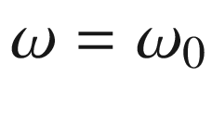

) results in very low transmission. The other two solutions[2](#u116076_4_En_19_Chapter-Fn2) yield the frequencies of the coupled normal mode peaks. For

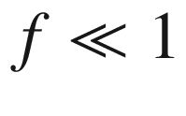

, we use (D.13a) in ([19.44](#u116076_4_En_19_Chapter-Equ45)) and find for the splitting

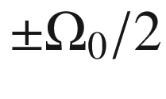

of the two modes

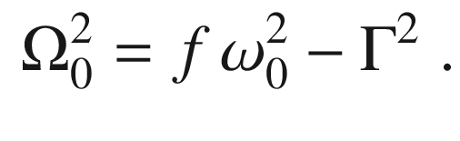

(19.45)

This frequency is called the Rabi frequency. If the dielectric function of the oscillator is put into ([19.38](#u116076_4_En_19_Chapter-Equ39)), the splitting is found to be

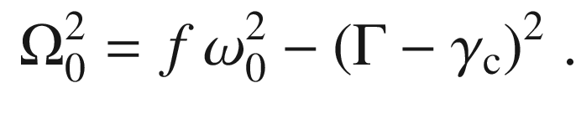

(19.46)

A splitting will only be observable if

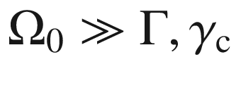

. If the two resonances

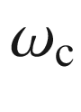

and



are detuned by

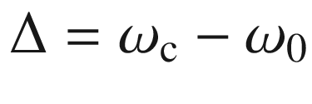

, the splitting

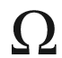

of the transmission peaks shows the typical anticrossing behavior of two coupled oscillators

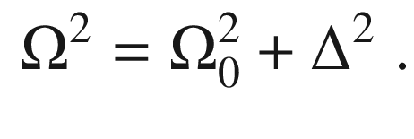

(19.47)

In the experiment, typically the electronic resonance remains fixed at

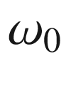

and the cavity resonance is detuned by variation of the cavity length across the wafer (Fig. [19.19](#u116076_4_En_19_Chapter-Fig19)b).

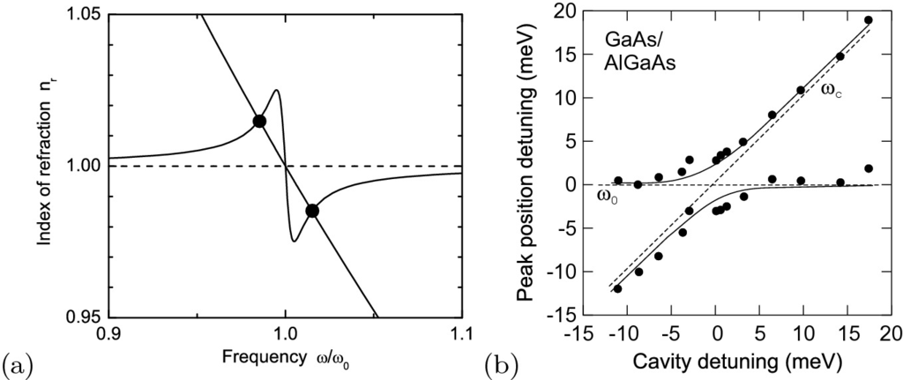

Fig. 19.19

**a** Graphical representation of ([19.44](#u116076_4_En_19_Chapter-Equ45)) with the two solutions marked with *circles* for

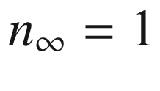

(*dashed line*),

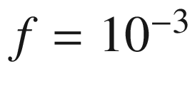

,

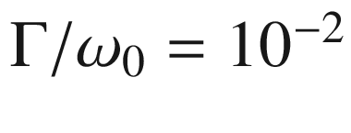

and

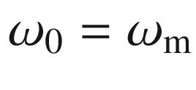

. **b** Reflectance peak positions (experimental data (*circles*) at

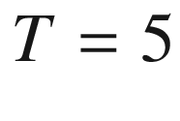

 K) versus cavity detuning

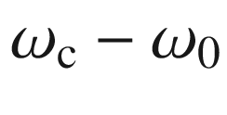

for a cavity with two GaAs/(Al,Ga)As Bragg mirrors (24/33 pairs for the front/bottom mirror) and five embedded quantum wells whose resonances are closely matched. *Solid lines* are a theoretical fit according to ([19.47](#u116076_4_En_19_Chapter-Equ48)) with

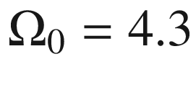

 meV. The *dashed lines* show the electronic resonance

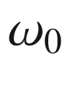

and the cavity resonance

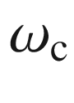

. Part (**b**) based on data from [1622]

A detailed theory of cavity polaritons is given in [1623]. The nonlinear optics of normal mode coupling in semiconductor microcavities is reviewed in [1624].

The in-plane dispersion of the cavity polaritons depends on the coupling strength. First, the photon dispersion is given by

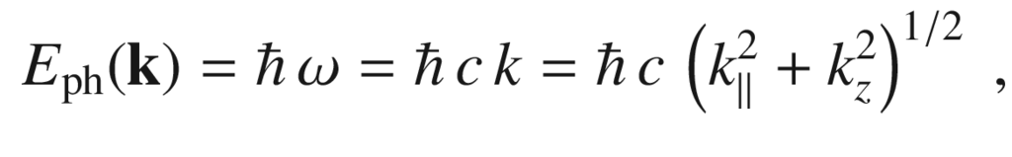

(19.48)

where

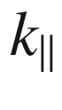

is the in-plane *k*-vector and

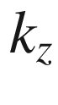

is given by the resonance condition,

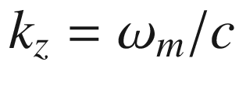

with ([19.39](#u116076_4_En_19_Chapter-Equ40)),

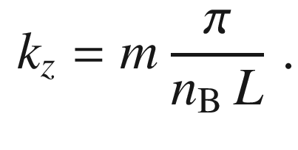

(19.49)

Thus the dispersion relation is no longer linear as for freely propagating light.

For small



this leads to an (in-plane) effective photon ‘rest mass’, applying ([6.​38](The_Physics_of_Semiconductors00003.docx#u116076_4_En_6_Chapter)),

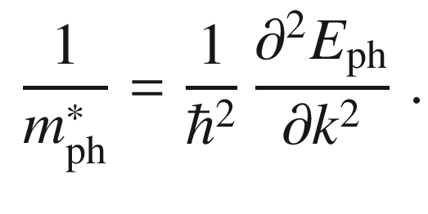

(19.50)

We find

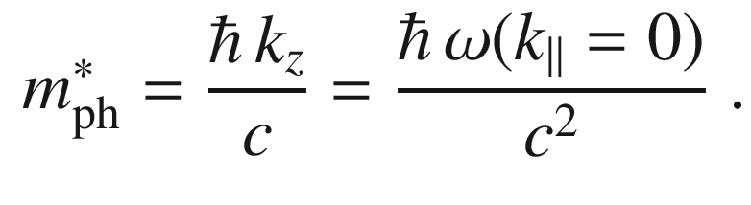

(19.51)

Now we assume the electronic oscillator to be in resonance with the photon dispersion at

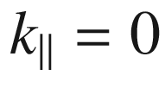

, i.e.

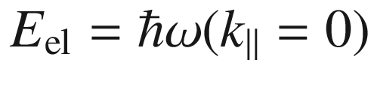

. The electronic resonance shall have vanishing dispersion for simplicity since the exciton mass is much larger than ([19.51](#u116076_4_En_19_Chapter-Equ52)). The eigenwert equation of the coupled system, resembling ([6.​61](The_Physics_of_Semiconductors00003.docx#u116076_4_En_6_Chapter)), is

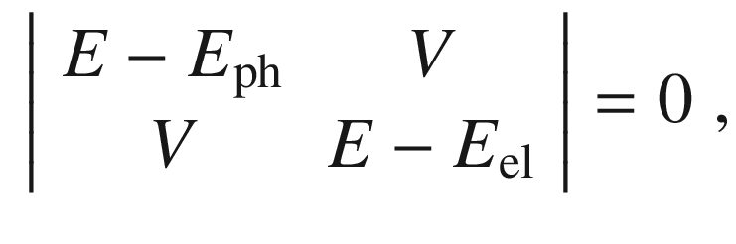

(19.52)

with two solutions, called the upper and lower cavity polariton branch, visualized in Fig. [19.20](#u116076_4_En_19_Chapter-Fig20). Their splitting at

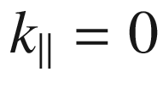

is 2*V*. Thus the coupling parameter

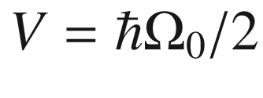

corresponds [1623] to the Rabi frequency ([19.45](#u116076_4_En_19_Chapter-Equ46)). Experimental values for the splitting of 3–15meV in (In,Al,Ga)As based [1622, 1625–1628], 17–44meV in (Cd,Zn)(Te,Se) based [1629], 6–60meV in (Al,In,Ga)N based [1630–1634] and 78 meV in ZnO based [1635] microcavities were found. It is possible to condensate cavity polaritons in the minimum of the dispersion around

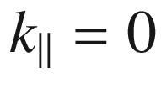

(Bose-Einstein condensation). In [1636] stimulated scattering and gain from cavity polaritons have been reported. Further details on cavity polaritons can be found in [1637, 1638].

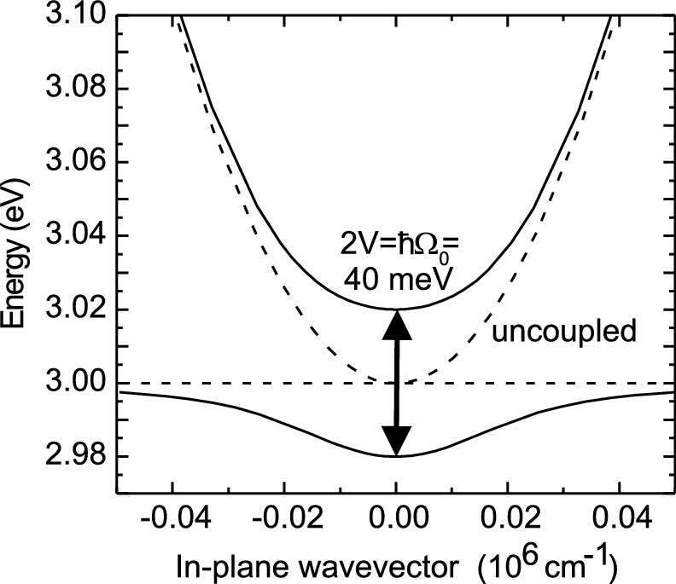

Fig. 19.20

Dispersion of cavity photon mode and electronic resonance at

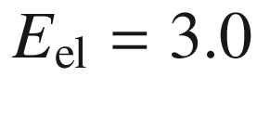

 eV (*dashed lines*) and coupled modes (*solid lines*) for

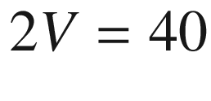

 meV

#### 19.1.10 Hyperbolic Optical Metamaterials

A special class of uniaxial materials, termed hyperbolic metamaterials (HMM), has a (relative) dielectric function of the form (cf. Table [9.​2](The_Physics_of_Semiconductors00004.docx#u116076_4_En_9_Chapter-Tab2))

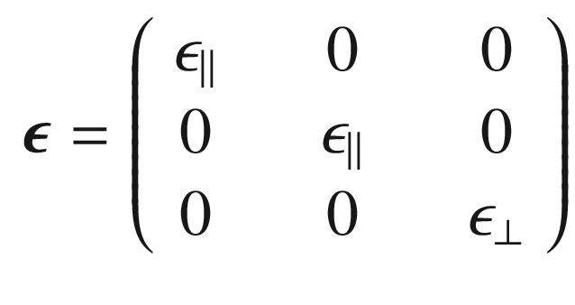

(19.53)

with

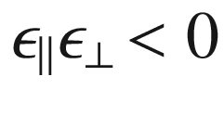

. A negative dielectric function is known from metals below the plasma frequency (cf. Sect. [9.​9.​1](The_Physics_of_Semiconductors00004.docx#u116076_4_En_9_Chapter)). From the conventional formula

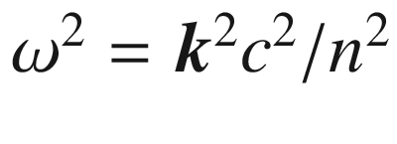

in a isotropic medium, in an uniaxial medium the isofrequency surface is given by

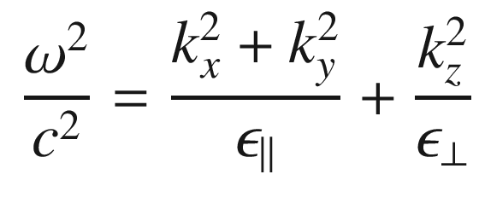

(19.54)

and for ’normal’ uniaxial materials an ellipsoid (or a sphere for isotropic materials, cmp. to band dispersions Fig. [6.​35](The_Physics_of_Semiconductors00003.docx#u116076_4_En_6_Chapter-Fig35)a, b). If one of the tensor elements is negative, two possible types of ’hyperbolic’ metamaterials develop with

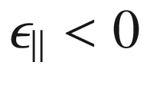

(HMM type I) and with

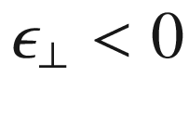

(HMM type II). Their isofrequency surfaces (for TM waves) for the two types are depicted in Fig. [19.21](#u116076_4_En_19_Chapter-Fig21).

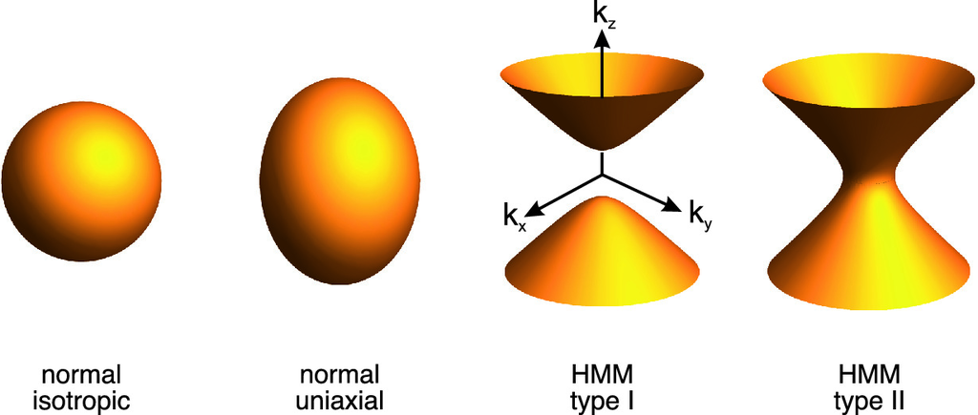

Fig. 19.21

Equifrequency surfaces ([19.54](#u116076_4_En_19_Chapter-Equ55)) for a ‘normal’ isotropic (

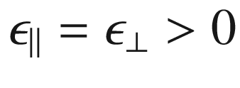

) and uniaxial (

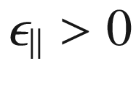

,

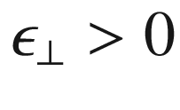

, here shown for

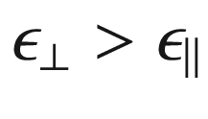

) optical medium and type I (

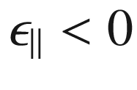

,

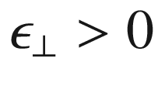

) and type II (

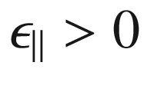

,



) hyberbolic metamaterials

Apart from homogeneous media, various geometries for HMM have been proposed and investigated [1639, 1640]. HMM can transport high-*k* waves and may enable devices for sub-wavelength resolution imaging. Also, the enhanced density of photonic states (within a restricted wavelength range) can be used for enhancement of spontaneous recombination rates (Purcell effect, cf. Sect. [19.2.2](#u116076_4_En_19_Chapter-Sec14)) [1641]. A possible epitaxial, almost perfectly lattice matched superlattice HMM system of alternating dielectric and metallic materials is MgO/TiN [1642]. Also HMM involving the anisotropic magnetic permittivity tensor have been considered [1643].

### 19.2 Microscopic Resonators

#### 19.2.1 Microdiscs

A microdisc is a cylindrical resonator with a thickness *d* that is small compared to the radius *R*. It can be fabricated from semiconductors and semiconductor heterostructures using patterning and material-selective etching. With underetching a mostly free-standing disc can be made that resides on a post (Fig. [19.22](#u116076_4_En_19_Chapter-Fig22)).

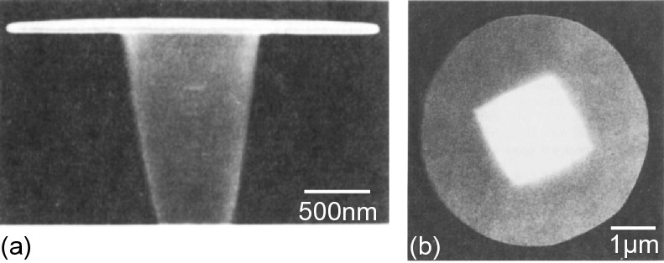

Fig. 19.22

**a** Side view of a 3-

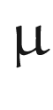

m diameter disc containing one 10-nm InGaAs quantum well between 20-nm (In,Ga)(As,P) barriers standing on an InP pillar that has been selectively underetched using HCl. **b** Top view SEM image of a 5-

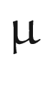

m diameter (In,Ga) (As,P) microdisc. The pedestal shape is a rhombus due to anisotropic etching of the HCl.

Adapted from [1644], reprinted with permission, ©1992 AIP

The coordinate system is (

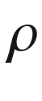

,

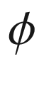

, *z*) with the *z* direction being perpendicular to the disc area. Typically, the disc is so thin that there is only one node along *z*. Solving the wave equation in this geometry [1645], the modes are characterized by two numbers (*m*, *l*). *m* describes the number of zeros along the azimuthal direction

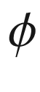

with the field amplitude being proportional to

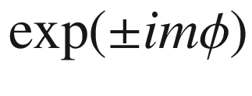

. Thus, except for

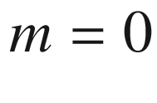

, the modes are simply degenerate. Modes with

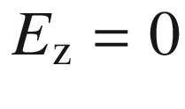

are called TE modes. This is the preferred polarization of emission. The number *l* denotes the number of zeros in the radial direction. Only for modes with

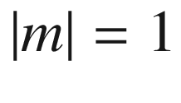

, is the intensity nonzero on the axis, i.e. for

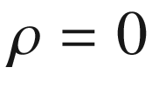

. All other modes have vanishing intensity in the disc center.

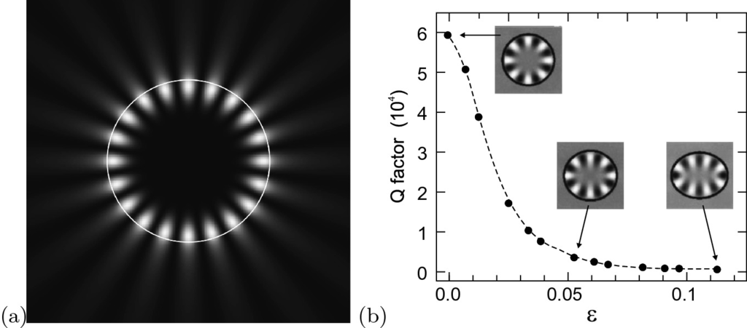

Fig. 19.23

**a** Field intensity for whispering gallery mode (10, 0) (TM-polarized) for a circle with 1



m radius (shown as *white line*) and

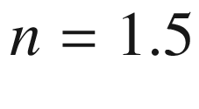

. The image size is

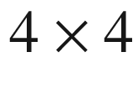

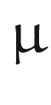

m

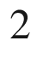

. **b** Theoretical quality factor of a 2-



m InP microdisc as a function of the deformation parameter ([19.56](#u116076_4_En_19_Chapter-Equ57)). The *insets* show (8,0) whispering gallery modes at a wavelength of 1.55



m for

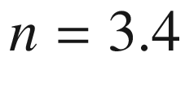

. Part (**b**) adapted from [1647]

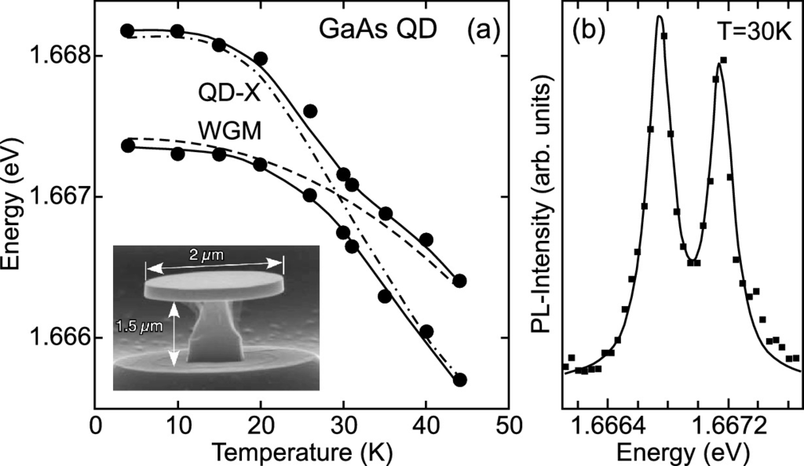

Fig. 19.24

Strong coupling of a single QD exciton (due to monolayer fluctuation in a 13 ML thick GaAs/Al

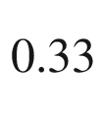

Ga

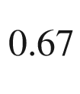

As QW) with a WGM in a microdisk of 2



m diameter (*inset*). (**a**) Anti-crossing of upper and lower peak for various temperatures. *Symbols* are data points, *solid lines* are theory considering coupling. The *dashed* (*dash-dotted*) line is the expected temperature shift of the WGM mode (exciton energy). (**b**) Photoluminescence spectrum at the anti-crossing point (

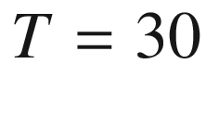

 K). Experimental data (*squares*) and fit with two peaks (*solid line*).

Adapted from [1648]

The light intensity in whispering gallery modes is preferentially concentrated along the circumference of the disc as shown in Fig. [19.23](#u116076_4_En_19_Chapter-Fig23)a. Since the light can only escape via evanescent waves, the light is well ‘captured’ in such a mode. The *Q*-factor ([19.36](#u116076_4_En_19_Chapter-Equ37)) is extremely high and takes values of several

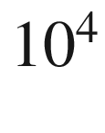

. In order to couple light out of such a disc, deformed resonators, e.g. with a defect in the form of protrusions [1646], were devised. Deformed resonators are discussed in more detail in the next section.

The strong coupling of a QD exciton to a whispering gallery mode is shown in Fig. [19.24](#u116076_4_En_19_Chapter-Fig24) where anti-crossing behavior is observed at low temperatures. Tuning is achieved by temperature variation. Behavior of a similar system in the weak coupling regime is shown in Fig. [19.26](#u116076_4_En_19_Chapter-Fig26).

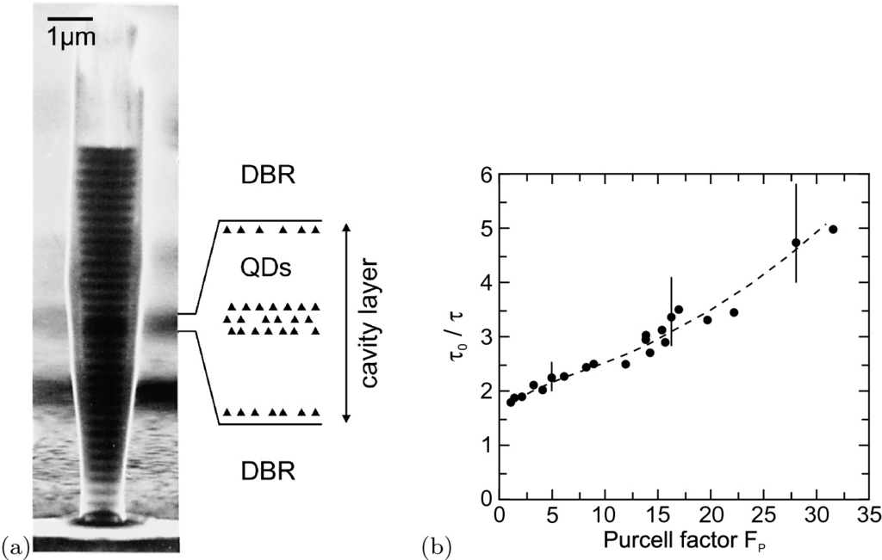

Fig. 19.25

**a** Micropillar with MBE-grown GaAs/AlAs DBRs and a cavity containing five layers of InAs quantum dots as indicated. The pillar has been prepared by reactive ion etching. Reprinted with permission from [1650], ©1998 APS. **b** Experimental decay time



of on-resonance quantum dot luminescence scaled by off-resonance lifetime

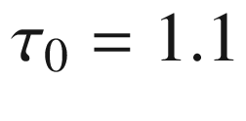

 ns (close to lifetime in a QD in bulk) for a variety of micropillars with different Purcell factors

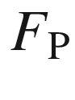

. The *error bars* correspond to the measurement accuracy of the decay time (

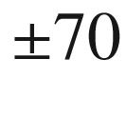

 ps), the *dashed line* is a guide to the eye.

Adapted from [1650]

#### 19.2.2 Purcell Effect

According to Fermi’s golden rule ([19.1](#u116076_4_En_19_Chapter-Equ1)), the probability of an optical transition depends on the density of available optical modes (final states). If the density of modes is enhanced compared to its vacuum value ([19.2](#u116076_4_En_19_Chapter-Equ2)) at a resonance of an optical cavity, the lifetime of the electronic state decreases by the Purcell factor [1649],

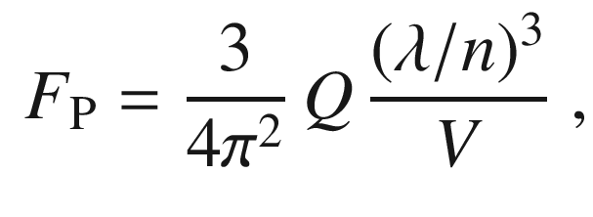

(19.55)

where *n* is the refractive index of the medium, *Q* is the quality factor of the cavity resonance and *V* is the effective mode volume.[3](#u116076_4_En_19_Chapter-Fn3) Experiments on the emission of quantum dots (that generally provide small absorption and thus allow for the weak coupling regime) in etched micropillars containing a microcavity (Fig. [19.25](#u116076_4_En_19_Chapter-Fig25)a) have shown that indeed the luminescence decay is faster for cavities with large Purcell factor (Fig. [19.25](#u116076_4_En_19_Chapter-Fig25)b) [1650]. The resonance of cavity mode and emitter leads to an enhanced emission intensity as shown in Fig. [19.26](#u116076_4_En_19_Chapter-Fig26) for the exciton emission of a single quantum dot in a microdisc [1651].

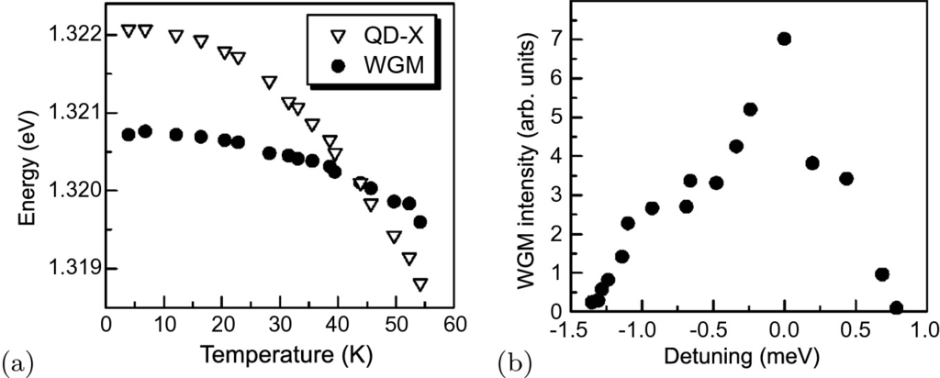

Fig. 19.26

**a** Temperature dependence of the energy positions of the whispering gallery mode (WGM) of a 5-



m diameter (Al,Ga)As/GaAs microdisc (

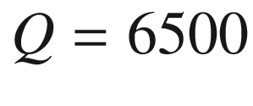

) and the single-exciton resonance of a single InAs quantum dot contained within the disc. **b** Intensity of WGM mode as a function of the detuning

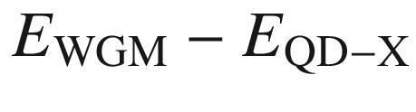

from the QD single exciton resonance. The excitation density was 15 Wcm

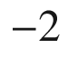

for all data.

Adapted from [1651]

#### 19.2.3 Deformed Resonators

The whispering gallery modes in circular (or spherical) cavities are long-lived and emission goes into all angles. Light escape is based only on the exponentially slow process of evanescent leakage (neglecting disorder effects such as surface roughness). In order to overcome the isotropic light emission, the resonator needs to be deformed. This can be accomplished with an ellipsoidal shape, i.e.

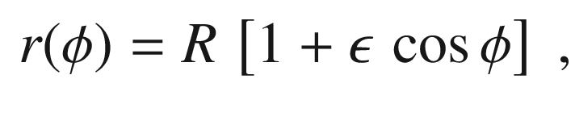

(19.56)

where

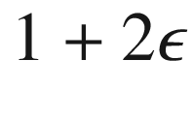

is the aspect ratio of the ellipse. The increased radiation leads to a decrease of the *Q*-factor as shown in Fig. [19.23](#u116076_4_En_19_Chapter-Fig23)b. Also, a new decay process, refractive escape, becomes possible. A ray that is initially in a whispering gallery trajectory diffuses in phase space until finally an angle smaller than the critical angle for total reflection ([9.​11](The_Physics_of_Semiconductors00004.docx#u116076_4_En_9_Chapter)) is reached. The ray dynamics becomes partially chaotic [1652].

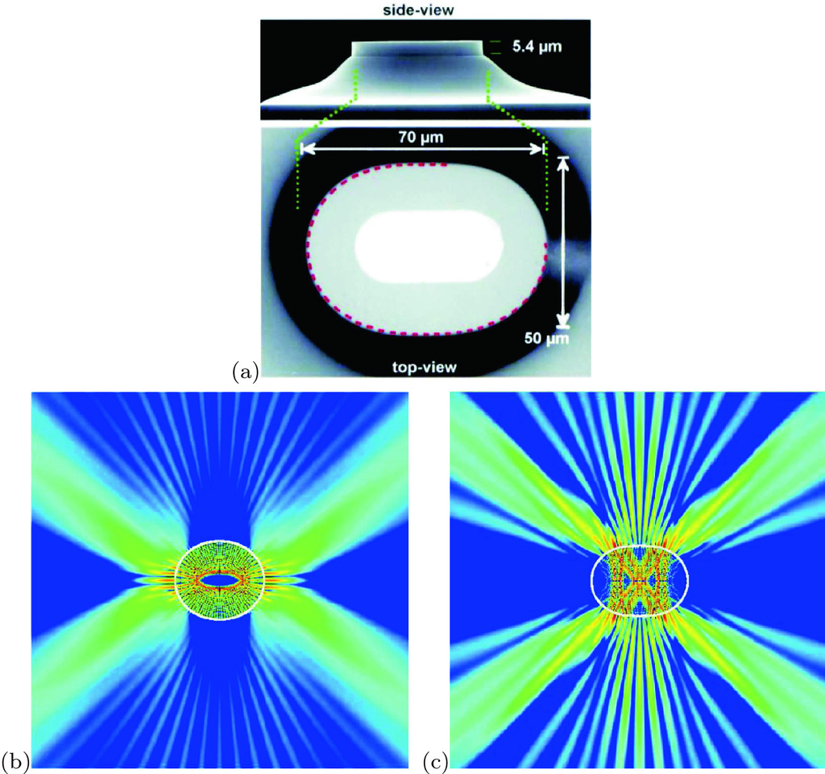

Fig. 19.27

**a** SEM image of a quadrupolar cylinder laser with deformation parameter

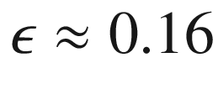

on a sloped InP pedestal. The *light grey area* in the top view is the electrical contact. **b** Simulated near-field intensity pattern of a chaotic whispering gallery mode for

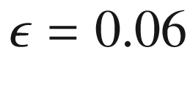

and

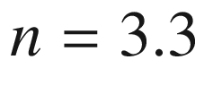

. **c** Simulated near-field intensity pattern of a bow-tie mode for

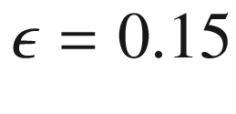

. The length of the minor axis for (**b**) and (**c**) is 50



m.

Reprinted with permission from [1653], ©1998 AAAS

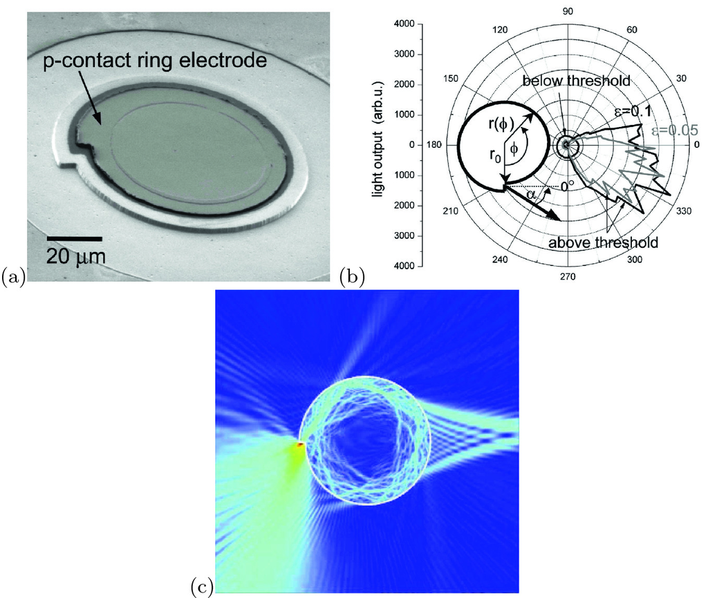

Fig. 19.28

**a** SEM image of a microcavity disc laser diode with a disc radius of 50



m. The p-contact ring electrode defines the areas through which carriers are injected into the microdisc and where stimulated emission can take place. **b** Radial distribution of the light output from the spiral-shaped microdisc laser diode measured below and above threshold. The radius of the spiral microdisc was

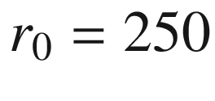



m and the deformation parameters were

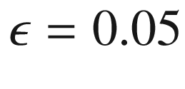

(*grey*) and

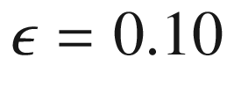

(*black*). An emission beam at an angle of

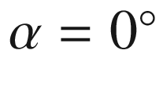

corresponds to a direction normal to the notch surface as shown in the *inset*. Below the laser threshold, the emission pattern is essentially isotropic and independent of the deformation parameter. Above the threshold, directional emission is clearly observed with the emission direction at a tilt angle

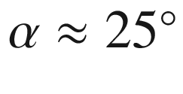

. The measured divergence angle of the far-field pattern is

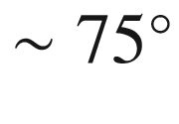

for

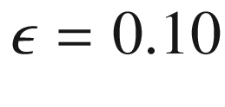

and

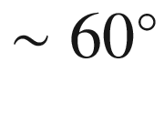

for

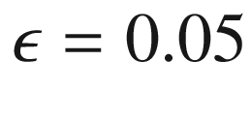

. Reprinted with permission from [1656], ©2004 AIP. **c** Simulated near-field intensity pattern of an emission mode with

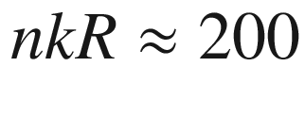

for deformation

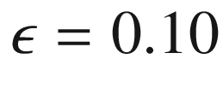

.

Reprinted with permission from [1654], ©2003 AIP

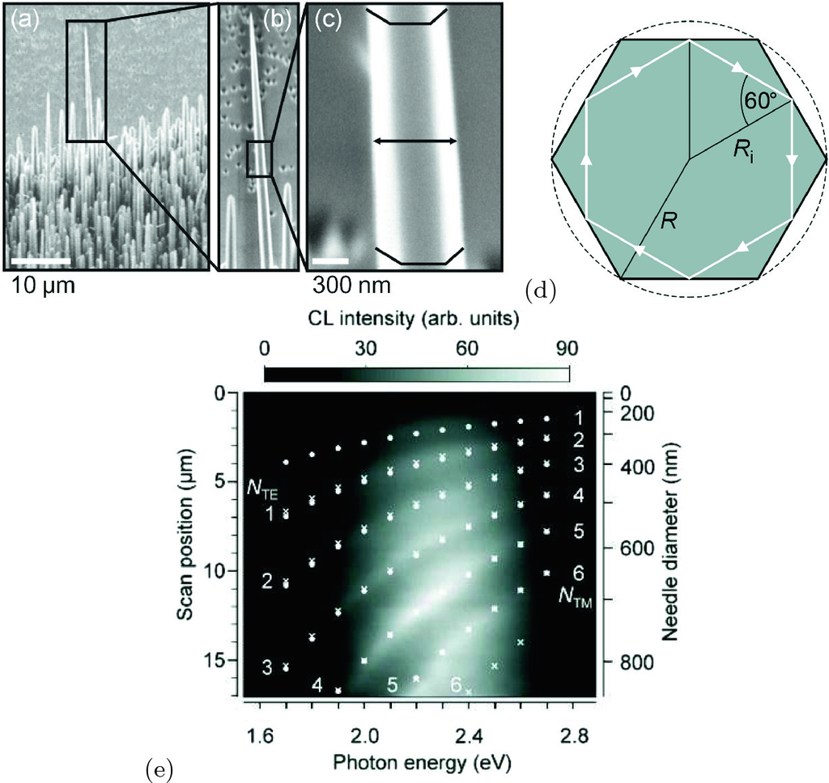

Fig. 19.29

**a**–**c** SEM images of ZnO nanoneedle fabricated by pulsed laser deposition. **d** Schematic geometry of cross-sectional plane.

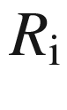

(*R*) is the radius of the incircle (circumscribing circle). The circumference of the inscribed *white hexagon*, representing the path of a whispering gallery mode, has a length of

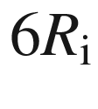

. **e** Two-dimensional plot of spectra recorded along a linescan along the needle’s longitudinal axis. The left vertical axis shows the linescan position *x*, the right one refers to the respective needle diameter *D*. The spectral maxima, i.e. the measured WGM energies, appear as bright belts going from the bottom left corner to the right upper one. With decreasing diameter, all resonances shift systematically to higher energies. The *white dots* give theoretical TM-resonance energy positions obtained from ([19.59](#u116076_4_En_19_Chapter-Equ60)), *white crosses* give the same for TE-polarization.

Reprinted with permission from [1657], ©2004 APS

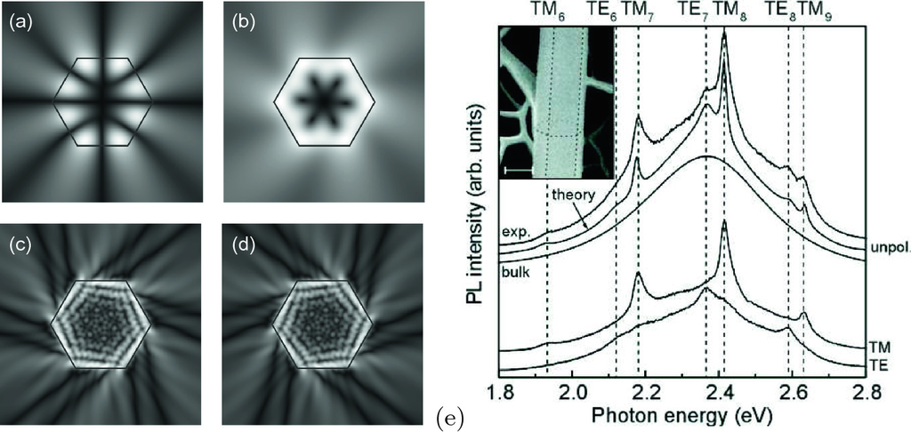

Fig. 19.30

Simulated near-field intensity pattern of modes in a cavity with hexagonal cross section (absolute value of electric field in linear grey scale): Modes (

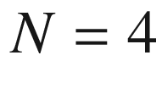

) with (**a**) symmetry

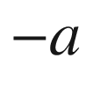

and (**b**) mode

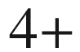

(nomenclature from [1659]) for

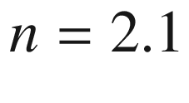

and

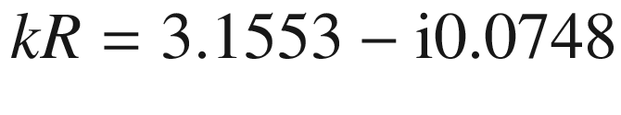

. Modes (**c**) 26− and (**d**)

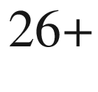

for

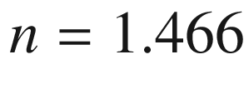

and

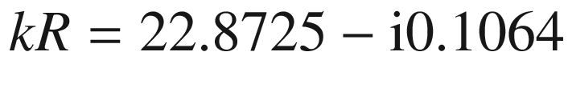

. The displayed modes have a chiral pattern. Emission originates mostly from the corners. **e** Micro-photoluminescence spectra of a single ZnO nanopillar. The three topmost curves are unpolarized. The curve labeled ‘bulk’ shows the unmodulated luminescence of the green luminescence in bulk. The line labeled ‘exp.’ shows the experimental

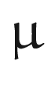

-PL spectrum of the investigated nanopillar. The experimental spectra recorded for TM- and TE-polarization, respectively, are shown in the lowest two curves. The curve labeled ‘theory’ displays the theoretical luminescence spectra. *Dashed vertical lines* are guides to the eye referring to the spectral position of the dominating WGMs. The *inset* shows a SEM image of the investigated pillar, the scale bar has a length of 500 nm. The *dotted lines* show the position of the edges of the hexagonal resonator obtained  from topography contrast

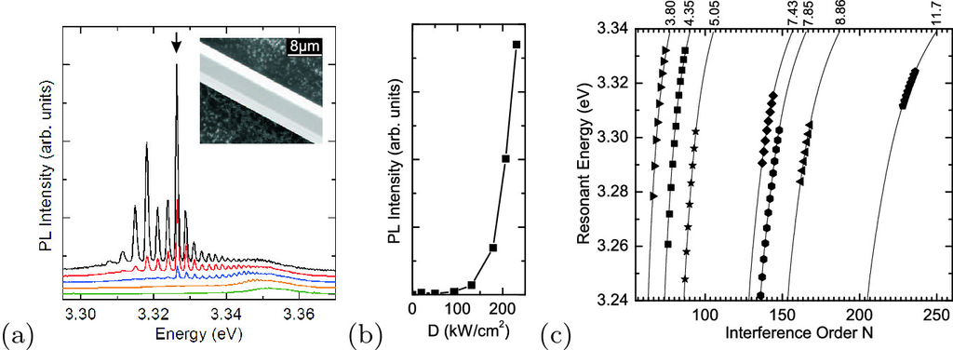

Fig. 19.31

**a** Photoluminescence spectra of a ZnO microwire with hexagonal cross section for various pump power densities (*lowest curve*:

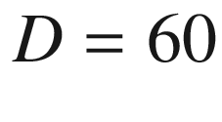

 kW/cm

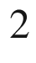

, *top curve*:

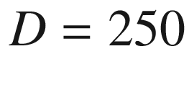

 kW/cm



) at

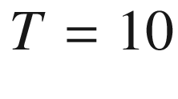

 K. The inset shows the scanning electron microscopy image of a typical microwire (

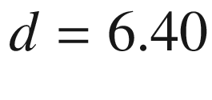



m). **b** Dependence of the emitted PL intensity of a selected lasing peak (denoted by an *arrow* in the spectrum in part (**a**)) on the excitation density *D*. *Lines* are guide to the eye. **c** Dependence of the resonant energies on the interference order *N* for wires with different diameters as labeled on top of the graph. *Lines* are the predicted theoretical values calculated from ([19.59](#u116076_4_En_19_Chapter-Equ60)) using diameter values obtained from SEM measurements; the *symbols* represent the experimentally observed peaks.

Adapted from [1660]

One other possible deformation of the circular disc geometry is a ‘flattened quadrupole’ as shown in Fig. [19.27](#u116076_4_En_19_Chapter-Fig27)a. This shape can be parameterized by a deformation parameter

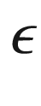

and the angle-dependent radius

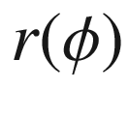

given by

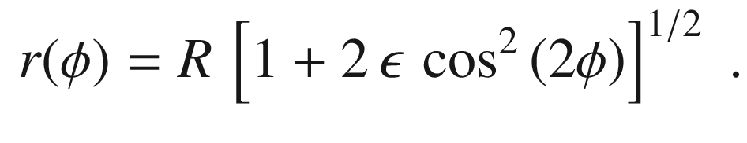

(19.57)

For small deformation, the whispering gallery modes become chaotic and exhibit preferred emission along the long axis of the resonator (Fig. [19.27](#u116076_4_En_19_Chapter-Fig27)b). For larger deformations (

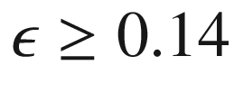

), a stronger and qualitatively different directionality occurs in the shape of a bow-tie [1653] as shown in Fig. [19.27](#u116076_4_En_19_Chapter-Fig27)c. The optical laser power extracted from deformed resonators was found to increase exponentially with

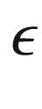

; for

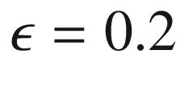

it was 50 times larger than for the circular resonator.

Another modification that can be applied to the microdisc in order to increase outcoupling of light, is the spiral resonator [1654] as shown in Fig. [19.28](#u116076_4_En_19_Chapter-Fig28)a. The radius is parameterized by

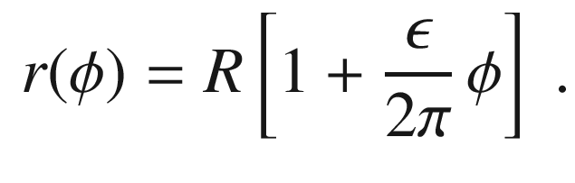

(19.58)

The experimental emission pattern is displayed in Fig. [19.28](#u116076_4_En_19_Chapter-Fig28)b. It exhibits a maximum along the direction of the tangent at the radius step. The simulated near-field intensity of such an emission mode is shown in Fig. [19.28](#u116076_4_En_19_Chapter-Fig28)c. In a spiral laser, ray dynamics is also chaotic [1655].

#### 19.2.4 Hexagonal Cavities

Hexagonal cavities develop, e.g., in microcrystals of wurtzite semiconductors (with the *c*-axis along the longitudinal axis of the pillar). In Fig. [19.29](#u116076_4_En_19_Chapter-Fig29)a, a ZnO tapered hexagonal resonator (needle) is shown. Whispering gallery modes modulate the intensity of the green ZnO luminescence [1657].[4](#u116076_4_En_19_Chapter-Fn4) In a simple plane-wave model, the resonance condition is given by

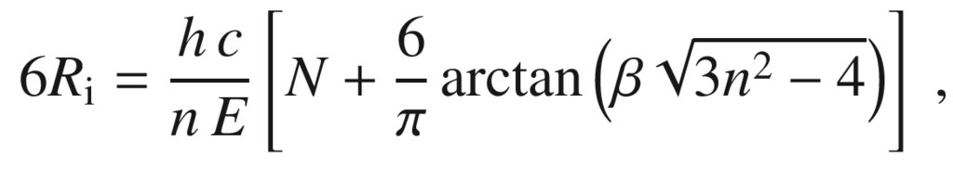

(19.59)

where

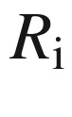

is the radius of the inner circle (Fig. [19.29](#u116076_4_En_19_Chapter-Fig29)d), *n* is the index of refraction, *N* is the mode number and

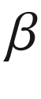

is given by

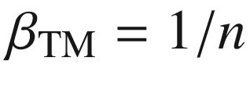

(

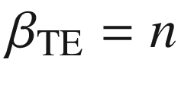

) for TM (TE) polarization, respectively. Due to birefringence,

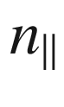

(

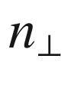

) has to be used as the index of refraction for TM (TE) polarization.

A

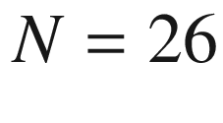

whispering gallery mode of a hexagonal resonator is shown in Fig. [19.30](#u116076_4_En_19_Chapter-Fig30)c,d. The 6-fold symmetric emission stems from the edges of the hexagon. While whispering gallery resonators have typically mode numbers

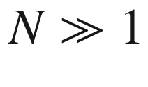

, in such hexagonal resonators the whispering gallery modes could be followed down to

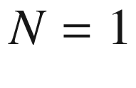

[1657] as shown in Fig. [19.29](#u116076_4_En_19_Chapter-Fig29)a, b, e.

Under high optical pumping laser action occurs on the whispering gallery modes. The peak positions, close to the band gap in the spectral region of the electron-hole plasma, follow ([19.59](#u116076_4_En_19_Chapter-Equ60)) [1660], as shown for various diameters in Fig. [19.31](#u116076_4_En_19_Chapter-Fig31). Pumping threshold even at room temperature is below 100 kW/cm

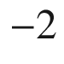

 [1661].

Footnotes

[1](#u116076_4_En_19_Chapter-Fn1_source)

This is a general property of Maxwell’s equations which do not contain a specific length scale.

[2](#u116076_4_En_19_Chapter-Fn2_source)

These solutions only occur for sufficient oscillator strength

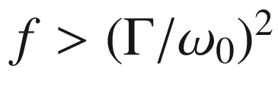

, i.e. in the strong coupling regime where

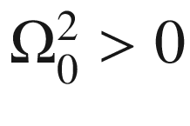

. The absorption coefficient at

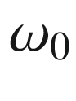

must be larger than

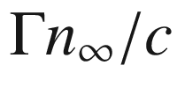

.

[3](#u116076_4_En_19_Chapter-Fn3_source)

*V* is given by the spatial integral of the vacuum field intensity for the cavity mode, divided by its maximum value.

[4](#u116076_4_En_19_Chapter-Fn4_source)

We note that besides the green luminescence as in Fig. [10.​20](The_Physics_of_Semiconductors00005.docx#u116076_4_En_10_Chapter-Fig20), an unstructured green band also occurs that is observed here. Its origin may be linked to the oxygen vacancy [1658].

© Springer Nature Switzerland AG 2021

M. Grundmann

The Physics of Semiconductors

Graduate Texts in Physics

<https://doi.org/10.1007/978-3-030-51569-0_20>

## 20. Transparent Conductive Oxide Semiconductors

Marius Grundmann[1](#u116076_4_En_20_Chapter-Aff11)

(1)

Felix Bloch Institute for Solid State Physics, Universität Leipzig, Leipzig, Germany

Marius Grundmann

Email:

[grundmann@physik.uni-leipzig.de](mailto:grundmann@physik.uni-leipzig.de)

Many of the most important semi-conductors are oxides.

*A.H Wilson, 1939* [72]

## Abstract

Typical materials in the class of transparent conductive oxides are mentioned. Their physical properties and the limits of conductivity versus transparency are discussed.

## 20.1 Introduction

Transparent conductive oxides (TCO) are semiconductors that are simultaneous transparent and highly conductive. Therefore they can serve as transparent contacts, e.g. as a solar cell front contact or in display applications. The materials are typically fabricated in the form of thin films on glass, polymers or similar substrates and devices. The crystallographic structure is polycrystalline or amorphous. The first TCO investigated was CdO in pressed powder [1662] and thin film form [38]. The recent historic development of the resistivity of the most important TCO materials in the last 30 years is shown in Fig. [20.1](#u116076_4_En_20_Chapter-Fig1). Further information on TCO films can be found in [1663–1665].

## 20.2 Materials

Any wide-gap (

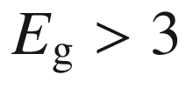

 eV) semiconductor that is conductive, e.g. due to intrinsic defects or by chemical impurities (doping), can be considered to be a TCO. Pratically only a few, non-toxic materials that can be easily deposited are of importance. The first TCO application was heating of air plane windows. As always in semiconductor technology, price drives the suitability for applications. This in particular true for TCO applications since they include large area devices such as solar cells, displays and also large glass panes for electromagnetic shielding and architectural heat and IR transparency management. Therefore large quantities of TCO are needed. The popular ITO (indium-tin-oxide) suffers from large indium price and potential indium scarcity, opening the field for aluminum-doped ZnO (ZAO) which is abundant. Possible other compounds including Cd are of no practical interest due to toxicity. Conductive GaN has not been considered due to its large processing temperatures. All practical TCO materials contain either Zn, Sn or In (Fig. [20.2](#u116076_4_En_20_Chapter-Fig2)). A number of TCO materials is reviewed in [1666]. TCO are mostly n-conducting. Also p-conducting TCOs have been reported, e.g. CuAlO



delafossite [1667] with room temperature conductivity of

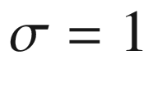

 S/cm, ZnIr



O



[1668] with

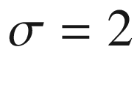

 S/cm and ZnCo



O



spinel [1669] with

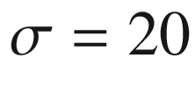

 S/cm. However, there has been so far no report on a practical transparent highly conductive p-type electrode.

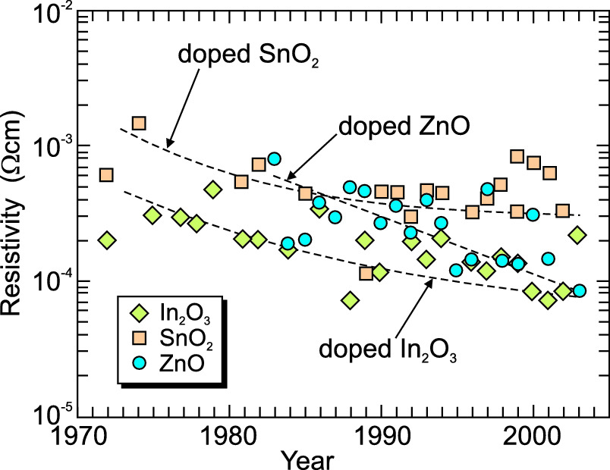

Fig. 20.1

Historical development of the resistivity of doped ZnO (*circles*), In



O



(*squares*) and SnO



(*diamonds*) TCO films.

Adapted from [1665]

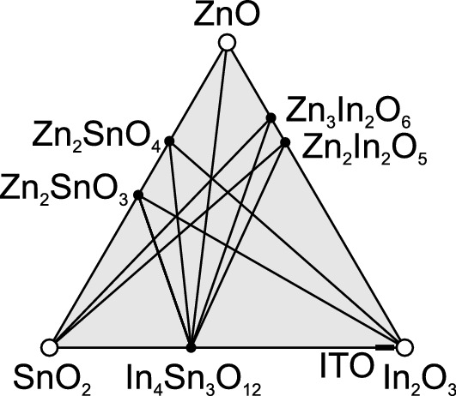

Fig. 20.2

Practical TCO materials

The term ITO stands for a variety of Sn-doped indium oxide (In



O



) materials, the Sn content being typically in the 5–10% range but not strictly defined. The crystal structure of In



O



[1670] is shown in Fig. [20.3](#u116076_4_En_20_Chapter-Fig3). The effect of the replacement of indium by tin atoms in In



O



on mechanical, electrical and optical properties of ITO has been calculated in [1671] using DFT. In Fig. [20.4](#u116076_4_En_20_Chapter-Fig4) the band structures of pure In



O



and (Sn

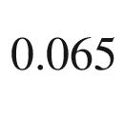

In

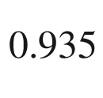

)



O



(one out of 16 indium atoms was replaced in the calculation) are compared [1672]. The fundamental band gap is slightly lowered, the high doping introduces a gigantic Burstein-Moss shift. Additionally another band gap opens that splits the lowest conduction band. Also the conduction mechanism in amorphous oxides has been discussed [151].

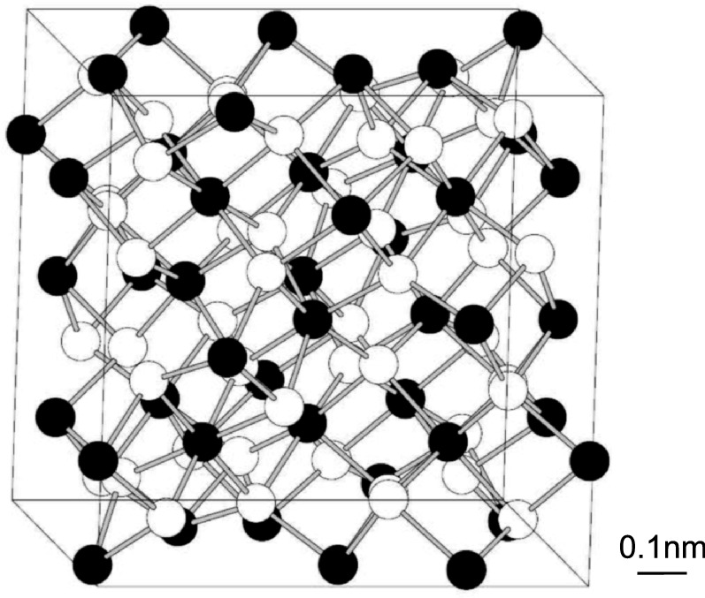

Fig. 20.3

The bixbyite crystal structure of indium oxide (In

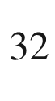

O

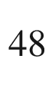

) showing one unit cell where the indium and oxygen atoms are represented by the *full* and *empty circles*, respectively.

Adapted from [1671]

## 20.3 Properties

The best conductivity of TCOs is in the range of

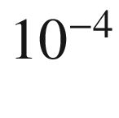

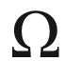

 cm for the specific resistivity. Such value is about three orders of magnitude smaller than that of metals. However, the TCO meanwhile is highly transparent in the visible region, while metals become transparent only in the UV region because of their high plasma frequency (cf. Sect. [9.​9.​1](The_Physics_of_Semiconductors00004.docx#u116076_4_En_9_Chapter)).

The conduction mechanism in ZnO:Al is band transport in a highly doped semiconductor. The carrier concentration is typically around

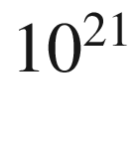

 cm

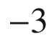

. One of the best results is a (Hall) mobility of 47.6 cm

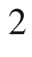

/Vs, leading to a specific resistivity of

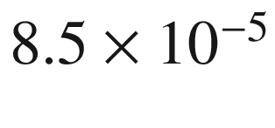



 cm [1673]. The mobility is limited by (doping level dependent) ionized impurity scattering (Sect. [8.​3.​3](The_Physics_of_Semiconductors00004.docx#u116076_4_En_8_Chapter)) as shown in Fig. [20.5](#u116076_4_En_20_Chapter-Fig5) for various films. A detailed discussion of ionized impurity scattering in doped ZnO films can be found in [1674]. Also the mobility is correlated (Fig. [20.6](#u116076_4_En_20_Chapter-Fig6)) with scattering at structural defects such as grain boundaries [1675] (cf. Fig. [8.​6](The_Physics_of_Semiconductors00004.docx#u116076_4_En_8_Chapter-Fig6)). We note that the carrier mobility in a (polycrystalline) TCO is not very different from that in highly doped (crystalline) silicon (Fig. [8.​9](The_Physics_of_Semiconductors00004.docx#u116076_4_En_8_Chapter-Fig9)).

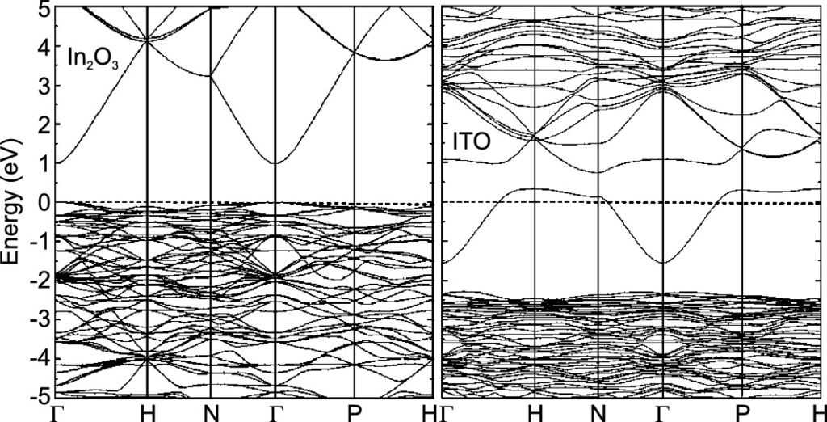

Fig. 20.4

Comparison of the band structure of In



O



(*left*) and (Sn



In



)



O



(*right*). The position of the Fermi level is for both cases at

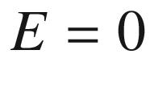

.

Adapted from [1672]

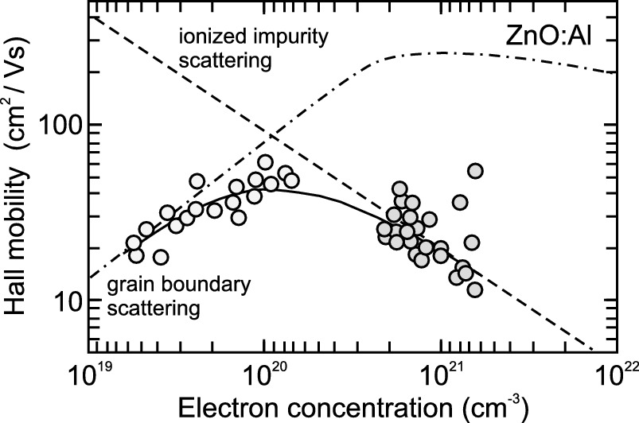

Fig. 20.5

Hall mobility for various ZnO:Al TCO thin films as a function of carrier (electron) concentration. The *dashed line* is the Brooks–Hering theory of ionized impurity scattering (taking into account non-parabolicity of the conduction band). The *dash-dotted* line is mobility in the presence of grain boundaries, the *solid line* is combined theory. *Symbols* are experimental data from two sets of samples.

Adapted from [1665]

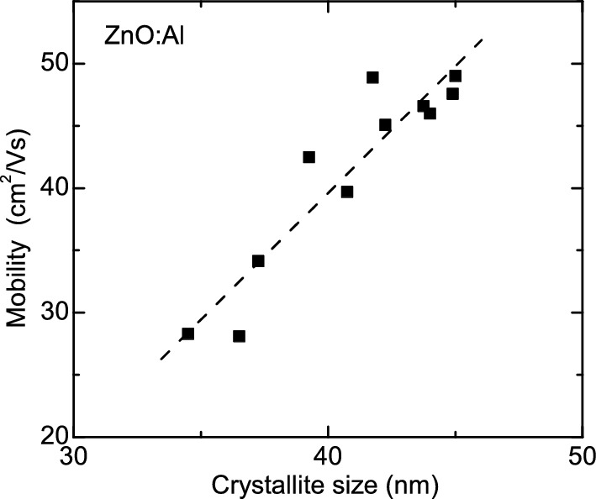

Fig. 20.6

Hall mobility of ZnO:Al films (of varying thickness) versus the crystallite size. Experimental data (from [1665]) are shown as *symbols*. The *dashed line* is a guide to the eye

Conductivity and transparency are, however, linked. The high doping of the TCO leads to shifts in the band gap (renormalization and Burstein-Moss shift), band tails and the like that can introduce absorption in the visible spectral region. Also the infrared transparency is related to the conductivity by free carrier absorption and the plasma edge (Sect. [9.​9.​1](The_Physics_of_Semiconductors00004.docx#u116076_4_En_9_Chapter)). With increasing carrier density, the plasma edge shifts into the visible spectral range (Fig. [20.7](#u116076_4_En_20_Chapter-Fig7)a), limiting the possible maximum carrier density to several



 cm



, the exact value depending on the carrier mass.

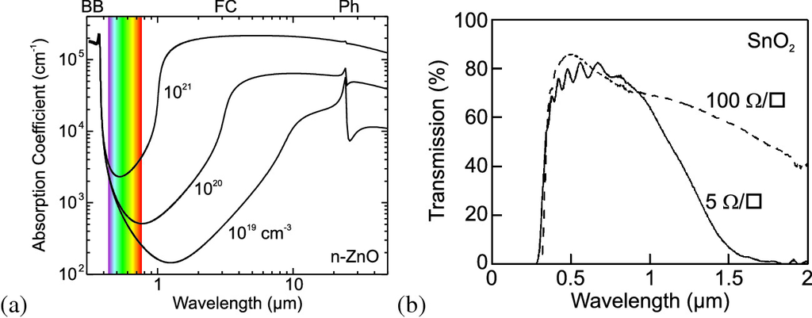

Fig. 20.7

**a** Absorption coefficient of n-type ZnO for various electron concentrations as labeled. Spectra synthesized from ellipsometric data of thin films. The visible spectral range is indicated. The contributing absorption processes are band-band transitions (BB), free carrier absorption (FC) and phonon-related absorption (Ph) as labeled. **b** Transparency versus wavelength spectra of two SnO



films with different conductivity as labeled.

Adapted from [1676]

In Fig. [20.7](#u116076_4_En_20_Chapter-Fig7)b the transparency spectra of two SnO



films with different conductivity are compared. The higher conductivity due to larger carrier concentration leads to reduced IR transparency. Generally, the transmission of a TCO is limited by the band edge on the high energy side of the spectrum and the plasma edge on the low energy side of the spectrum. The limited carrier concentration due to the onset of free carrier absorption in the visible spectral range (

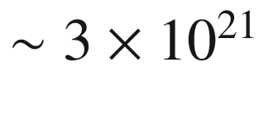

 cm



) and the limited mobility in the presence of such high impurity concentration (max. 50 cm



/Vs) restrict the minimum resistivity of a TCO (or any transparent conductor) to about

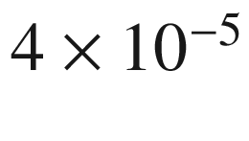



 cm [1677].

# Part IIIApplications

© Springer Nature Switzerland AG 2021

M. Grundmann

The Physics of Semiconductors

Graduate Texts in Physics

<https://doi.org/10.1007/978-3-030-51569-0_21>

## 21. Diodes

Marius Grundmann[1](#u116076_4_En_21_Chapter-Aff11)

(1)

Felix Bloch Institute for Solid State Physics, Universität Leipzig, Leipzig, Germany

Marius Grundmann

Email:

[grundmann@physik.uni-leipzig.de](mailto:grundmann@physik.uni-leipzig.de)

## Abstract

A thorough treatment of Schottky (metal-semiconductor) diodes, MIS (metal-insulator-semiconductor) diodes and (bipolar) pn-diodes is given, focussing on suitable materials, the formation of space charge layers and the forward and reverse current-voltage characteristics. Applications of such devices based on their rectifying properties are discussed.

### 21.1 Introduction

One of the simplest[1](The_Physics_of_Semiconductors00008.docx#u116076_4_En_21_Chapter-Fn1) semiconductor devices is the diode. It is a so-called two-terminal device, i.e. a device with two leads. The most prominent property of a diode is the rectifying current-voltage (*I*–*V*) characteristic. This function was initially realized with vacuum tubes (Fig. [21.1](#u116076_4_En_21_Chapter-Fig1)); a heated filament emits electrons that are transferred through vacuum to the anode if it is on a positive potential. The semiconductor diode technology led to a tremendous miniaturization, integration with other devices (in planar technology) and cost reduction.

We distinguish[2](The_Physics_of_Semiconductors00008.docx#u116076_4_En_21_Chapter-Fn2) *unipolar* diodes, for which the *majority* carriers cause the effects (e.g. metal-semiconductor diodes), and *bipolar* diodes in which *minority* carriers play the decisive role, e.g. in the pn junction diode.

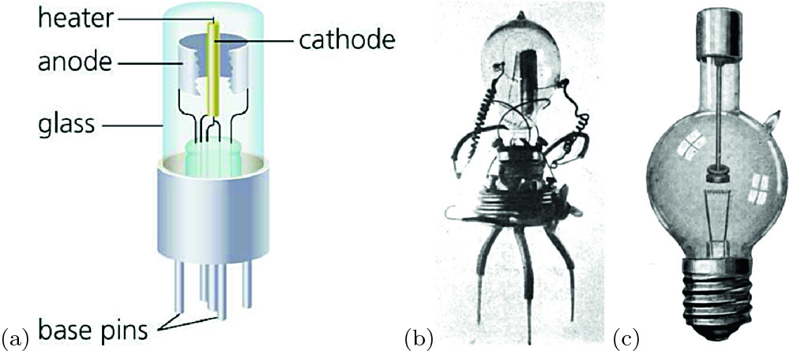

Fig. 21.1

**a** Schematic image of a vacuum diode. The electron current flows from the heated cathode to the anode when the latter is at a positive potential. **b** One of John A. Fleming’s first diode ‘valves’, 1904. **c** Commercial ‘tungar’ rectifier, around 1916 [1679] (**b**, **c**).

Adapted from [1678]

Semiconductor devices carry vastly different currents depending on their design and eventual application. In Table [21.1](#u116076_4_En_21_Chapter-Tab1), an overview of typical current densities is provided as a guide through the following chapters.

### 21.2 Metal-Semiconductor Contacts

The metal-semiconductor contact was investigated in 1874 by F. Braun (see Sect. [1.​1](The_Physics_of_Semiconductors00001.docx#u116076_4_En_1_Chapter)). For metal sulfides, e.g. CuFeS



, he found nonohmic behavior. We remark here that we treat first metal-semiconductor contacts with rectifying properties. Later it becomes understandable that metal-semiconductor contacts can also be used as ohmic contacts, i.e. contacts with a very small contact resistance. Rectifying metal-semiconductor contacts are also called Schottky diodes. A very important variation are metal-insulator-semiconductor diodes for which an insulator, mostly an oxide, is sandwiched between the metal and the semiconductor. Such diodes are treated in Sect. [21.3](#u116076_4_En_21_Chapter-Sec10). An early treatment on ‘crystal rectifiers’ can be found in [1680]. Reviews on Schottky diodes can be found in [1681–1687].Table 21.1

Typical current densities for various semiconductor devices

| Device | *j* (A/cm  $$^2$$  ) |
| --- | --- |
| Dark current of cooled CCD (  $$T \sim 200$$   K) | $$&lt;10^{-12}$$ |
| Dark current of CCD at room temperature | $$10^{-9}$$ |
| 3.6 nm SiO*x* gate dielectric (at 1 V) | $$10^{-9}$$ |
| Photocurrent of Si solar cell (at 1 sun) | 0.04 |
| 1.5 nm SiO*x* gate dielectric (at 1 V) | 1 |
| 4-junction solar cell (at 508 sun) | 6.5 |
| Threshold of QD laser diodes | 10 |
| LED in typical operation | 10 |
| Threshold of QW laser diodes | $$10^2$$ |
| LED in high power operation | $$10^2$$ |
| Threshold of VCSEL | $$10^3$$ |
| High power III–V laser diode in cw operation | $$10^3$$  –  $$10^4$$ |
| High power III–V laser diode in pulsed operation | $$10^5$$ |
| Resonant tunneling diode peak current | $$10^5$$ |
| Power electronics transistors | $$10^5$$  –  $$10^7$$ |

#### 21.2.1 Band Diagram in Equilibrium

The metal and the semiconductor have generally different positions of the Fermi levels relative to the vacuum level. When the metal is in contact with the semiconductor, charges will flow in such a way that in thermodynamic equilibrium the Fermi level is constant throughout the structure.[3](The_Physics_of_Semiconductors00008.docx#u116076_4_En_21_Chapter-Fn3) In the following we treat two limiting cases: The contact of a metal with a semiconductor without any surface states (Schottky-Mott model) and a contact where the semiconductor has a very high density of surface states (Bardeen model).

The position of the Fermi level in the metal is given by the work function

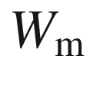

that is shown in Fig. [21.2](#u116076_4_En_21_Chapter-Fig2) for various metals (see also Table [21.2](#u116076_4_En_21_Chapter-Tab2)). A recent review of published values of metal work functions is given in [1688]. The work function reflects the atomic shell structure; minima of the work function exist for group-I elements. The work function is the energy difference between the vacuum level (an electron is at rest in an infinite distance from the metal surface) and the metal Fermi level (

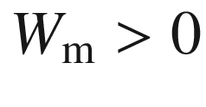

). Since the electron density in the metal conduction band is very high, the position of the metal Fermi level does not change considerably when charge is exchanged between the metal and the semiconductor.

Since in a semiconductor the Fermi level depends strongly on the doping and temperature it is not useful to characterize the material itself. For semiconductors the electron affinity

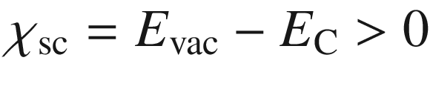

is defined as the energy difference between the vacuum level and the conduction-band edge (see Fig. [12.​21](The_Physics_of_Semiconductors00005.docx#u116076_4_En_12_Chapter-Fig21)).

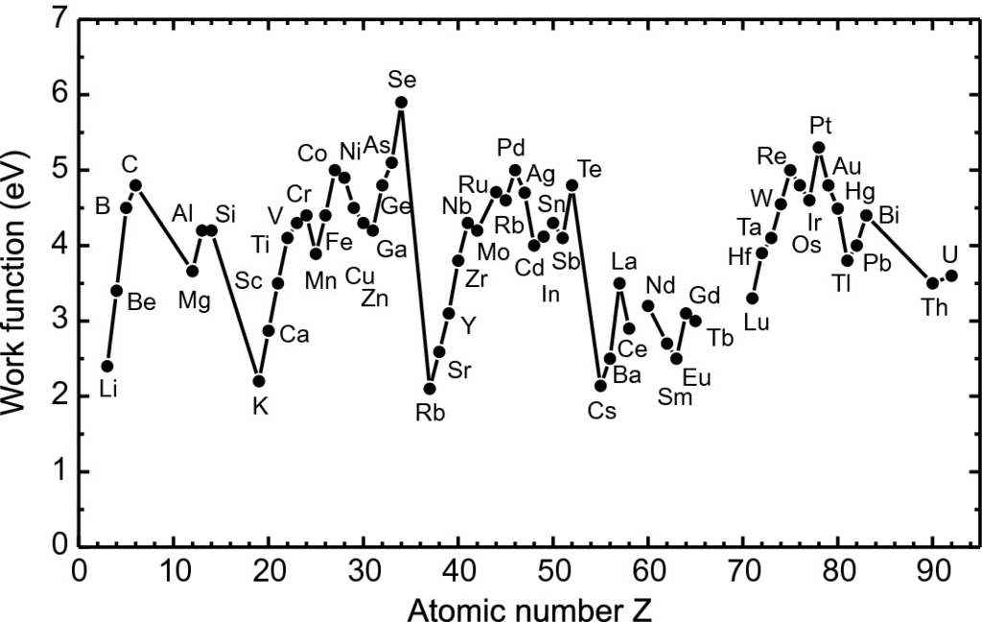

Fig. 21.2

Work function

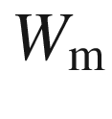

of various metals

Table 21.2

Values of the work function

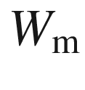

of various metals

| *Z* | Element | $$W_{\mathrm {m}}$$  (eV) | *Z* | Element | $$W_{\mathrm {m}}$$  (eV) | *Z* | Element | $$W_{\mathrm {m}}$$  (eV) |
| --- | --- | --- | --- | --- | --- | --- | --- | --- |
| 3 | Li | 2.4 | 37 | Rb | 2.1 | 64 | Gd | 3.1 |
| 4 | Be | 3.4 | 38 | Sr | 2.59 | 65 | Tb | 3.0 |
| 5 | B | 4.5 | 39 | Y | 3.1 | 66 | Dy | – |
| 6 | C | 4.8 | 40 | Zr | 3.8 | 67 | Ho | – |
| 12 | Mg | 3.66 | 41 | Nb | 4.3 | 68 | Er | – |
| 13 | Al | 4.2 | 42 | Mo | 4.2 | 69 | Tm | – |
| 14 | Si | 4.2 | 44 | Ru | 4.71 | 70 | Yb | – |
| 19 | K | 2.2 | 45 | Rh | 4.6 | 71 | Lu | 3.3 |
| 20 | Ca | 2.87 | 46 | Pd | 5.0 | 72 | Hf | 3.9 |
| 21 | Sc | 3.5 | 47 | Ag | 4.7 | 73 | Ta | 4.1 |
| 22 | Ti | 4.1 | 48 | Cd | 4.0 | 74 | W | 4.55 |
| 23 | V | 4.3 | 49 | In | 4.12 | 75 | Re | 5.0 |
| 24 | Cr | 4.4 | 50 | Sn | 4.3 | 76 | Os | 4.8 |
| 25 | Mn | 3.89 | 51 | Sb | 4.1 | 77 | Ir | 4.6 |
| 26 | Fe | 4.4 | 52 | Te | 4.8 | 78 | Pt | 5.3 |
| 27 | Co | 5.0 | 55 | Cs | 2.14 | 79 | Au | 4.8 |
| 28 | Ni | 4.9 | 56 | Ba | 2.5 | 80 | Hg | 4.49 |
| 29 | Cu | 4.5 | 57 | La | 3.5 | 81 | Tl | 3.8 |
| 30 | Zn | 4.3 | 58 | Ce | 2.9 | 82 | Pb | 4.0 |
| 31 | Ga | 4.2 | 59 | Pr | - | 83 | Bi | 4.4 |
| 32 | Ge | 4.8 | 60 | Nd | 3.2 | 90 | Th | 3.5 |
| 33 | As | 5.1 | 62 | Sm | 2.7 | 92 | U | 3.6 |
| 34 | Se | 5.9 | 63 | Eu | 2.5 |

**Ideal Band Diagram**

When the metal and the semiconductor are not in contact (Fig. [21.3](#u116076_4_En_21_Chapter-Fig3)a), the metal is characterized by its work function

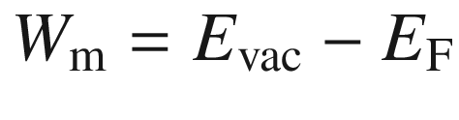

and the semiconductor by its electron affinity

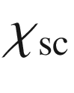

. First, we assume that

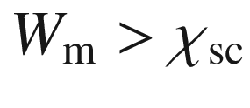

. For an n-type semiconductor, the energy difference between the Fermi level and the conduction band is denoted as

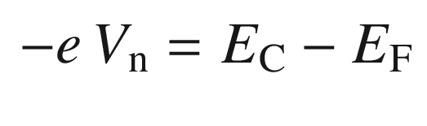

(21.1)

being negative,

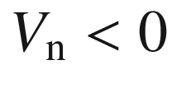

, for nondegenerate semiconductors. Thus, the position of the semiconductor Fermi level is given as

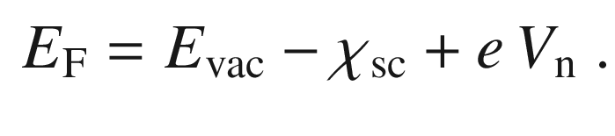

(21.2)

If the metal and semiconductor are brought into contact the Fermi levels will equilibrate. For the case of Fig. [21.3](#u116076_4_En_21_Chapter-Fig3) (

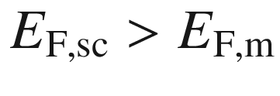

) electrons will flow from the semiconductor to the metal. The negative surface charge of the metal is compensated by a positive charge (due to D

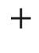

) in the semiconductor in the vicinity of the surface. Eventually a (Schottky) barrier of height[4](The_Physics_of_Semiconductors00008.docx#u116076_4_En_21_Chapter-Fn4)

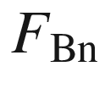

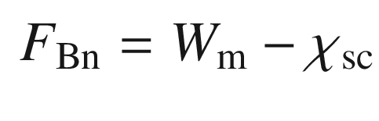

(21.3)

forms at the interface. The subscript ‘n’ stands for the contact on an n-type semiconductor. Surface/interface effects such as non-matching bonds, surface states, etc. are neglected at this point. In the semiconductor there exists a positively charged region that is called the *depletion layer* or space-charge region  [1689]. Its extension (*w* in Fig. [21.3](#u116076_4_En_21_Chapter-Fig3)b) and properties will be discussed in Sect. [21.2.2](#u116076_4_En_21_Chapter-Sec4). The space charge region in the metal is very thin due to the small screening length.

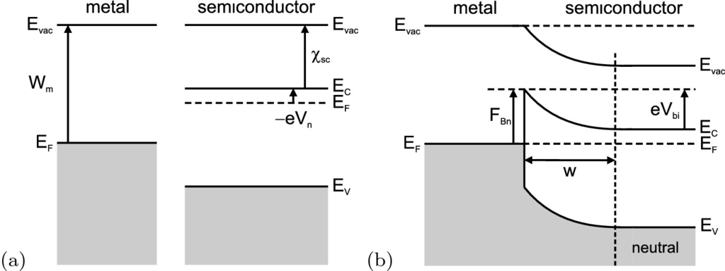

Fig. 21.3

Schematic band diagram of a metal-semiconductor junction that is dominated by bulk properties of the semiconductor. **a** no contact, **b** metal and semiconductor in contact. *w* denotes the width of the depletion layer. Outside the depletion layer the semiconductor is neutral.

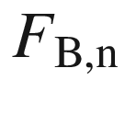

denotes the Schottky barrier height,

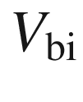

denotes the built-in voltage (here

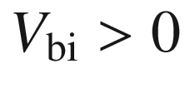

)

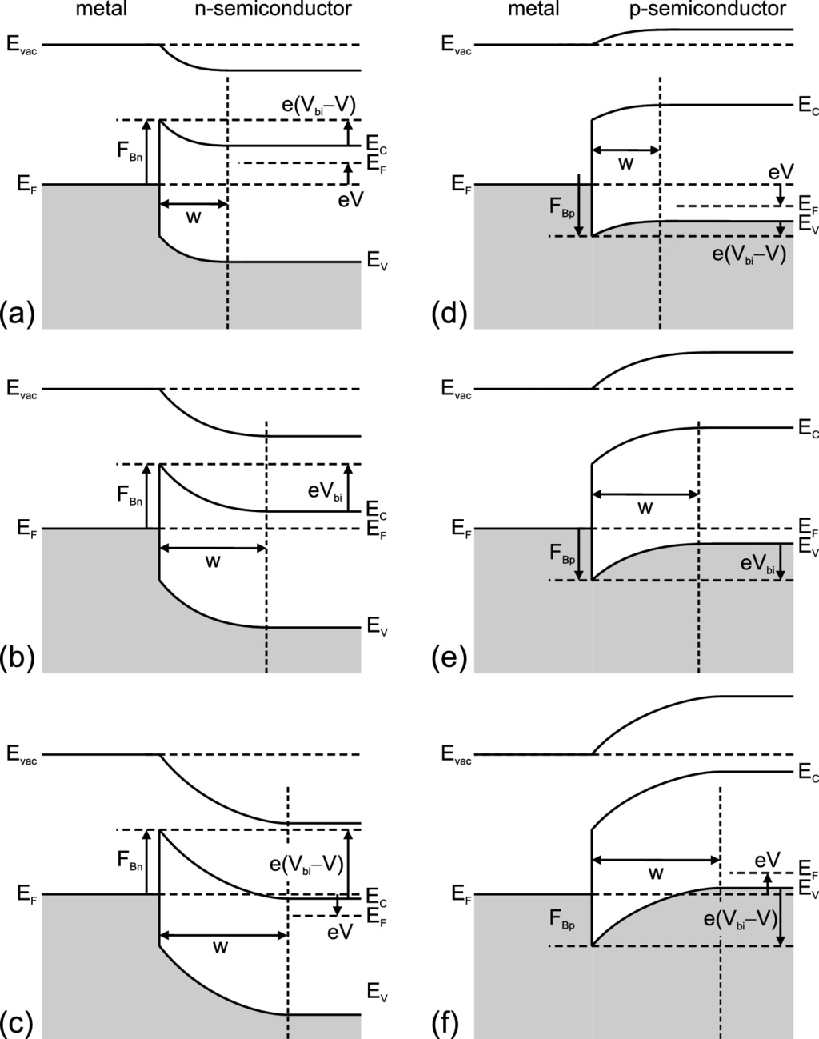

Fig. 21.4

Band diagrams of metal-semiconductor junctions for **a**, **b**, **c** an n-type semiconductor and **d**, **e**, **f** a p-type semiconductor (here

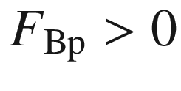

). (**b**, **e**) in thermodynamic equilibrium, (**a**, **d**) with forward bias (

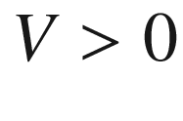

), (**c**, **f**) with reverse bias (

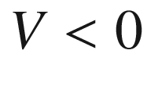

)

For a contact on a p-type semiconductor the barrier

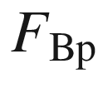

(to the valence band) is (see Fig. [21.4](#u116076_4_En_21_Chapter-Fig4)d)

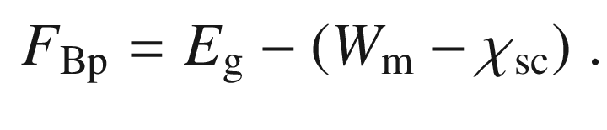

(21.4)

Between the surface of the metal and the bulk part of the semiconductor there is a potential drop

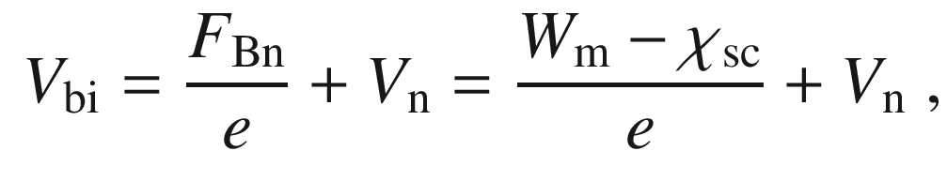

(21.5)

which is termed the built-in potential (or diffusion voltage). The exact form of the voltage drop, the so-called band bending, will be discussed in Sect. [21.2.2](#u116076_4_En_21_Chapter-Sec4).

The surface index is defined as

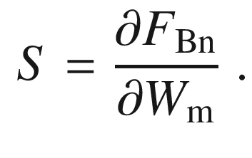

(21.6)

From the present consideration ([21.3](#u116076_4_En_21_Chapter-Equ3)), the same semiconductor with metals of varying work function should result in

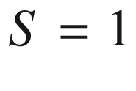

.

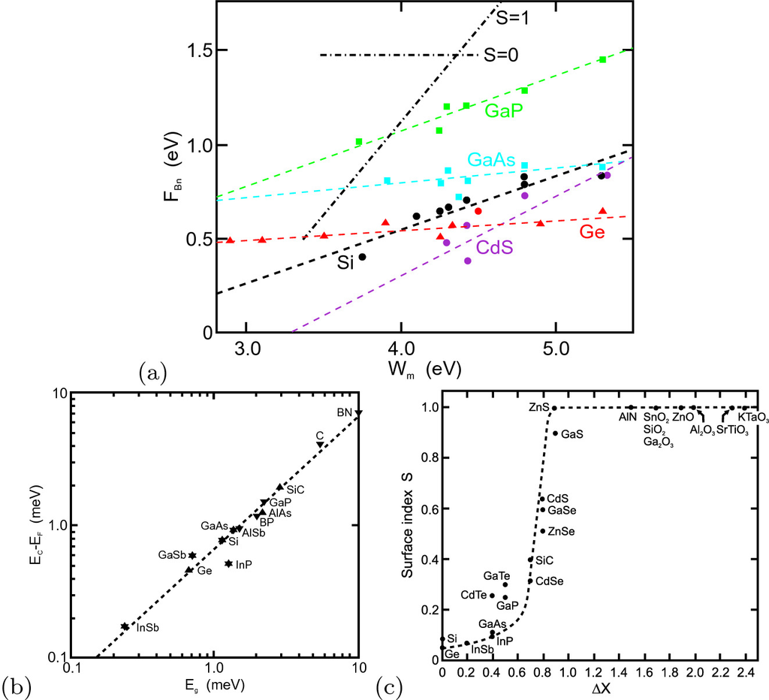

Fig. 21.5

**a** Experimental Schottky barrier heights

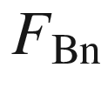

versus metal work function

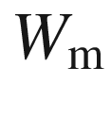

for various metal-semiconductor junctions as labeled. *Dashed lines* are guides to the eye, *dash-dotted lines* indicate dependencies for the surface index ([21.6](#u116076_4_En_21_Chapter-Equ6))



and

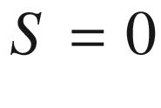

. Data from [1690, 1691]. **b**

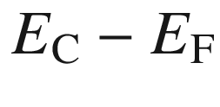

at the metal-semiconductor interface versus the band gap

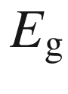

for Au Schottky contacts on various semiconductors. The *dashed line* represents

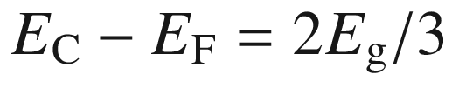

. Data from [1692]. **c**Surface index *S* versus the electronegativity difference

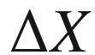

between the species of compound semiconductors. *Dashed line* is a guide to the eye. Data from [1691, 1693]

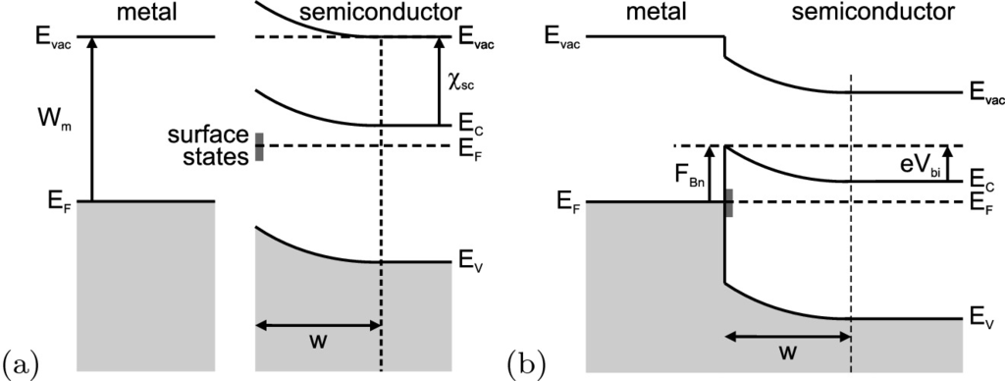

Fig. 21.6

Schematic band structure of a metal-semiconductor junction that is dominated by surface properties of the semiconductor. **a** no contact; due to pinning of the Fermi level at surface states of the semiconductor, a depletion-layer of width *w* is already present. **b** Metal and semiconductor in contact

**Band Diagram in the Presence of Surface States**

Experimental data shown in Fig. [21.5](#u116076_4_En_21_Chapter-Fig5)a, however, show a different behavior with smaller slope. For GaAs, e.g., the barrier height is almost independent of the metal work function. Thus, a different model is needed for realistic Schottky diodes. A rule of thumb for the dominantly covalent semiconductors is that for n-type material the barrier height is 2/3 of the band gap and for p-type material 1/3 of the band gap, such that

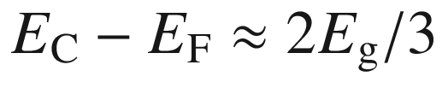

(Fig. [21.5](#u116076_4_En_21_Chapter-Fig5)b). Only for ionic semiconductors

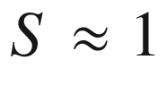

holds (Fig. [21.5](#u116076_4_En_21_Chapter-Fig5)c) [1694].

If the semiconductor has a large density of states at its surface (

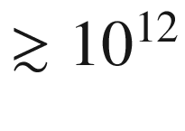

 cm

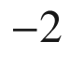

), there is a space-charge region already without the metal [1695]. Surface traps are filled up to the Fermi level (Fig. [21.6](#u116076_4_En_21_Chapter-Fig6)a). The size of the band bending in the semiconductor will be denoted as

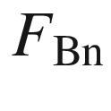

since it will turn out below as the Schottky barrier height. If the density of surface states is very high, the charge carriers moving from the semiconductor into the metal upon contact formation are accommodated in the surface states and the position of the Fermi level at the semiconductor surface changes only very little. Thus, the space-charge region is not modified and it is identical to the surface depletion region. The Schottky barrier height is then given by the band bending at the (bare) semiconductor surface

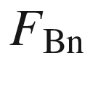

(Fig. [21.6](#u116076_4_En_21_Chapter-Fig6)d) and does not depend on the metal work function at all (Bardeen model [1695]). For this limiting case we find for the surface index

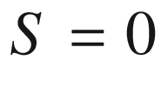

.

For actual metal-semiconductor contacts the surface index *S* takes values between 0 and 1. A theory involving the semiconductor band structure and midgap (surface) states (MIGS) is needed [695, 1696]. For Si, the experimental result is

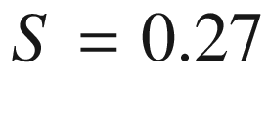

; the corresponding density of surface states is

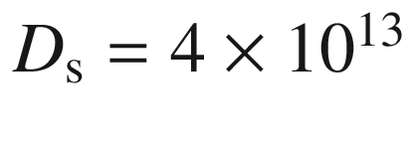

 cm

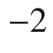

 eV

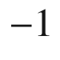

.

#### 21.2.2 Space-Charge Region

The width *w* of the space-charge region is calculated next. First, we make the so-called abrupt approximation. In this approximation (Schottky-Mott model), the charge density

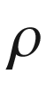

in the space-charge region (

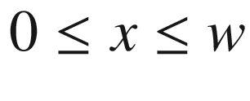

) is given by the doping, i.e.

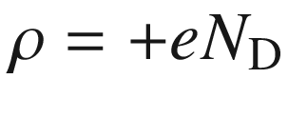

. Outside the space-charge region the semiconductor is neutral, i.e.

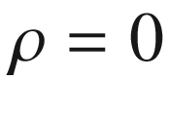

and the electric field is zero, i.e.

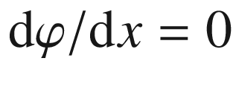

. As further boundary conditions the potential at the interface is

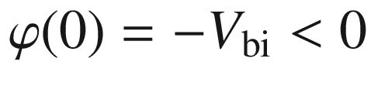

. The potential drop in the space-charge region is determined by the one-dimensional Poisson equation

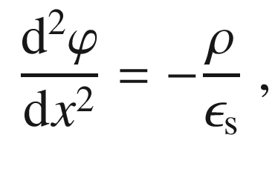

(21.7)

where

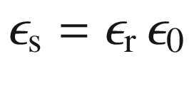

is the static dielectric constant of the semiconductor. Using the ansatz

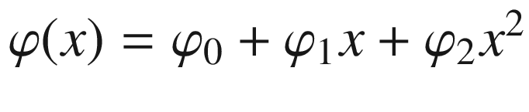

we find

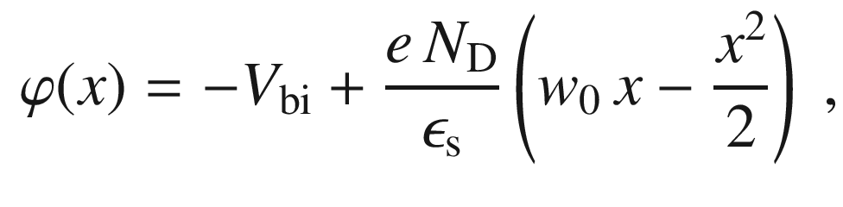

(21.8)

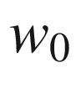

being the depletion layer width at zero bias.

The spatial dependence *E*(*x*) of the electric field strength is

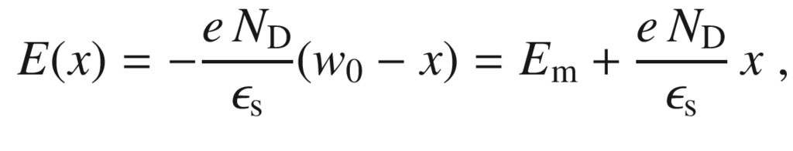

(21.9)

with the maximum field strength

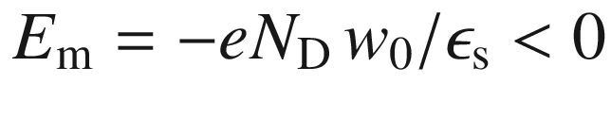

at

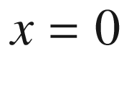

. From the condition

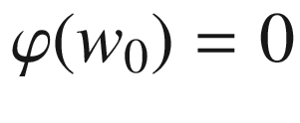

we obtain

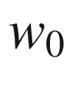

 as

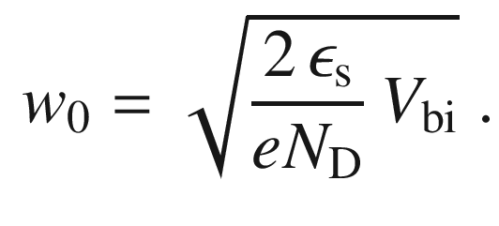

(21.10)

The charge density and the potential in the abrupt approximation are shown in Fig. [21.7](#u116076_4_En_21_Chapter-Fig7) for GaAs material parameters.

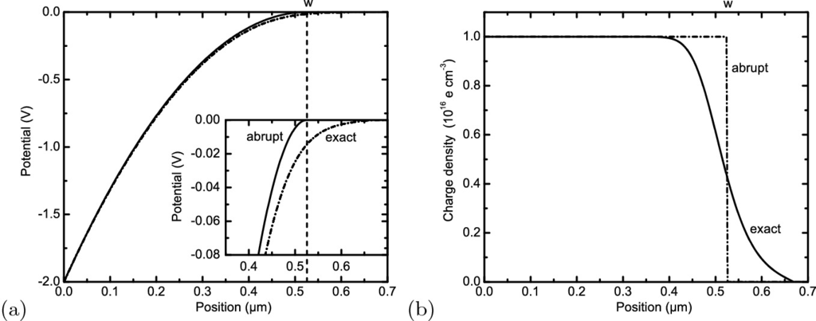

Fig. 21.7

**a** Potential

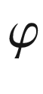

and **b** charge density

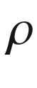

across the depletion layer of a Schottky n-GaAs diode. Calculation parameters are

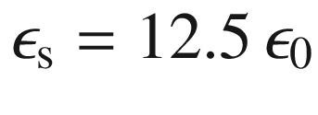

,

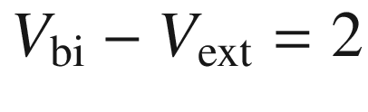

 V (small reverse bias),

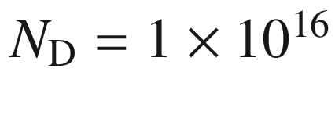

 cm

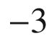

,

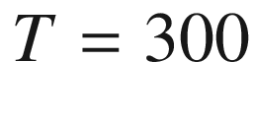

 K. Abrupt approximation is shown as *solid lines*, exact (numerical) calculation as *dash-dotted line*. *Dashed line* in (**a**) indicates depletion layer width

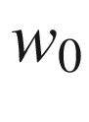

in the abrupt approximation

**Beyond the abrupt approximation**

The thermal distribution of the majority carriers should be treated with a little more care. The dependence of the charge density

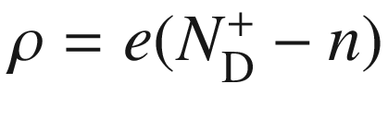

on the potential

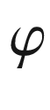

(within the Boltzmann approximation) is (

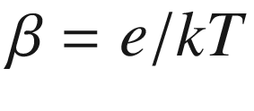

)

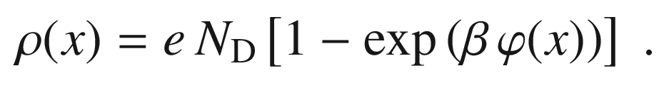

(21.11)

The actual charge density and the potential, obtained from a numerical solution of ([21.7](#u116076_4_En_21_Chapter-Equ7)), are shown in Fig. [21.7](#u116076_4_En_21_Chapter-Fig7) in comparison with the abrupt approximation. Clearly, at the Schottky depletion layer width

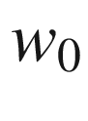

, the charge varies continuously and the potential does not drop to zero.

We note that for the depletion layer

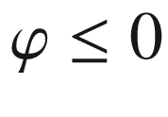

and

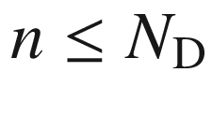

. The charge difference

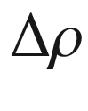

(due to the tail of the thermal distribution of the majority charge carriers in the depletion layer) between the real distribution ([21.11](#u116076_4_En_21_Chapter-Equ11)) to the abrupt approximation model with constant charge density (

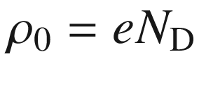

) in the depletion layer is

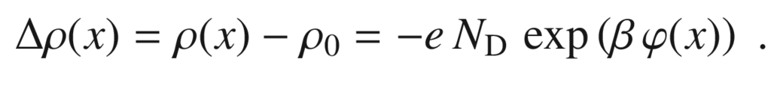

(21.12)

The integration of

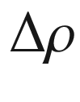

over the depletion layer yields that the voltage drop

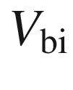

across the depletion layer needs to be corrected by

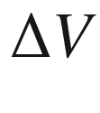

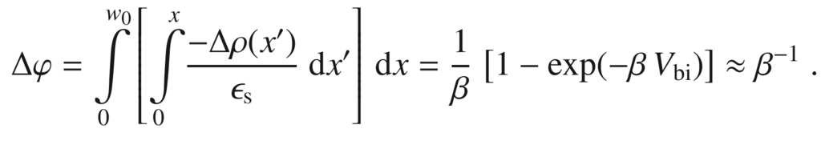

(21.13)

The approximation is valid for

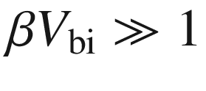

. Therefore, ([21.10](#u116076_4_En_21_Chapter-Equ10)) is corrected to

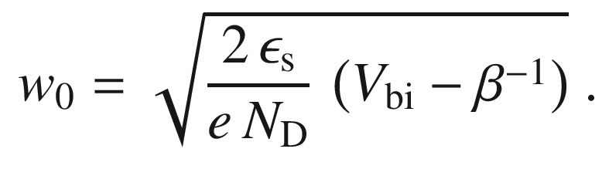

(21.14)

When a potential difference

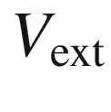

is applied externally to the diode, ([21.14](#u116076_4_En_21_Chapter-Equ14)) is modified by the change in the interface boundary condition,

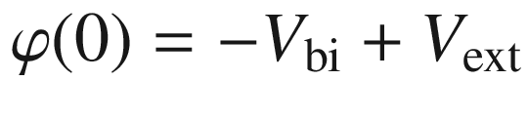

. The band diagram is shown schematically in Fig. [21.4](#u116076_4_En_21_Chapter-Fig4)a for a forward bias and in Fig. [21.4](#u116076_4_En_21_Chapter-Fig4)c for a reverse bias. Therefore, we obtain for the depletion-layer width (within the abrupt approximation)

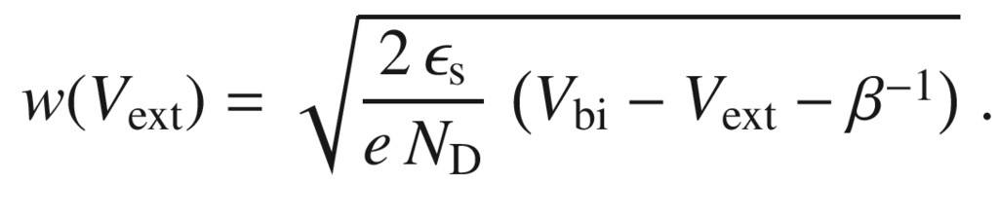

(21.15)

Now we can also give explicitly the value of the maximum electric field

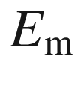

(at

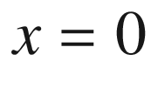

)

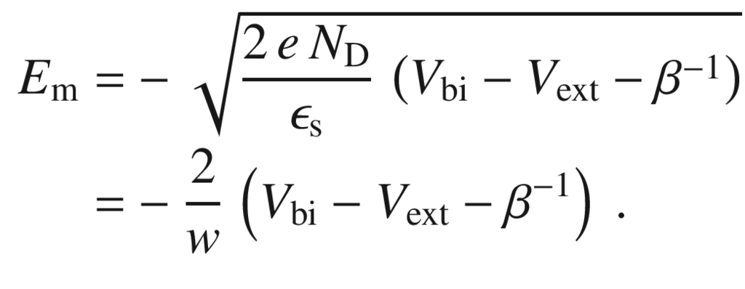

(21.16)

We note that so far the barrier height is independent of the applied bias voltage. In the next section, it is shown that this is actually not the case.

An alternative approach to solve the Poisson equation is to consider the field as a function of the potential,

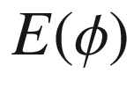

. Then,

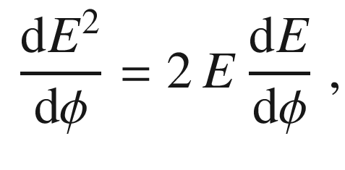

(21.17)

and

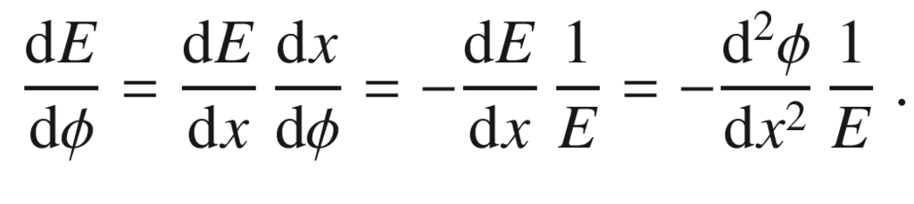

(21.18)

Combining these two equations and using ([21.7](#u116076_4_En_21_Chapter-Equ7)) and ([21.11](#u116076_4_En_21_Chapter-Equ11)) we find

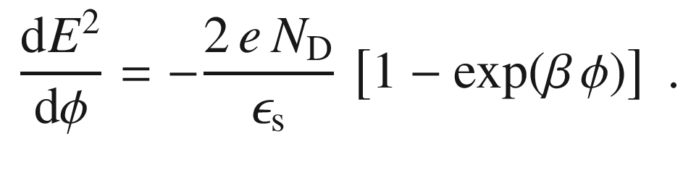

(21.19)

The integration of this equation yields with the boundary condition

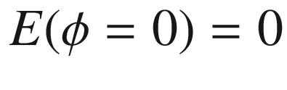

,

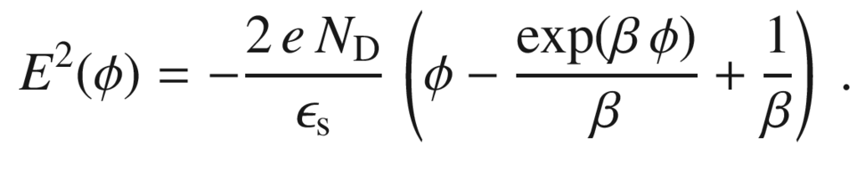

(21.20)

At the interface

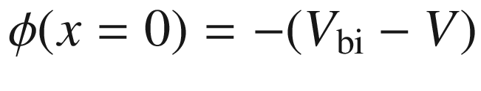

, and for sufficient voltage drop in the semiconductor

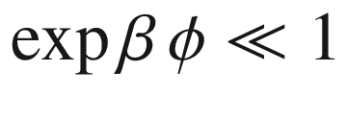

, and therefore ([21.16](#u116076_4_En_21_Chapter-Equ16)) for

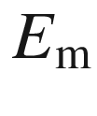

is recovered without using the abrupt approximation or its correction ([21.13](#u116076_4_En_21_Chapter-Equ13)).[5](The_Physics_of_Semiconductors00008.docx#u116076_4_En_21_Chapter-Fn5) Without approximation,

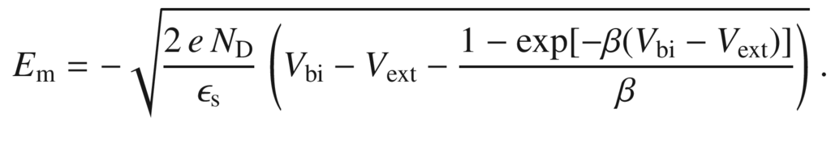

(21.21)

#### 21.2.3 Schottky Effect

The barrier height is reduced by the image-charge effect that has been neglected so far. This effect has been worked out for metals by Schottky [1698] and has been adapted to semiconductors [1699, 1700]. An electron (charge

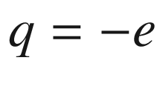

) at position *x* in the semiconductor is facing a metal surface at

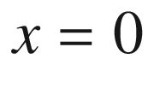

(Fig. [21.8](#u116076_4_En_21_Chapter-Fig8)a). The potential distribution of the free charge is modified since the metal surface is an equipotential surface. The potential distribution outside the metal is identical to that if an *image* charge

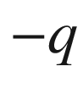

was located at

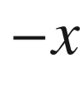

. This image charge exerts a force (image force

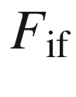

) on the electron

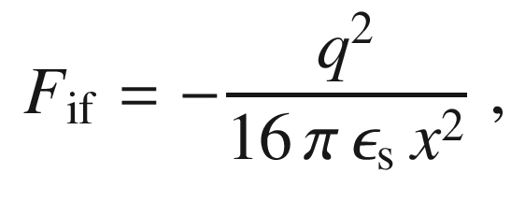

(21.22)

where

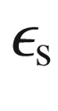

is again the relative dielectric constant of the semiconductor. In order to bring an electron from infinity to *x* the work

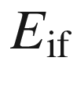

,

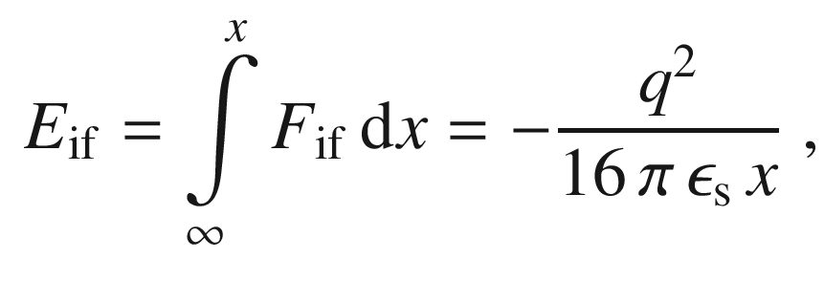

(21.23)

is needed. This image potential energy is shown in Fig. [21.8](#u116076_4_En_21_Chapter-Fig8)a. The total energy

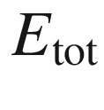

(solid line in Fig. [21.8](#u116076_4_En_21_Chapter-Fig8)a) of the electron in the presence of an electric field *E* is given by (

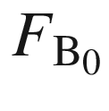

is the relabeled Schottky barrier ([21.3](#u116076_4_En_21_Chapter-Equ3)) without image charge effect,

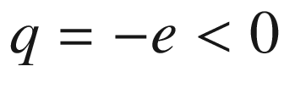

and

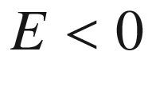

)

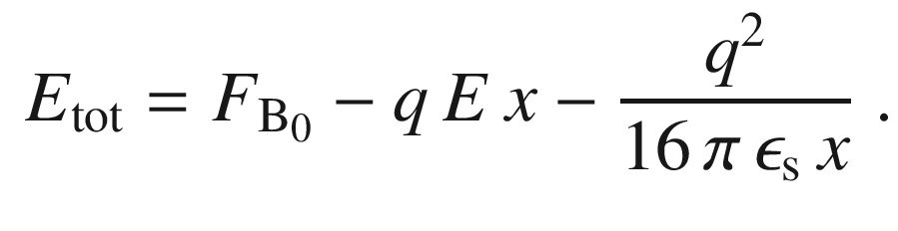

(21.24)

We note that the divergence at

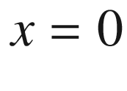

stems from the continuum idealization of the problem. It can be removed by shifting the position of the image charge slightly against the interface or by using an extended charge [1188].

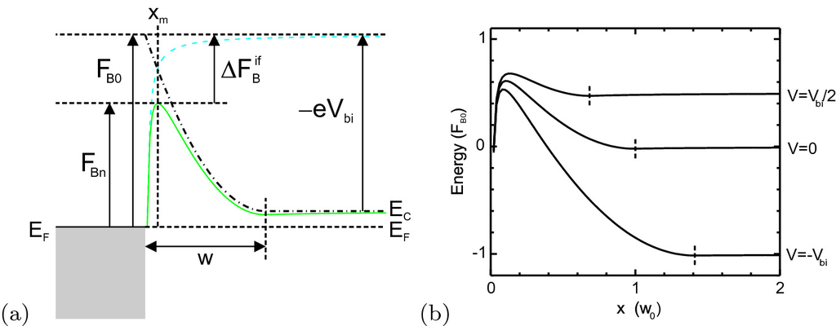

Fig. 21.8

**a** Energy of a particle with respect to the metal surface (*dashed line*), conduction band in semiconductor depletion layer (*dash-dotted line*) and combined effect (*solid line*). The image charge energy lowers the potential barrier

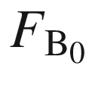

by the amount

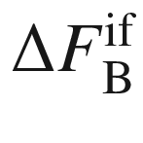

to

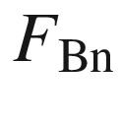

. **b** Conduction band on the semiconductor side of a metal-semiconductor junction at various bias voltages (

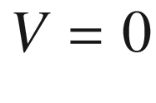

,

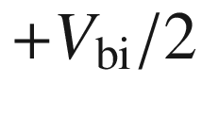

, and

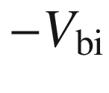

as labeled) taking into account the Schottky effect. The width of the depletion layer is indicated with a *short vertical dashed line*. The barrier height without Schottky effect is

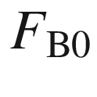

. The *dashed line* is the situation without Schottky effect for zero bias

The maximum of this function (

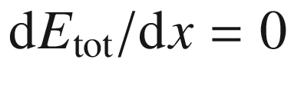

) is at

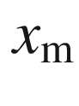

,

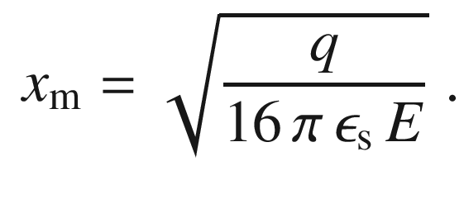

(21.25)

The Schottky barrier

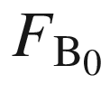

is thus reduced by

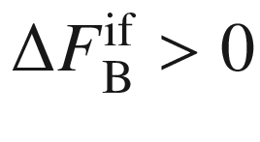

given by

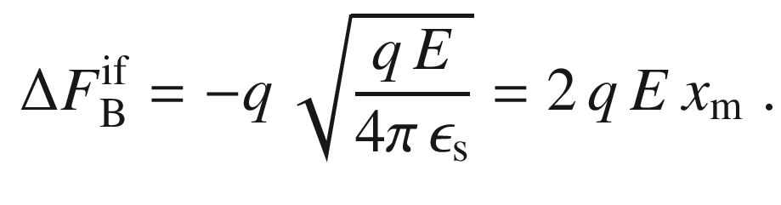

(21.26)

With the electrical field in the vicinity of the interface (

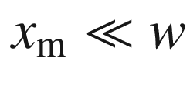

) given by

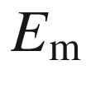

from ([21.16](#u116076_4_En_21_Chapter-Equ16)), the barrier reduction is[6](The_Physics_of_Semiconductors00008.docx#u116076_4_En_21_Chapter-Fn6)

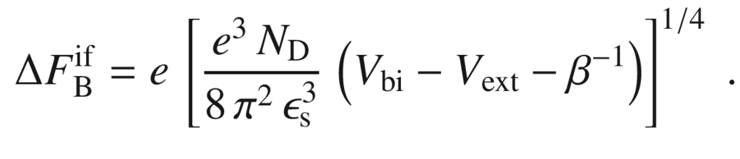

(21.27)

For

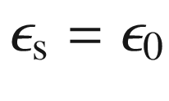

(vacuum) and a field strength of

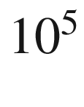

 V/cm, the maximum position is at

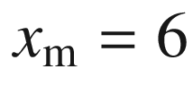

 nm and the barrier reduction is

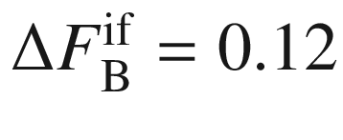

 eV. For

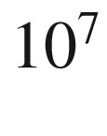

 V/cm,

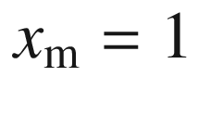

 nm and

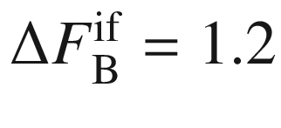

 eV. For semiconductors with

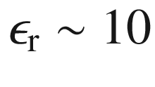

the effect is smaller (Fig. [21.9](#u116076_4_En_21_Chapter-Fig9)). The Schottky effect depends on the bias voltage as visualized in Fig. [21.8](#u116076_4_En_21_Chapter-Fig8)b and therefore the barrier height depends on the applied bias voltage.

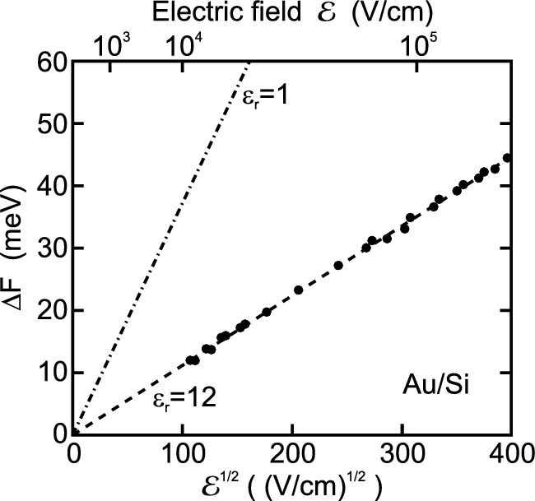

Fig. 21.9

Electric-field dependence of the image charge lowering of the Schottky barrier. *Dash-dotted* line is for vacuum dielectric constant, *dashed line* is ([21.26](#u116076_4_En_21_Chapter-Equ26)) for

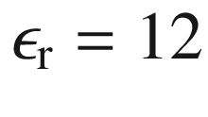

.

Adapted from [1701]

#### 21.2.4 Capacitance

The total space charge *Q* (per unit area) in the semiconductor is (

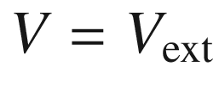

)

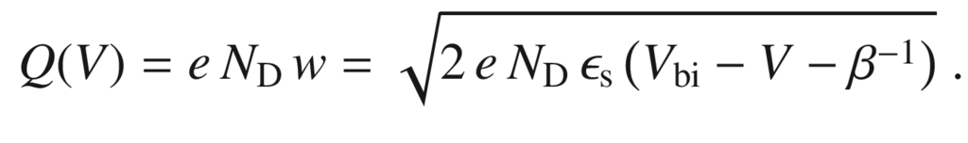

(21.28)

and depends on the external voltage.

For measurement of the depletion layer capacitance first the external dc bias voltage *V* is set which defines the extension of the depletion layer. The (differential) capacitance is probed by an ac voltage with small amplitude

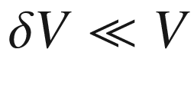

. First we assume that the ac frequency

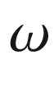

is small compared to characteristic time constants of the electrically active impurities (quasi-static capacitance) and discuss the bias dependence *C*(*V*). Following we discuss the frequency and temperature dependence of the capacitance[7](The_Physics_of_Semiconductors00008.docx#u116076_4_En_21_Chapter-Fn7)

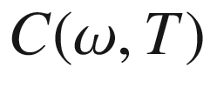

, in particular when the measurement frequency is in the range of the (temperature dependent) electron capture or emission rate ([10.​42](The_Physics_of_Semiconductors00005.docx#u116076_4_En_10_Chapter), [10.​43](The_Physics_of_Semiconductors00005.docx#u116076_4_En_10_Chapter)).

**Bias Dependence**

From ([21.28](#u116076_4_En_21_Chapter-Equ28)) the capacitance

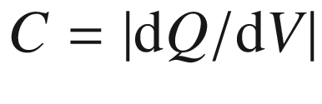

(per unit area) of the space charge region is given by

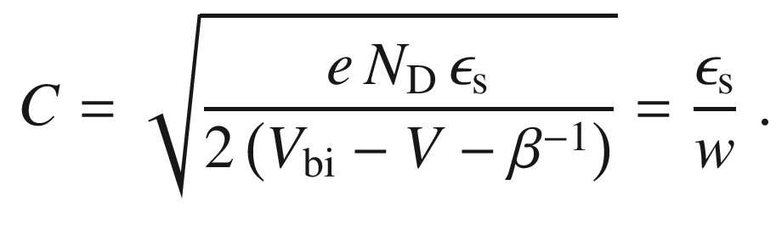

(21.29)

Equation ([21.29](#u116076_4_En_21_Chapter-Equ29)) can also be written as

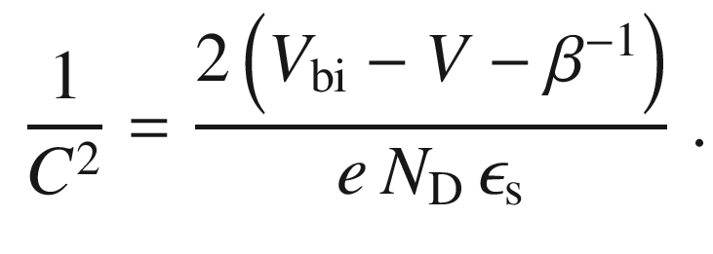

(21.30)

If

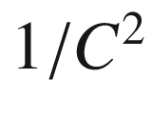

is measured as a function of the bias voltage (*C*–*V* spectroscopy), it should be linearly dependent on the bias voltage if the doping concentration is homogeneous (Fig. [21.10](#u116076_4_En_21_Chapter-Fig10)a). The doping concentration can be determined from the slope via

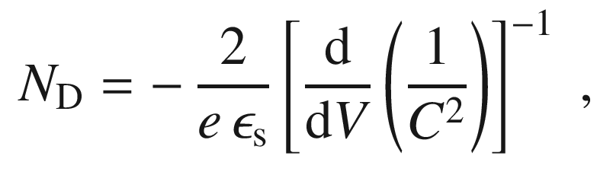

(21.31)

(see Fig. [21.10](#u116076_4_En_21_Chapter-Fig10)b) and the built-in voltage

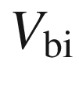

from the extrapolation to

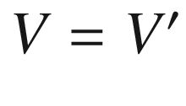

such that

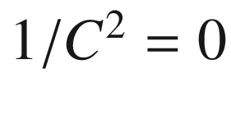

,

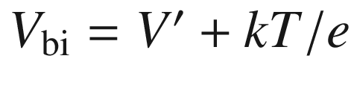

. Using ([21.5](#u116076_4_En_21_Chapter-Equ5)) the Schottky barrier height can be determined from this [1702] via

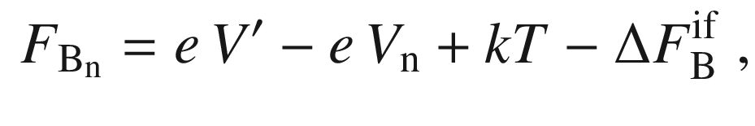

(21.32)

where

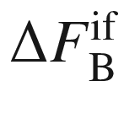

is the barrier lowering ([21.27](#u116076_4_En_21_Chapter-Equ27)) due to the image force effect between the flat-band and the zero-bias cases.

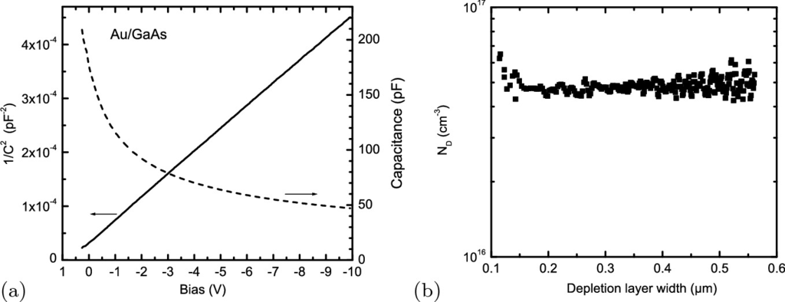

Fig. 21.10

**a** Capacitance *C* (*dashed line*) and 1/

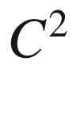

(*solid line*) versus bias voltage dependence for an Au/GaAs Schottky diode (2- µm MOVPE-grown GaAs:Si on a n-GaAs substrate) at room temperature. From the extrapolation to 1/

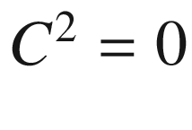

and ([21.30](#u116076_4_En_21_Chapter-Equ30)) we obtain

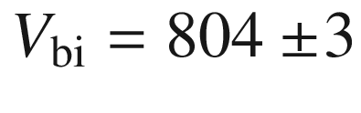

 mV. **b** Donor concentration (

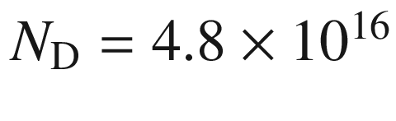

 cm

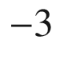

) determined via ([21.31](#u116076_4_En_21_Chapter-Equ31)) from the 1/

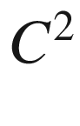

plot versus the depletion layer width (calculated using ([21.29](#u116076_4_En_21_Chapter-Equ29)))

We note that for inhomogeneous doping the depth profile of the doping can be determined by *C*–*V* spectroscopy. The 1/

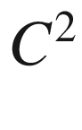

versus bias curve is then no longer a straight line and exhibits a varying slope.

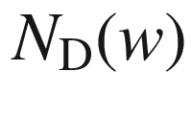

is evaluated according to ([21.31](#u116076_4_En_21_Chapter-Equ31)) using

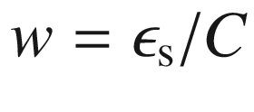

from ([21.29](#u116076_4_En_21_Chapter-Equ29)) [1703],

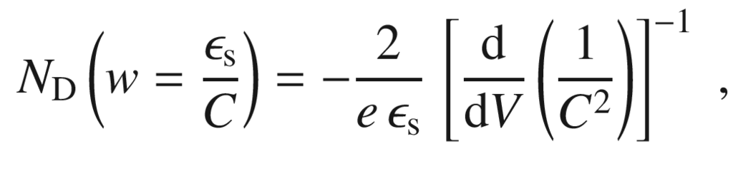

(21.33)

Using functional integration, the capacitance of a depletion layer can be expressed in terms of

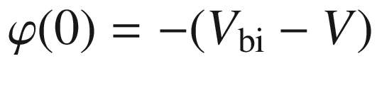

without explicit knowledge of the potential

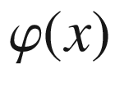

[1697].[8](The_Physics_of_Semiconductors00008.docx#u116076_4_En_21_Chapter-Fn8) In the approximation

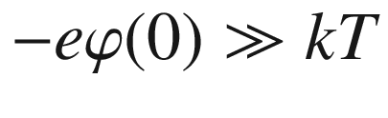

we obtain for homogeneous doping as refinement of ([21.29](#u116076_4_En_21_Chapter-Equ29))

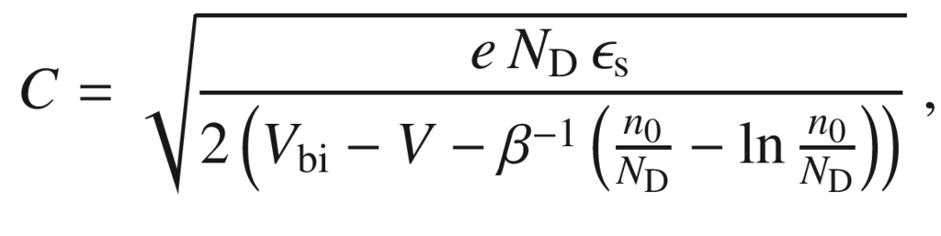

(21.34)

where

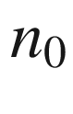

is the electron concentration in the neutral region. Within this general treatment, the validity of ([21.31](#u116076_4_En_21_Chapter-Equ31)) has been confirmed. Also, *C* does not diverge in the flatband case, for

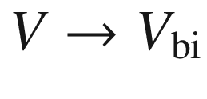

, as for the abrupt approximation but exhibits a maximum [1697].

At a given bias voltage, the charge (ionized donors or acceptors) at the boundary of the space-charge region is tested by the capacitance measurement. However, this principle works only if the depth of the space-charge region actually changes with the bias voltage. The method can therefore not be directly applied to such systems like

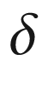

-doped layers or quantum wells.

**Frequency and Temperature Dependence**

The release of carriers from (and capture on) a donor occurs with a characteristic emission rate

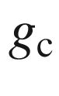

([10.​43](The_Physics_of_Semiconductors00005.docx#u116076_4_En_10_Chapter)) (capture rate

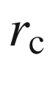

). This is true similarly for acceptors. Therefore, the capacitance depends on the sampling frequency (Fig. [21.11](#u116076_4_En_21_Chapter-Fig11)a). If the capacitance is probed with a frequency much smaller than the release rate, the system appears to be in equilibrium and has the (quasi-)static capacitance

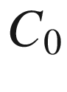

. If the probe frequency is much higher, the system cannot follow and the donor does not contribute to the capacitance. The characteristic frequency

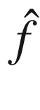

at the turning point of *C*(*f*) is [1016, 1017]

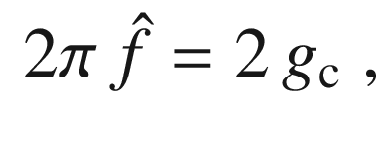

(21.35)

with corrections of the simple factor of 2 discussed in [1704]. Since the emission rate depends exponentially on temperature, for a given frequency the capacitance depends on temperature [1705]. This is shown in Fig. [21.11](#u116076_4_En_21_Chapter-Fig11)b for ZnO which exhibits several donor levels. At low temperature shallow levels release their carriers, at higher temperature the deeper levels start to contribute. The DX center in AlGaAs (see Sect. [7.​7.​6](The_Physics_of_Semiconductors00003.docx#u116076_4_En_7_Chapter)) has been investigated in [1706] with this technique.

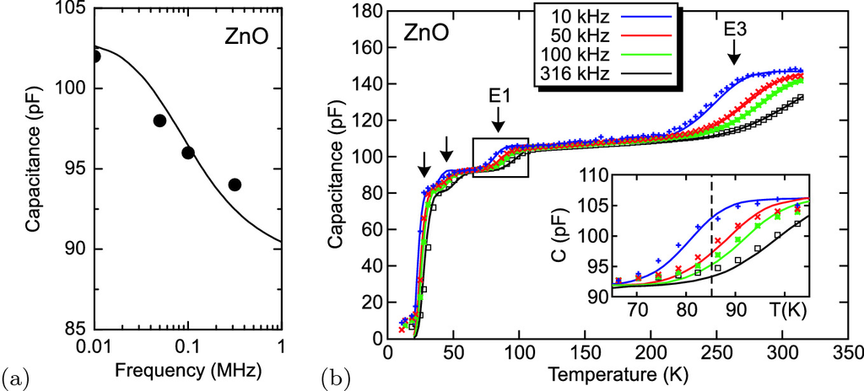

Fig. 21.11

**a** Capacitance versus probing frequency *f* for a Pd/ZnO Schottky diode (zero bias) at

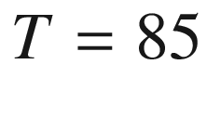

 K. Theoretical dependence (*solid line*) and experimental data (*circles*). **b** Capacitance of the same diode as a function of temperature (thermal admittance spectroscopy, TAS) for four different probing frequencies

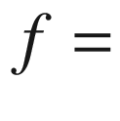

10, 50, 100 and 316 kHz (ac amplitude 50 mV). *Arrows* denote the release of carriers from four different defect levels, two shallow ones and the well-known defects E1 and E3 [737, 1707]. The *inset* shows the contribution of the E1 defect, indicated by a *rectangle* in the main graph, in more detail. *Symbols* are experimental data, *lines* are fit with four-level model (E1:

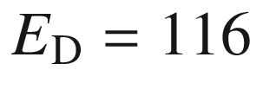

 meV, E3:

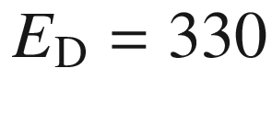

 meV) [1708]

#### 21.2.5 Current-Voltage Characteristic

The current transport through a metal-semiconductor junction is dominated by the majority charge carriers, i.e. electrons (holes) in the case of an n-type (p-type) semiconductor, respectively.

In Fig. [21.12](#u116076_4_En_21_Chapter-Fig12), the possible transport mechanisms are visualized for an n-type semiconductor. Thermionic emission ‘above’ the barrier involves the hot electrons from the thermal distribution and will be important at least at high temperatures. Tunneling ‘through’ the barrier will be important for thin barriers, i.e. at high doping (

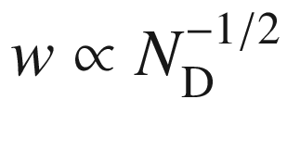

, cf. ([21.15](#u116076_4_En_21_Chapter-Equ15))). ‘Pure’ tunneling for electrons close to the (quasi-) Fermi level, also called field emission, and thermionic field emission, i.e. tunneling of electrons with higher energies, are distinguished. Also, recombination in the depletion layer and hole injection from the metal are possible.

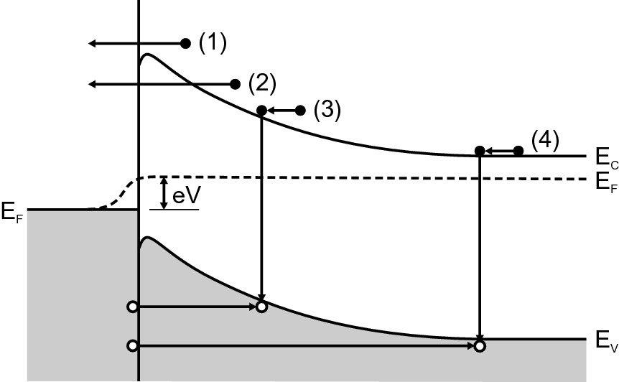

Fig. 21.12

Transport mechanisms at metal-semiconductor junctions. (**1**) Thermionic emission (‘above’ the barrier) (**2**) tunneling (‘through’ the barrier), (**3**) recombination in the depletion layer, (4) hole injection from metal

The transport of electrons above the barrier can be described with diffusion theory [1709, 1710] or thermionic-emission theory [576]. A detailed treatment can be found in [1711, 1712]. In both cases the barrier height is large compared to *kT*. For thermionic emission (typically relevant for semiconductors with high mobility) the current is limited by the emission process and an equilibrium (constant electron quasi-Fermi level) is established throughout the depletion layer and ballistic transport is considered. In diffusion theory (for low mobility) a thermal equilibrium between metal and semiconductor electrons is established in the interface plane and the current is limited by diffusion and drift in the depletion region.

**Thermionic Emission**

The current density per unit area

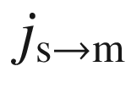

of electrons that flow from the semiconductor into the metal is due to the hot electrons from the thermal distribution function

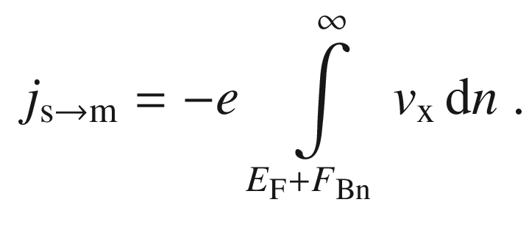

(21.36)

The integral starts at the lowest possible energy, the top of the Schottky barrier (no tunneling allowed in this model!). The electron density

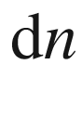

in a small energy interval

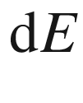

 is

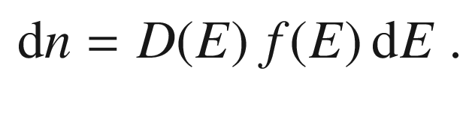

(21.37)

For a bulk semiconductor density of states ([6.​71](The_Physics_of_Semiconductors00003.docx#u116076_4_En_6_Chapter)) and the Boltzmann distribution (

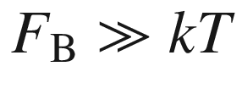

)

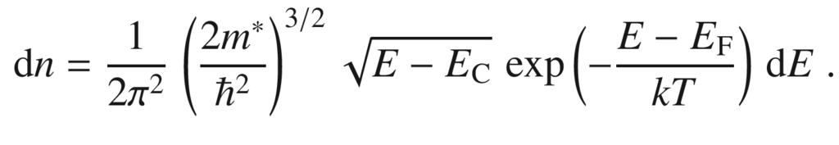

(21.38)

For a given energy *E*, the carrier velocity *v* is determined by

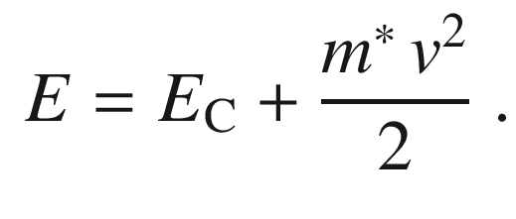

(21.39)

Thus we obtain

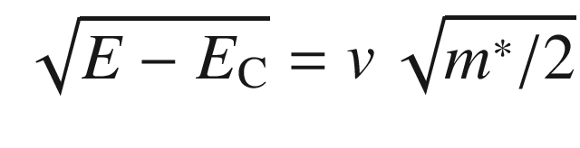

(21.40)

and

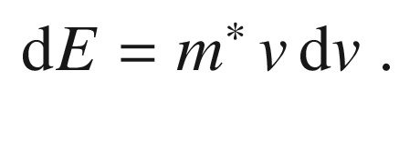

(21.41)

Also, with ([21.39](#u116076_4_En_21_Chapter-Equ39)) and ([21.1](#u116076_4_En_21_Chapter-Equ1)),

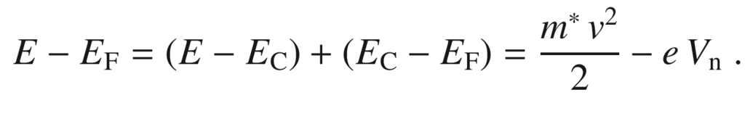

(21.42)

Therefore we write ([21.38](#u116076_4_En_21_Chapter-Equ38)) as

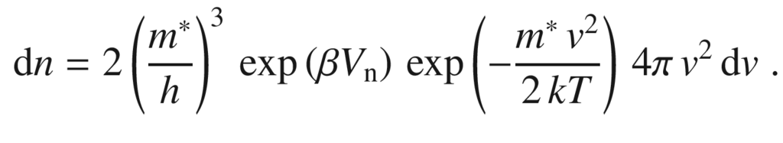

(21.43)

Then the one-dimensional integral over

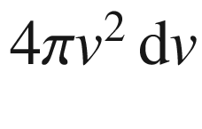

is converted into a three-fold integral over

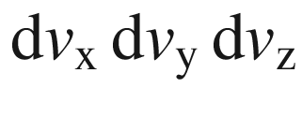

. Integration over all velocities in *y* and *z* directions yields a factor

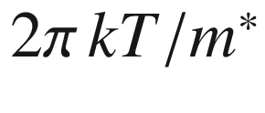

. The integration over

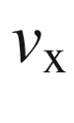

runs from the minimum velocity

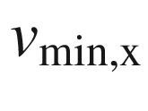

necessary to pass the barrier,

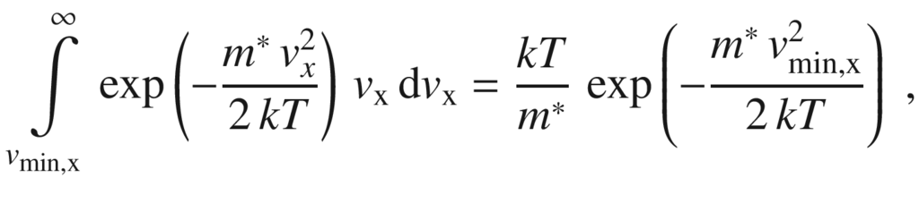

(21.44)

with the minimum velocity determined by

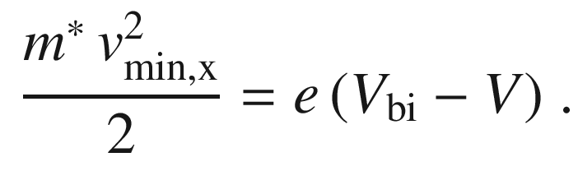

(21.45)

Thus the current density is given as, using ([21.5](#u116076_4_En_21_Chapter-Equ5)),

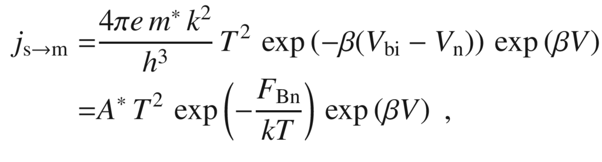

(21.46)

with

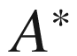

being the Richardson constant given by

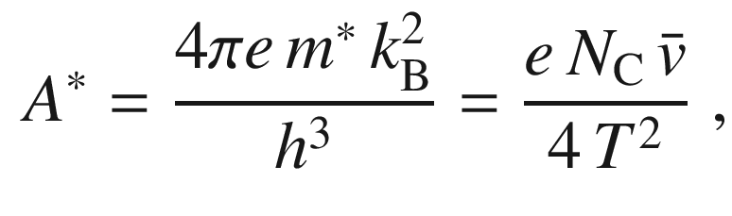

(21.47)

where

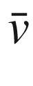

is the average thermal velocity in the semiconductor.

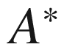

for electrons in vacuum is 120 A cm

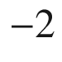

 K



. A similar result is obtained for the thermionic emission of electrons from a metal (overcoming the work function) into vacuum.

If the bias is changed, the current from the semiconductor to the metal increases in the forward direction because the energy difference between the quasi-Fermi level and the top of the barrier is reduced. The current is reduced for reverse bias. The barrier from the metal into the semiconductor remains constant (except for the Schottky effect whose impact on the current-voltage characteristic is discussed next). Therefore the current

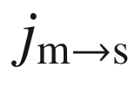

from the metal into the semiconductor is constant and can be obtained from the condition

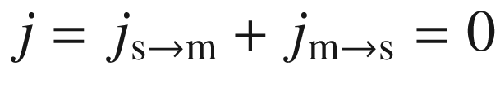

for zero bias. Therefore the current-voltage characteristic in the thermionic-emission model is

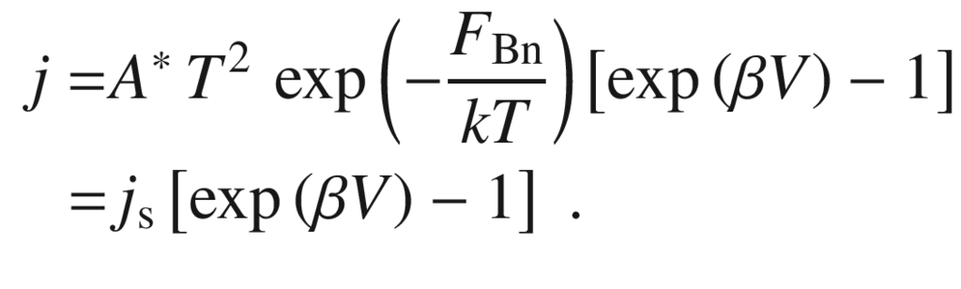

(21.48)

The pre-factor

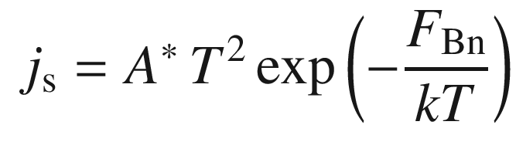

(21.49)

is called the saturation current density. The saturation current increases with increasing temperature.

The dependence ([21.49](#u116076_4_En_21_Chapter-Equ49)) represents the ideal diode characteristic and is plotted in Fig. [21.13](#u116076_4_En_21_Chapter-Fig13).

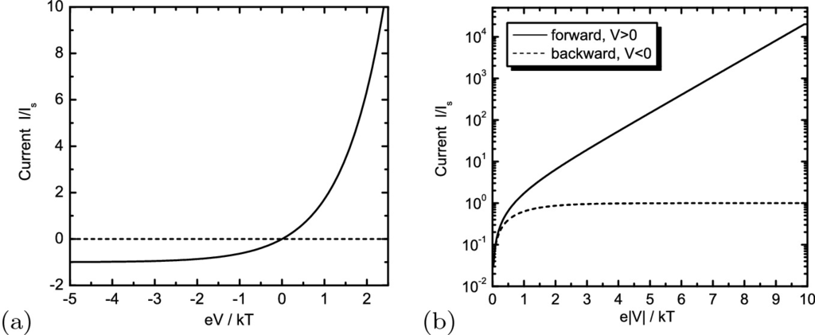

Fig. 21.13

Ideal diode *I*–*V* characteristics

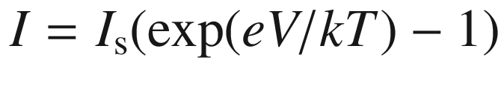

(**a**) in linear plot and (**b**) semilogarithmic plot

The temperature dependence of the saturation current

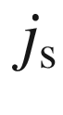

can be written as

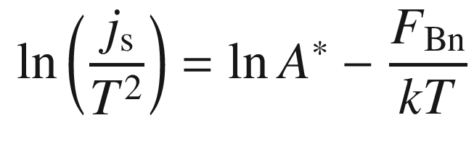

(21.50)

by transforming ([21.49](#u116076_4_En_21_Chapter-Equ49)). The plot of

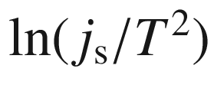

to versus 1/*T* is called a Richardson plot and allows the barrier height and the Richardson constant to be determined from a linear fit (Fig. [21.14](#u116076_4_En_21_Chapter-Fig14)b).

**Ideality Factor**

If the Schottky (image force) effect, i.e. the change of barrier height with bias voltage, is considered, the semilogarithmic slope of the forward *I*–*V* characteristic is no longer

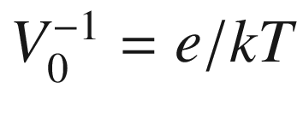

but can be expressed as

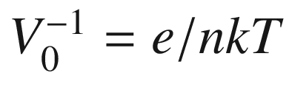

, *n* being a dimensionless parameter termed the ideality factor,[9](The_Physics_of_Semiconductors00008.docx#u116076_4_En_21_Chapter-Fn9)

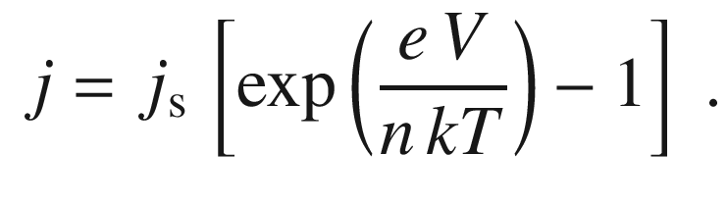

(21.51)

*n* is given by

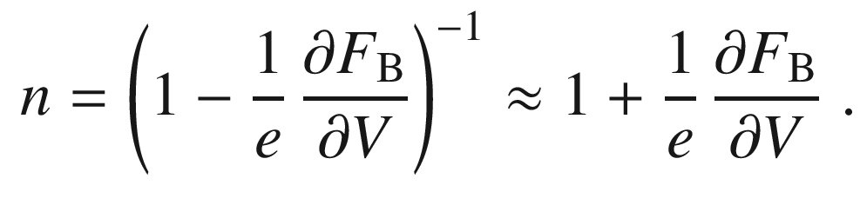

(21.52)

The ideality factor due to the image force effect

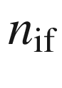

(using ([21.27](#u116076_4_En_21_Chapter-Equ27)) and the image force barrier lowering

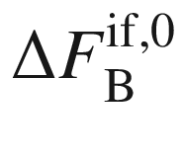

at zero bias) [1680] is

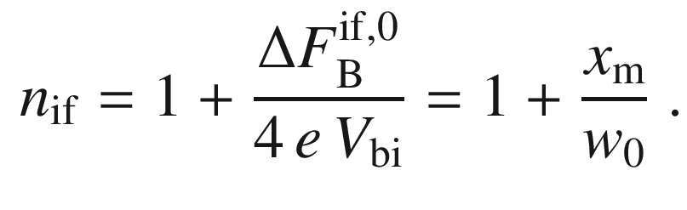

(21.53)

Typical values are smaller than 1.03. For GaAs and

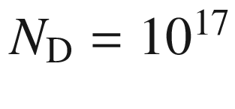

 cm

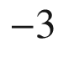

,

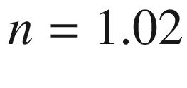

. With regard to

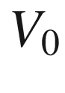

and its temperature dependence, we refer also to Fig. [21.17](#u116076_4_En_21_Chapter-Fig17) and the related discussion.

In Fig. [21.14](#u116076_4_En_21_Chapter-Fig14)a the temperature dependence of the *I*–*V*-characteristic of an almost ideal ZnO Schottky diode [1713] is depicted. The extracted barrier height is almost independent of temperature as it should be. Also the ideality factor is rather small (about 1.1) and also independent of temperature. The Richardson plot Fig. [21.14](#u116076_4_En_21_Chapter-Fig14)b according to ([21.50](#u116076_4_En_21_Chapter-Equ50)) for this diode is a straight line. The extracted constant

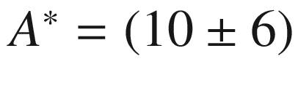

 A cm

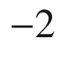

 K

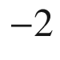

is reasonably close to the theoretical value of 32 A cm

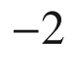

 K

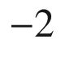

(using

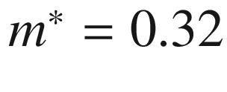

).

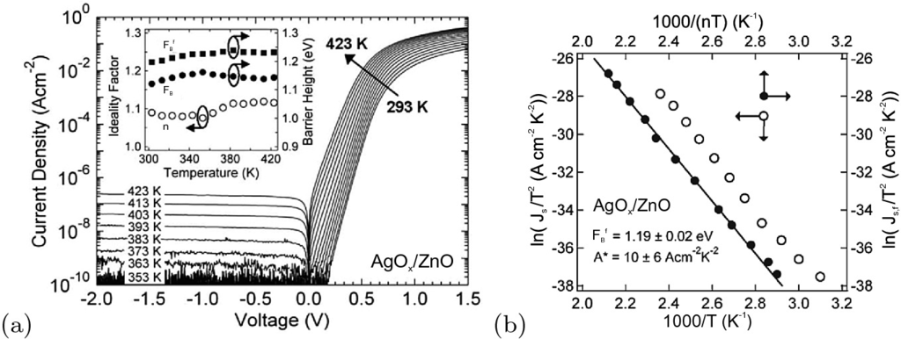

Fig. 21.14

Temperature dependent behavior of an AgO



/ZnO Schottky diode. **a** *I*–*V*-characteristics. *Inset* depicts extracted parameters, ideality factor *n*, barrier height

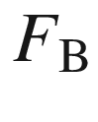

and flatband barrier height

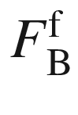

([21.54](#u116076_4_En_21_Chapter-Equ54)). **b** Richardson plots for the extracted barrier height and the calculated flatband barrier height with linear fit.

Adapted from [1713]

In order to gain a barrier height independent from non-idealities, in [1714] the flatband barrier height

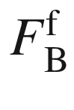

is discussed which is calculated from the diode parameters via

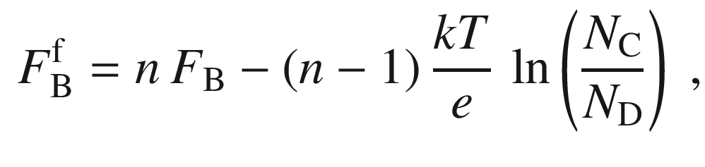

(21.54)

assuming all donors are ionized (otherwise

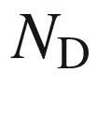

shall be replaced by the electron density *n*, not to be confused here with the ideality factor). Accordingly, the saturation current density ([21.49](#u116076_4_En_21_Chapter-Equ49)) is rewritten as

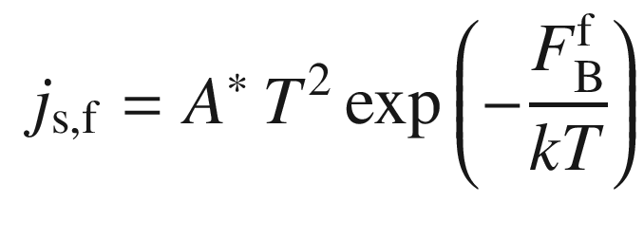

(21.55)

**Laterally Inhomogeneous Barrier**

The increase of the ideality factor due to a spatially inhomogeneous barrier height has been proposed early on [1715–1719]. The barrier height

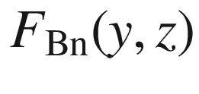

across the contact area is typically assumed to have a Gaussian probability distribution [1720]

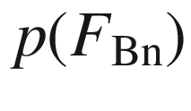

with a mean value

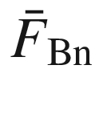

and a standard deviation

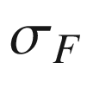

.

It turns out that the barrier height

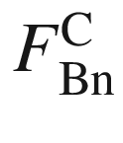

responsible for the capacitance, and thus the diffusion voltage determined by *C*–*V* spectroscopy, is given by the spatial average, i.e.

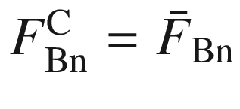

. The barrier height

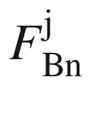

determining the current-voltage characteristics (cf. ([21.48](#u116076_4_En_21_Chapter-Equ48))) via

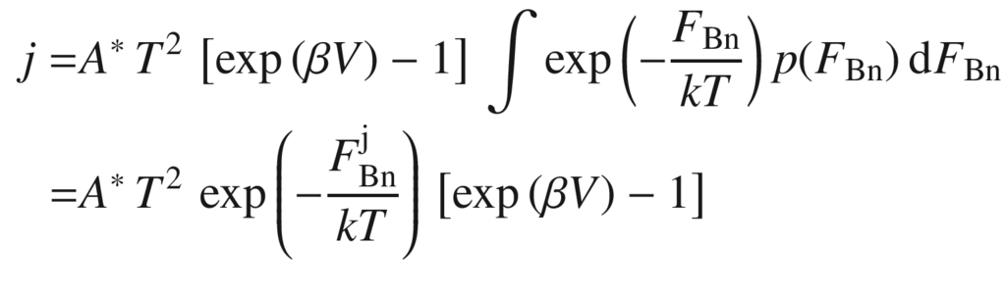

(21.56)

is given by

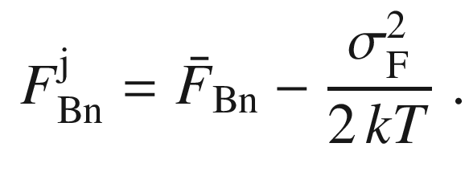

(21.57)

Thus, the barrier height determined from the current-voltage characteristic underestimates the spatial average of the barrier height.[10](The_Physics_of_Semiconductors00008.docx#u116076_4_En_21_Chapter-Fn10) The Richardson plot ([21.50](#u116076_4_En_21_Chapter-Equ50)) is now modified (and is nonlinear in 1/*T*) to

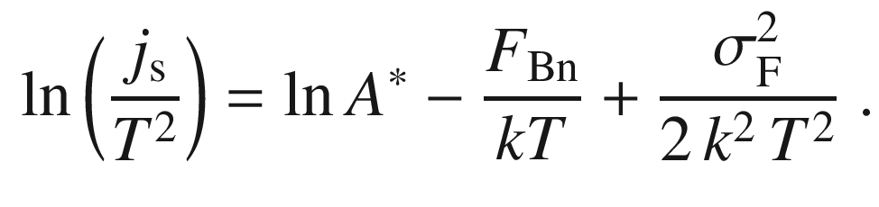

(21.58)

In [1721] the barrier nonuniformity due to the random distribution and discreteness of impurity charges in the depletion region is evaluated. This mechanism, yielding increasing barrier inhomogeneity for larger doping, represent a fundamental limit to the ideality of a Schottky diode.

If the distribution of barrier heights is discrete, at low voltages the current will first flow at certain spots with low barrier (‘hot spots’). This leads to kinks in the *I*–*V* characteristics as found for SiC [1722] or ZnO [1723] (Fig. [21.15](#u116076_4_En_21_Chapter-Fig15)).

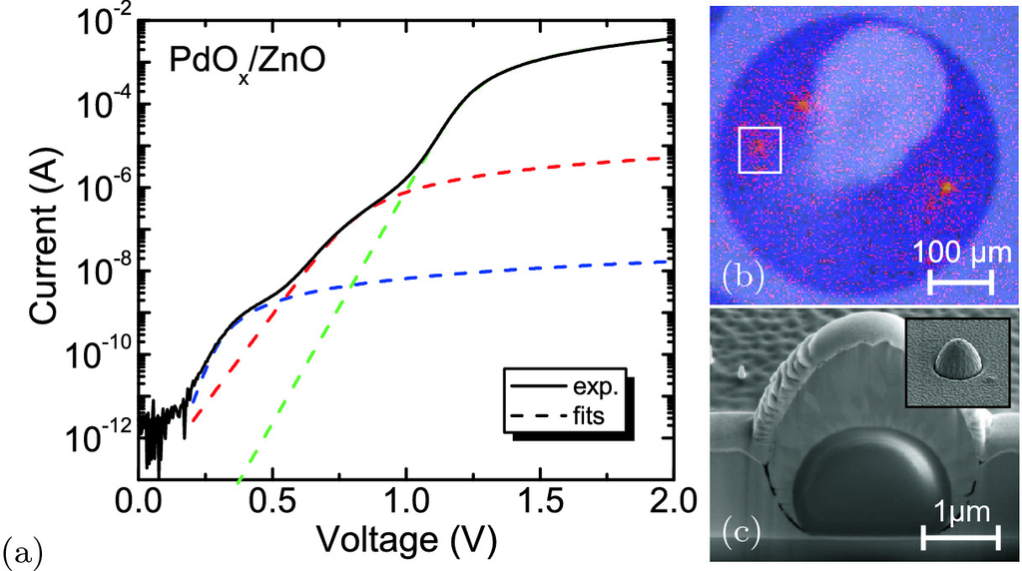

Fig. 21.15

**a** *I*–*V* characteristic of ZnO Schottky diode (*solid line*) with fits due to regions with three different barrier heights (*dashed lines*). **b** Thermography image at bias of 1 V. The *white square* marks the area where one hot spot was investigated in detail. **c** SEM image of FIB prepared cross section of a defect (Al



O



particle) causing the lowest barrier hot spots, *inset*: plane view of such defect before preparation.

Adapted from [1723]

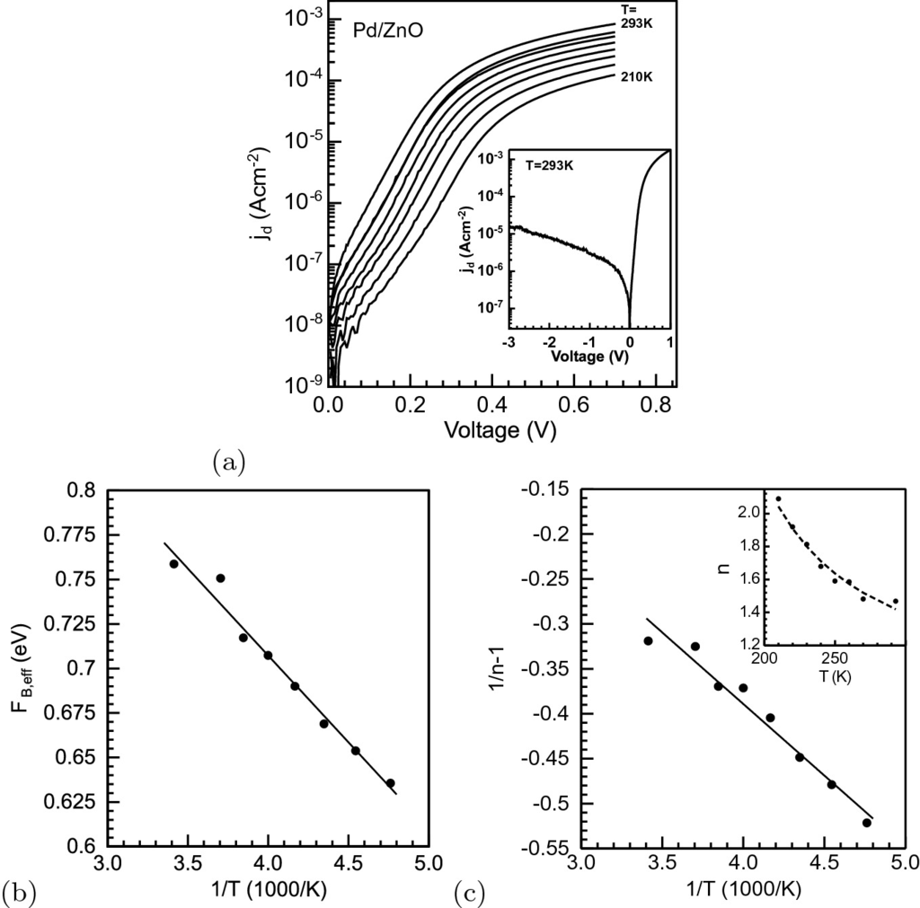

Fig. 21.16

**a** Forward *I*–*V* characteristic of Pd/ZnO Schottky diodes for various temperatures. Diode temperatures are 210, 220, 230, 240, 250, 260, 270, and 293 K. The *inset* shows the current density versus voltage for 293 K on a semilogarithmic scale. **b** Effective barrier height

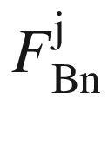

versus the inverse temperature. The *solid line* is a linear fit according to ([21.57](#u116076_4_En_21_Chapter-Equ57)) yielding the standard deviation

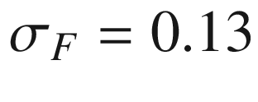

 eV and the mean barrier height

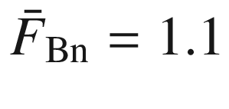

 eV. (**c**) Plot of

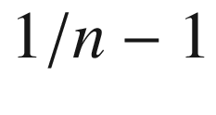

versus the inverse temperature. The *solid line* is a linear fit of the data yielding the voltage deformation coefficients

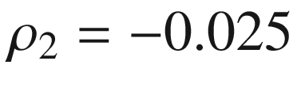

and

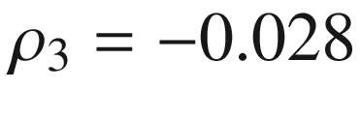

 eV. The *inset* shows the experimentally determined *n* factors and the *n* factors calculated from ([21.59](#u116076_4_En_21_Chapter-Equ59)) using the voltage-deformation coefficients obtained from the linear fit (*dashed line*).

Adapted from [1724]

**Temperature Dependence**

Figure [21.16](#u116076_4_En_21_Chapter-Fig16)a shows the temperature-dependent *I*–*V* characteristics of a Pd/ZnO Schottky diode. A straightforward evaluation according to ([21.48](#u116076_4_En_21_Chapter-Equ48)) results in a barrier height of about 700 meV and a Richardson constant that is orders of magnitude smaller than the theoretical value of 32 A K

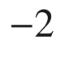

 cm



(for

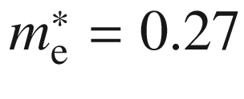

). A fit of the temperature-dependent data with ([21.57](#u116076_4_En_21_Chapter-Equ57)), as shown in Fig. [21.16](#u116076_4_En_21_Chapter-Fig16)b, results in

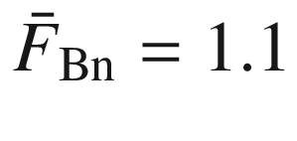

 eV, in agreement with the (temperature-independent) value obtained from CV spectroscopy, and

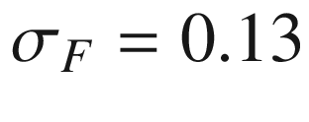

 eV [1724].

The temperature dependence of the ideality factor *n* is given by [1725]

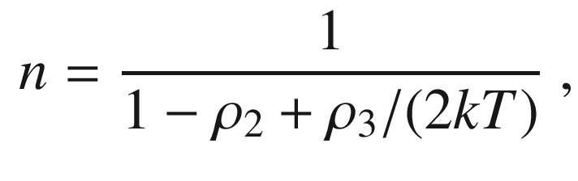

(21.59)

where

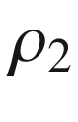

(

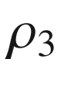

) is the (temperature-independent) proportionality coefficient of the bias dependence of the mean barrier height (standard deviation), i.e.

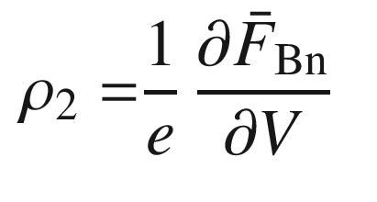

(21.60a)

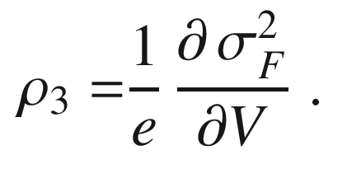

(21.60b)

The fit of

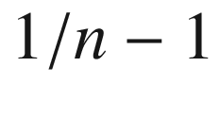

versus 1/*T* in Fig. [21.16](#u116076_4_En_21_Chapter-Fig16)c yields

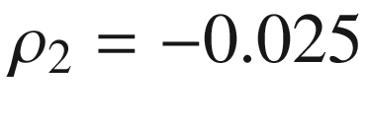

and

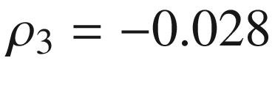

 eV for the ZnO diodes under investigation.

The forward *I*–*V* characteristic of an Au/GaAs Schottky diode reported in [1726, 1727] is shown in Fig. [21.17](#u116076_4_En_21_Chapter-Fig17)a at various temperatures. The current amplitude decreases with decreasing temperature due to the temperature dependence of the saturation current ([21.48](#u116076_4_En_21_Chapter-Equ48)). Also, the slope

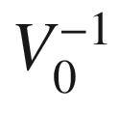

of the characteristic

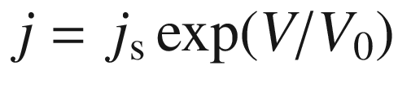

varies with temperature. Looking at the temperature dependence of

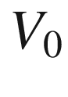

, it is described as

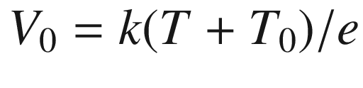

rather than with an ideality factor *n* in the form of

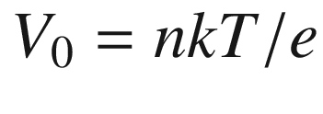

. In other words, the ideality factor follows a temperature dependence

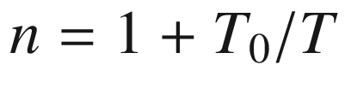

. In view of ([21.59](#u116076_4_En_21_Chapter-Equ59)), such behavior means for small

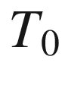

that

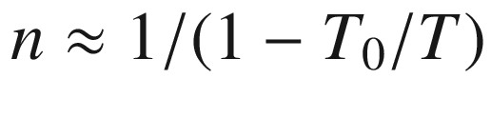

and thus

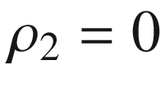

and

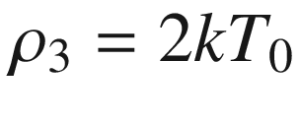

. For

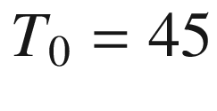

 K,

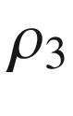

is 0.008 eV, which is a fairly small value. Thus, the temperature behavior of the diode is due to the narrowing of the Gaussian distribution of barrier height with bias voltage [1720].

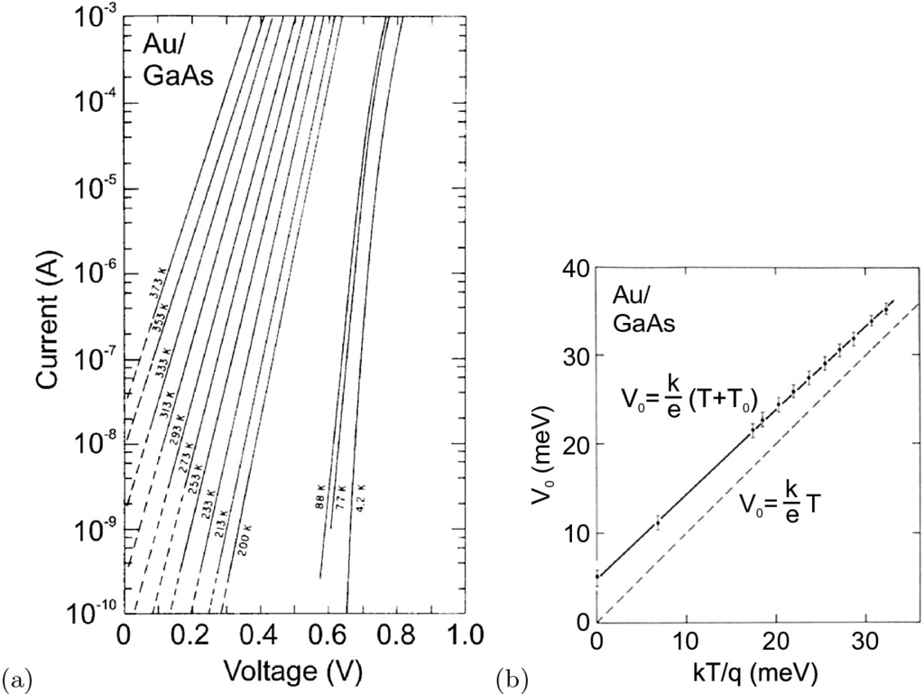

Fig. 21.17

**a** Forward *I*–*V* characteristic of Au/GaAs diode for various temperatures. **b** Temperature dependence of the voltage

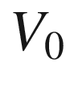

. The experimental data are fitted with

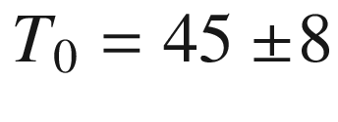

 K.

Adapted from [1726]

In a set of similar diodes with varying magnitude of barrier inhomogeneities, it is found that the effective barrier height and the ideality factor correlate [1728]. The extrapolation to

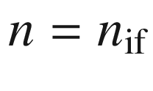

yields the limit of the barrier height for a homogeneous barrier (Fig. [21.18](#u116076_4_En_21_Chapter-Fig18)). For silicon, it is found that the surface orientation has a minor influence on the Schottky barrier height (Fig. [21.18](#u116076_4_En_21_Chapter-Fig18)b) for an unreconstructed surface. The presence of a reconstruction lowers the barrier height[11](The_Physics_of_Semiconductors00008.docx#u116076_4_En_21_Chapter-Fn11) (Fig. [21.18](#u116076_4_En_21_Chapter-Fig18)a).

**Correlation of Barrier Height and Ideality Factor**

**Diffusion Theory**

In diffusion theory the current density is considered in the presence of a carrier-density and electric-field gradient. In the Boltzmann approximation the electron current is given by ([8.​60a](The_Physics_of_Semiconductors00004.docx#u116076_4_En_8_Chapter)). In stationary equilibrium the current density is constant, i.e. independent of *x*. Assuming that the carrier density has its equilibrium values at

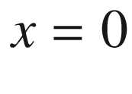

and

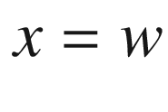

, we find after integration and using ([21.8](#u116076_4_En_21_Chapter-Equ8))

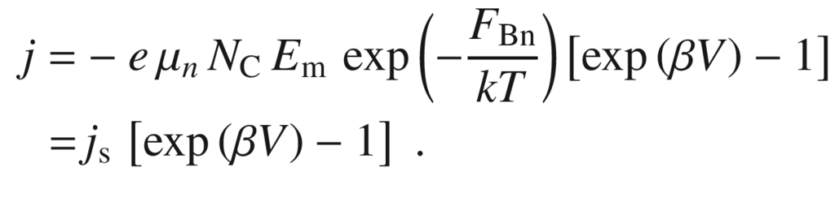

(21.61)

Therefore, also in this case the ideal diode characteristic is obtained, however, with a different saturation current. The ideality factor in diffusion theory is

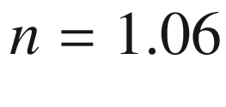

(for

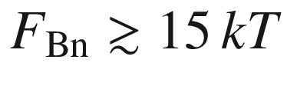

) [1684].

**Combined Theory**

A combination of both theories [1729] considers both mechanisms to be in series. The current can then be expressed as

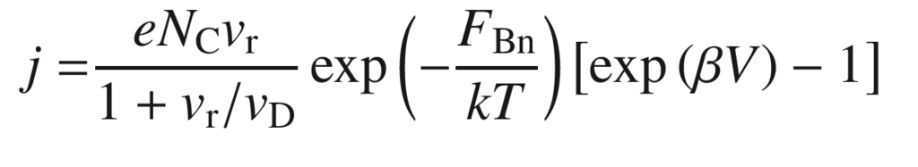

(21.62a)

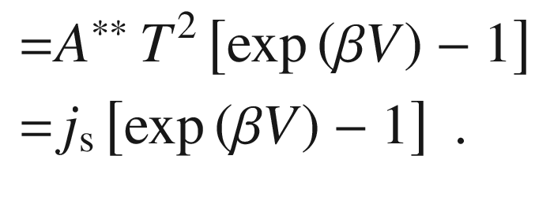

(21.62b)

Here

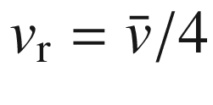

is a ‘recombination velocity’ [1730] at the top of the barrier according to

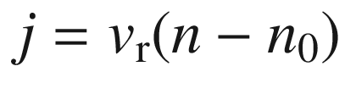

,

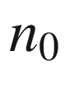

being the equilibrium electron density at the top of the barrier and



is the average thermal velocity in the semiconductor.

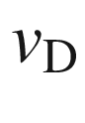

is an effective diffusion velocity describing the transport of electrons from the edge of the depletion layer (

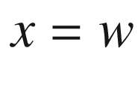

) to the top of the barrier (

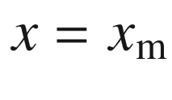

). It is defined as

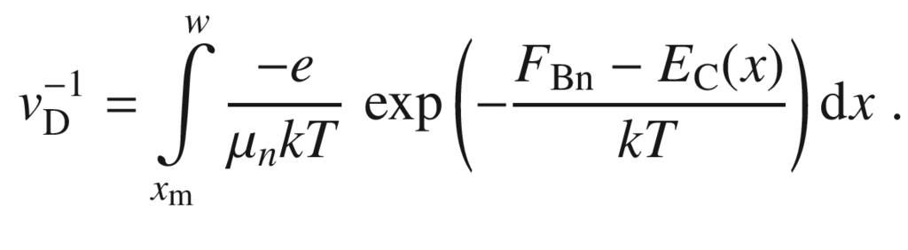

(21.63)

In [1729]

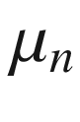

has been assumed to be independent of the electric field. This assumption is potentially not realistic. If

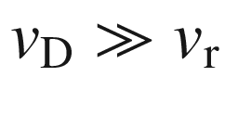

, thermionic theory applies and we obtain ([21.48](#u116076_4_En_21_Chapter-Equ48)). The case

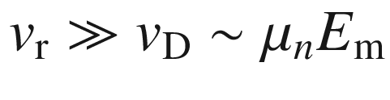

relates to diffusion theory and we recover ([21.61](#u116076_4_En_21_Chapter-Equ62)).

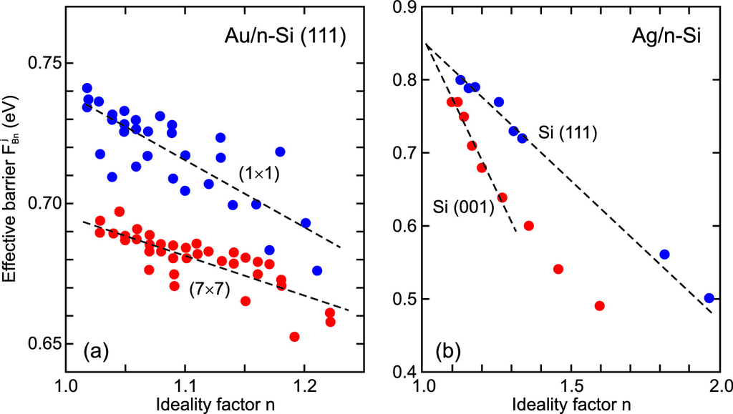

Fig. 21.18

**a** Effective barrier height versus ideality factor for Ag/n-Si Schottky diodes prepared on Si(111) surface with (

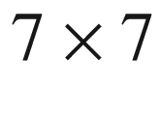

) reconstruction or unreconstructed (

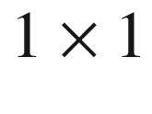

) as labeled. The more ideal (

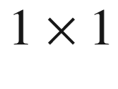

) surface exhibits the higher barrier. The *dashed lines* are linear fits. **b** Effective barrier height versus ideality factor for Au/n-Si Schottky diodes prepared on HF-dipped (

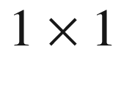

) unreconstructed (001) and (111) surfaces. The *dashed lines* are linear fits and extrapolation to

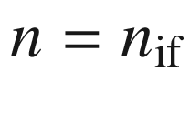

. Both surface orientations exhibit the same extrapolated homogeneous barrier height. Based on data compiled in [1728]

The constant

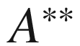

in ([21.62b](#u116076_4_En_21_Chapter-Equ64)) is called the effective Richardson constant. Its calculated dependence on the electric field is shown in Fig. [21.19](#u116076_4_En_21_Chapter-Fig19) for Si. At room temperature for most Ge, Si and GaAs Schottky diodes the thermionic emission of majority carriers is the dominating process. The effect of lateral barrier height inhomogeneity in a diffusion model has been discussed in [1731].

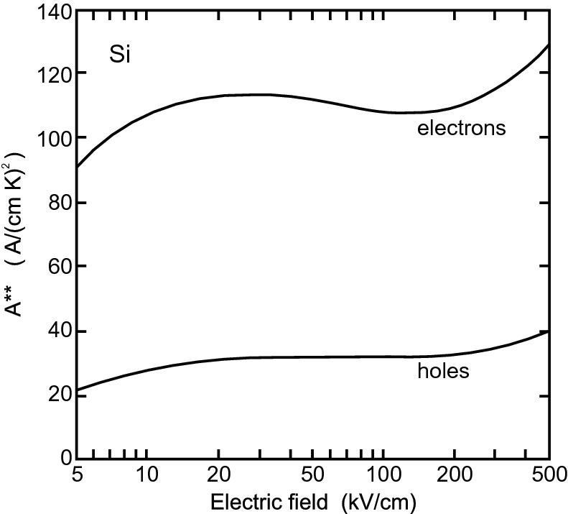

Fig. 21.19

Calculated effective Richardson constant

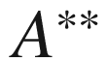

as a function of the electric field for a metal-Si diode at

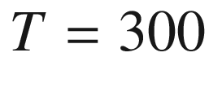

 K for a (n-type or p-type) doping of

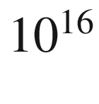

 cm

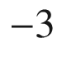

.

Adapted from [1732]

**Tunneling Current**

At high doping the width of the depletion layer becomes small and tunneling processes become more probable. Also at low temperatures, when thermionic emission is very small, tunneling processes can dominate the transport between metal and semiconductor. One process is tunneling of electrons close to the Fermi level of the semiconductor. This process is called field emission (F) and is at least important for degenerate semiconductors at very low temperatures. If the temperature is raised, electrons are excited to higher energies where they encounter a thinner barrier. The tradeoff between thermal energy and barrier width selects an electron energy

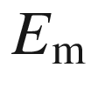

above the conduction-band edge for which the current is largest. This process is known as thermionic field emission (TF). For very high temperatures enough carriers can overcome the barrier completely and we are back in the thermionic emission regime. The validity of the two regimes is shown in Fig. [21.20](#u116076_4_En_21_Chapter-Fig20) for Au/GaAs Schottky diodes as a function of doping concentration (n-type) and temperature.

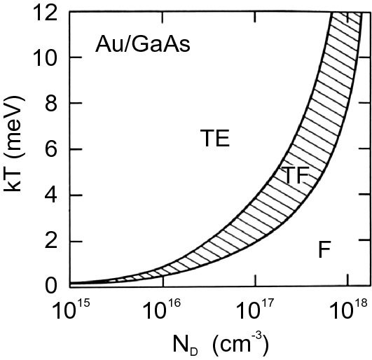

Fig. 21.20

Calculated conditions for thermionic field (‘TF’), field (‘F’) and thermionic (‘TE’) emission in a Au/GaAs Schottky diode as a function of temperature and doping concentration.

Adapted from [1684]

Tunneling through the image-charge effect rounded triangular Schottky barrier is discussed in detail in [1733]. In the field-emission regime the forward current is given by [1684]

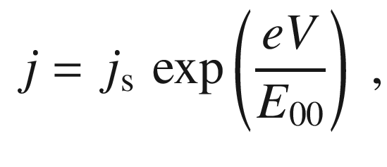

(21.64)

with the characteristic energy parameter

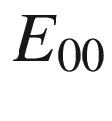

given by

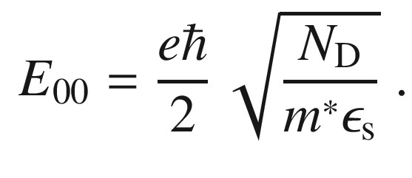

(21.65)

The saturation current is

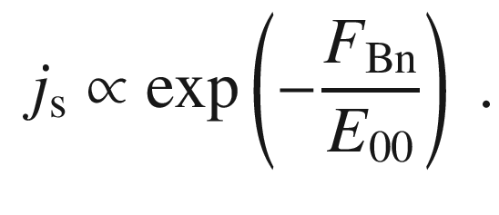

(21.66)

In Fig. [21.21](#u116076_4_En_21_Chapter-Fig21), the forward characteristic of a highly doped Au/Si is shown. The experimental value of

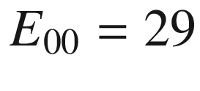

 meV agrees well with the theoretical expectation of

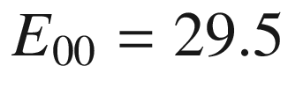

 meV. Note that at

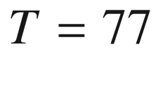

 K

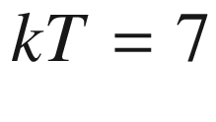

 meV, thus thermionic emission is excluded for the diode current.

In the reverse direction the *I*–*V* characteristic under field emission is given by [1684]

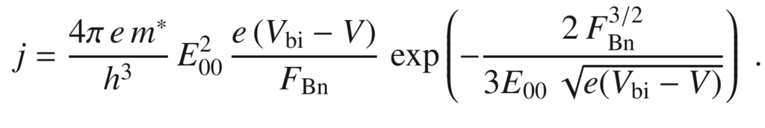

(21.67)

From Fig. [21.21](#u116076_4_En_21_Chapter-Fig21)b, a barrier height of 0.79 eV is deduced.

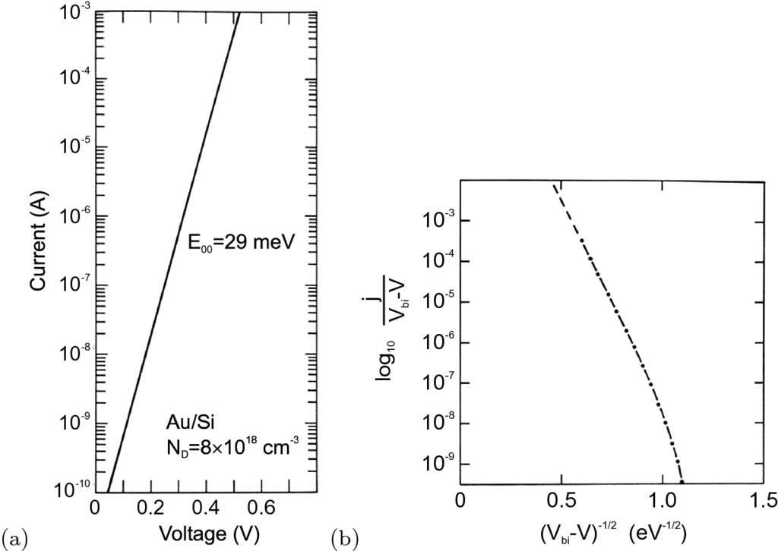

Fig. 21.21

**a** Forward and **b** reverse *I*–*V* characteristic of a Au/Si Schottky diode at 77 K. The doping concentration of the Si was

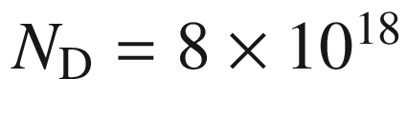

 cm

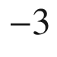

.

Adapted from [1684]

In the TF-emission regime the current-voltage characteristic is given by

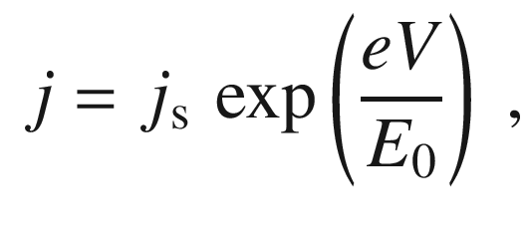

(21.68)

with

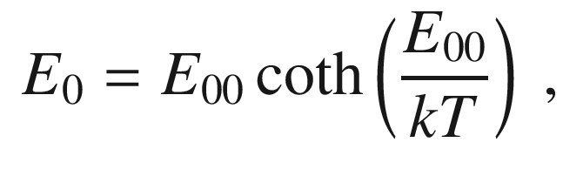

(21.69)

where

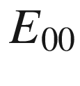

is given by ([21.65](#u116076_4_En_21_Chapter-Equ67)). The energy for maximum TF emission

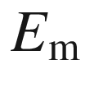

is given by

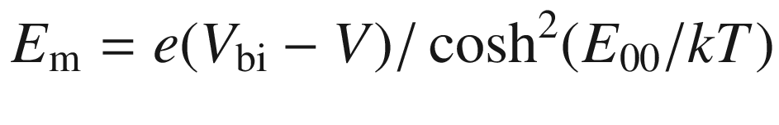

. The

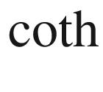

-dependence of

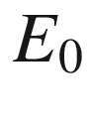

is shown in Fig. [21.22](#u116076_4_En_21_Chapter-Fig22) for an Au/GaAs diode.

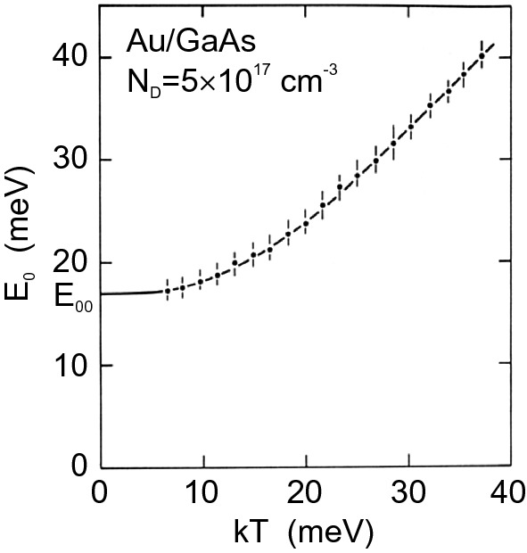

Fig. 21.22

Temperature dependence of

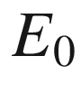

of an Au/GaAs diode with

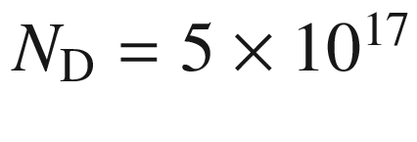

 cm



. The *solid line* is the theoretical dependence for thermionic emission according to ([21.69](#u116076_4_En_21_Chapter-Equ71)) with

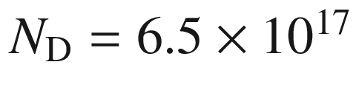

 cm



and

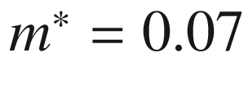

.

Adapted from [1684]

A Schottky diode can suffer from non-idealities such as series and parallel ohmic resistance [1725]. These effects are discussed in some detail below for pn diodes in Sect. [21.4.4](The_Physics_of_Semiconductors00008.docx#u116076_4_En_21_Chapter-Sec19) and apply similarly to Schottky diodes.

#### 21.2.6 Ohmic Contacts

Although an ohmic contact does not have a diode characteristic, it can be understood from the previous remarks. An ohmic contact will have a small contact resistance for both current directions. The voltage drop across the contact will be small compared to the voltage drop in the active layer (somewhere else). Details on electric contacts can be found in [1734].

The contact resistance

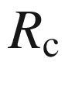

is defined as the differential resistance at

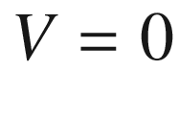

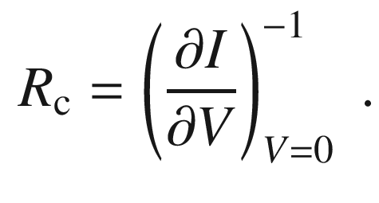

(21.70)

At low doping, the transport is dominated by thermionic emission ([21.48](#u116076_4_En_21_Chapter-Equ48)). In this case

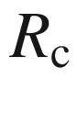

is given by

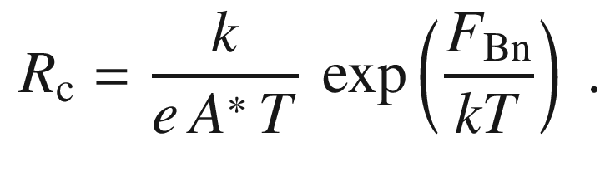

(21.71)

A small barrier height (Fig. [21.23](#u116076_4_En_21_Chapter-Fig23)a) will lead to small contact resistance. A negative Schottky barrier height, i.e.

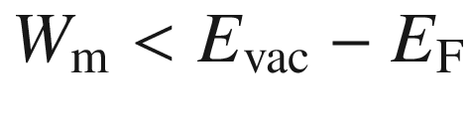

for a n-type semiconductor, leads to an accumulation layer without a barrier for carrier transport (Fig. [21.23](#u116076_4_En_21_Chapter-Fig23)b).

For high doping

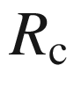

is determined by the tunneling current (Fig. [21.23](#u116076_4_En_21_Chapter-Fig23)c) and is proportional to

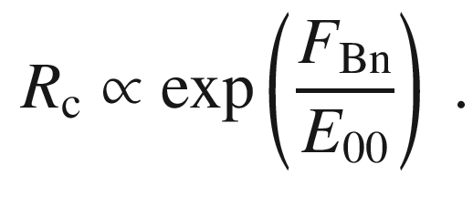

(21.72)

The contact resistance decreases exponentially with the doping. A theoretical calculation and experimental data are compared in Fig. [21.24](#u116076_4_En_21_Chapter-Fig24) for contacts on Si.

The three mechanisms, low barrier height, accumulation layer and high doping, for the formation of Ohmic contacts are summarized schematically in Fig. [21.23](#u116076_4_En_21_Chapter-Fig23). Ohmic contacts on wide band gap semiconductors are difficult, since metals with sufficiently small (large) work function for contacting n-type (p-type) material are mostly not available.

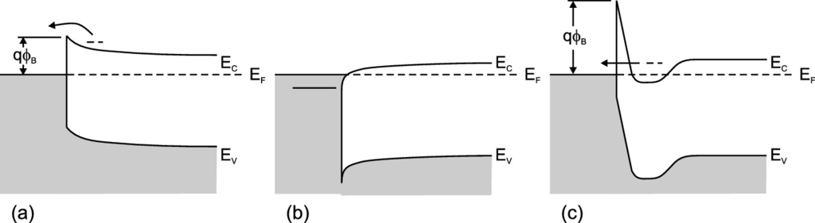

Fig. 21.23

Schematic conditions for the formation of an Ohmic contact, **a** low barrier height, **b** accumulation layer **c** high doping (thin depletion layer)

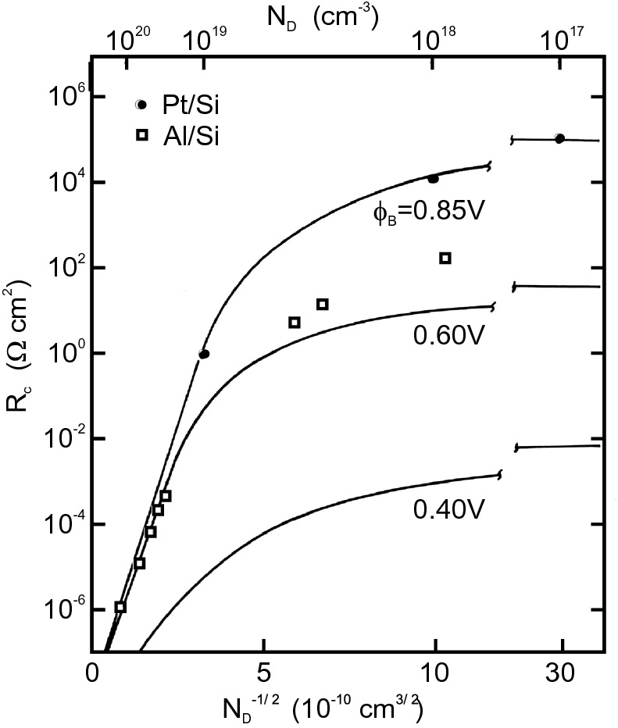

Fig. 21.24

Theoretical and experimental values of specific contact resistances at

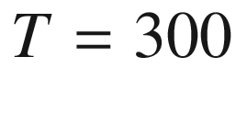

 K for Al/n-Si [1735] and PtSi/n-Si [1736] contacts as a function of donor concentration. *Solid lines* are theoretical dependencies for different values of the barrier height as labeled. Adapted from [574]

Although Schottky contact devices have their place in semiconductor technology, Ohmic contacts are indispensable for almost all devices.[12](The_Physics_of_Semiconductors00008.docx#u116076_4_En_21_Chapter-Fn12) Ohmic contacts are typically prepared by evaporating a contact metal containing the doping material for the semiconductor, e.g. Au/Zn for a contact on p-type GaAs [1737] and Au/Ge for a contact [1738] on n-type GaAs. The contact is alloyed around 400–500

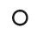

C (see Fig. [21.25](#u116076_4_En_21_Chapter-Fig25)) above the eutectic temperature of

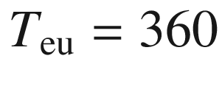



C (for Au/Ge) to form a eutectic liquid in which the dopant can quickly diffuse. When the eutectic liquid cools it forms a solid, a highly doped semiconductor layer underneath the metal. The liquid-phase reactions can lead to inhomogeneous contacts. On n-type GaAs Pd/Ge/Au contacts have been reported to have superior structural quality [1739]. Ohmic contacts for a number of different semiconductors are reviewed in [1740, 1741].

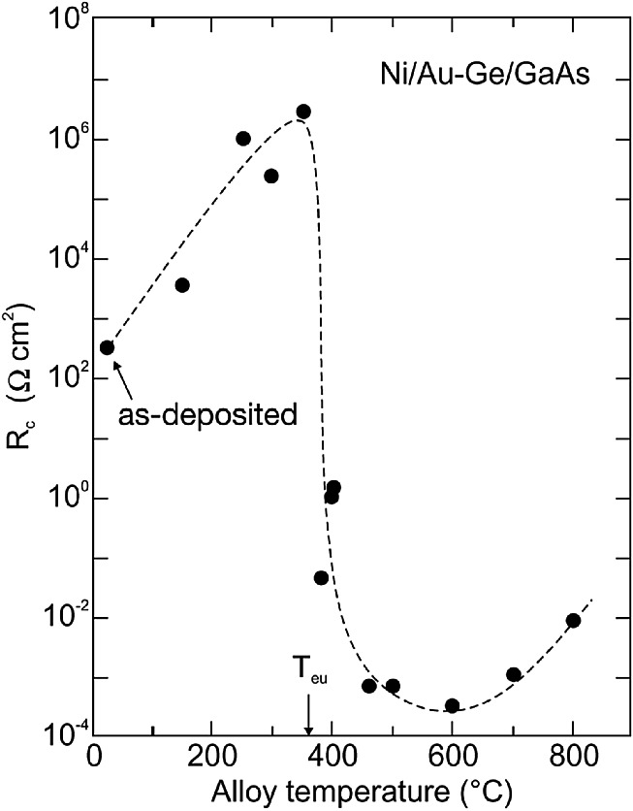

Fig. 21.25

Specific contact resistance for Ni/Au-Ge on n-type epitaxial GaAs for varying alloying temperatures (2 min). *Arrow* at

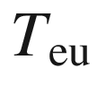

denotes the eutectic temperature of Au-Ge.

Adapted from [1742]

The current-voltage characteristics of an intrinsic (low carrier density, trap-free) semiconductor with ohmic contacts is dominated by so-called *space-charge limited current*  (SCLC) as proposed by Mott and Gurney [1743, 1744]. In a one-dimensional model, the semiconductor of length *L* is considered with ohmic contacts and applied voltage

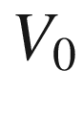

(applied electrical field

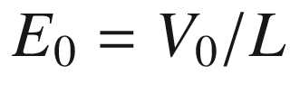

). The thermal carriers shall be negligible compared to the injected ones. The space charge density

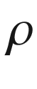

in the current density

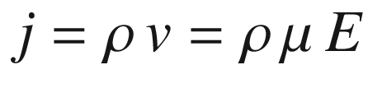

is then in the space-charge limited regime due to the dependence of the electric field

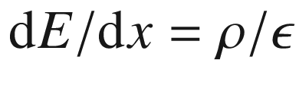

within the semiconductor (also

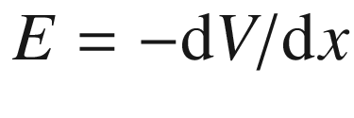

). Therefore the current density can be written as

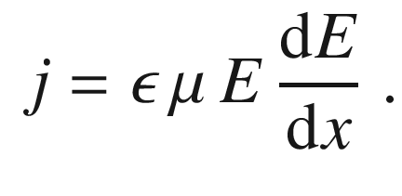

(21.73)

Integration (remember that *j* is independent of *x*) and the boundary condition

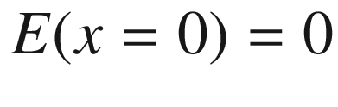

yields

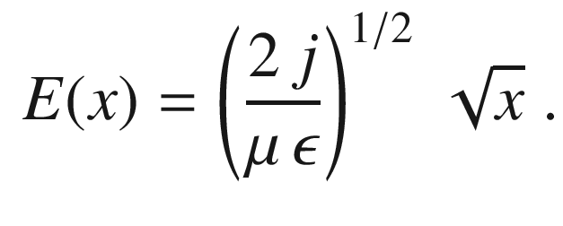

(21.74)

We integrate again and find

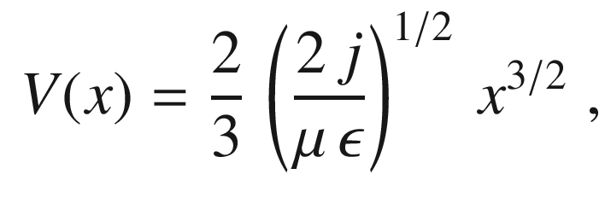

(21.75)

and for *j* (and

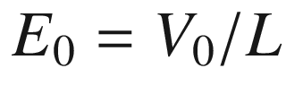

) therefore the Mott-Gurney law[13](The_Physics_of_Semiconductors00008.docx#u116076_4_En_21_Chapter-Fn13)

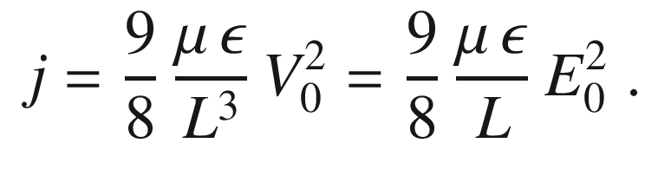

(21.76)

A quantum theory of space-charge limited current has been put forward in [1747]. For small voltages, Ohm’s law

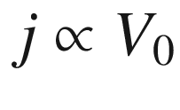

is valid.

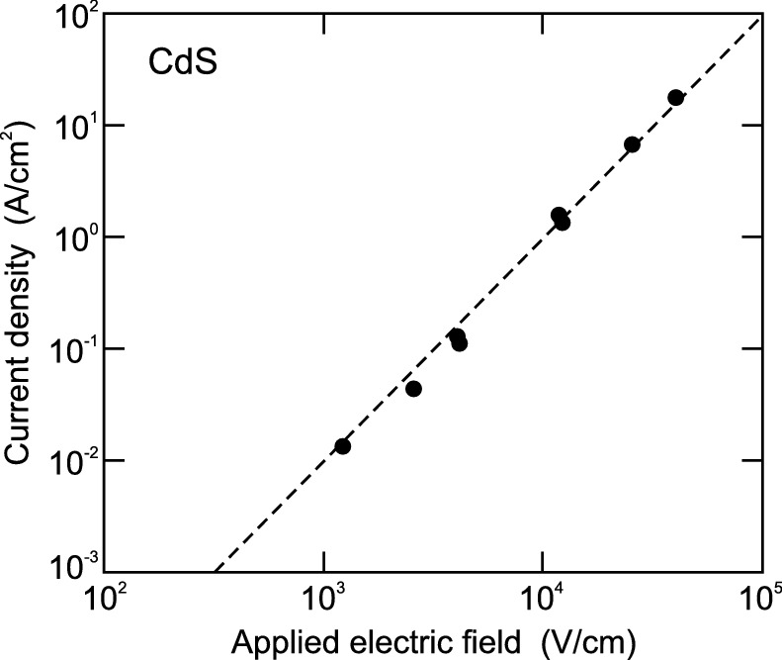

Fig. 21.26

Current density from the beginning (

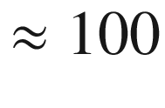

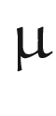

s) of a pulsed experiment versus applied field (applied voltage divided by sample thickness) for 50

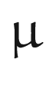

m thick CdS crystal between indium-tipped electrodes. The dashed line shows a

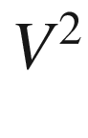

-dependence.

Adapted from [1748]

The

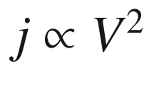

-dependence has been first observed for CdS [1748, 1749]. In order to avoid the effect of injected charge being trapped, pulsed measurements are applied [1748]; in this case, the

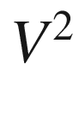

-dependence is well fulfilled (trap-free SCLC) (Fig. [21.26](#u116076_4_En_21_Chapter-Fig26)) while the steady-state current would be many orders of magnitude smaller. In [1750], an investigation of crystalline silicon and also a theory for bipolar transport can be found. Equation ([21.76](#u116076_4_En_21_Chapter-Equ78)) can also serve to determine the mobility if the conditions for space-charge limited current are fulfilled. Modifications are necessary in the presence of traps as discussed in [1751] for the case of amorphous silicon.

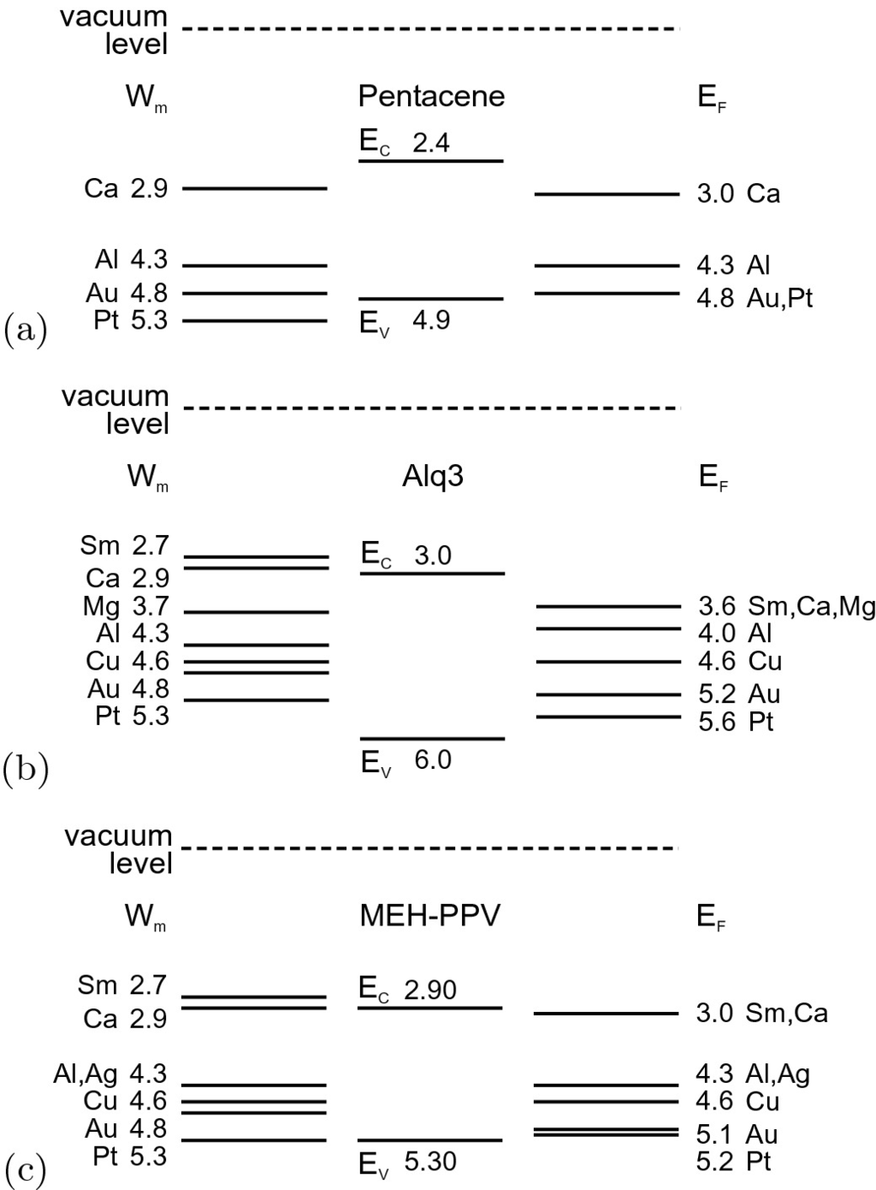

Fig. 21.27

Measured Fermi energies

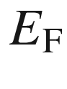

(*labeled data* in eV) and the work functions

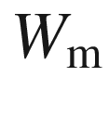

of various metals contacting (**a**) pentacene, (**b**) Alq



and (**c**) MEH-PPV.

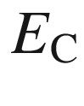

(

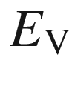

) denotes the energy position of the electron (hole) polaron. Measured data for

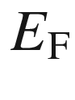

for MEH-PPV from [1753], other from [1754]. Data for



from Table [21.2](#u116076_4_En_21_Chapter-Tab2)

#### 21.2.7 Metal Contacts to Organic Semiconductors

Also, for organic semiconductors the metal contact plays a vital role, either for carrier injection or for manipulation of the space-charge region. The position of the Fermi level has been determined for various organic semiconductors as shown in Fig. [21.27](#u116076_4_En_21_Chapter-Fig27). These data have been obtained from measurements on metal-semiconductor-metal structures (MSM, see also Sect. [22.​3.​5](The_Physics_of_Semiconductors00008.docx#u116076_4_En_22_Chapter)) as shown in Fig. [21.28](#u116076_4_En_21_Chapter-Fig28)a. The thin (50 nm) organic layer is fully depleted, thus the built-in field inside the semiconductor is constant. The built-in field is measured by applying an external dc bias and finding the external potential at which the electroabsorption signal vanishes. Figure [21.28](#u116076_4_En_21_Chapter-Fig28)b shows the measured electroabsorption signal

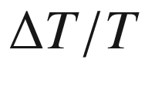

(relative change of transmission *T*) and the optical density of an MEH-PPV film as a function of photon energy for an Al/MEH-PPV/Al structure. The exciton absorption peak is found at 2.25 eV. The bias at which the built-in field vanishes can then be determined for various other metals in metal/MEH-PPV/Al structures. Figure [21.27](#u116076_4_En_21_Chapter-Fig27) summarizes such results for various metals and three organic semiconductors. The plot of the Fermi level position versus the metal work function (Fig. [21.28](#u116076_4_En_21_Chapter-Fig28)d,e) shows that the metals investigated do not introduce interface states in the single-particle gap that pin the Schottky barrier (see Fig. [21.5](#u116076_4_En_21_Chapter-Fig5) for inorganic semiconductors). An electron trap, such as C

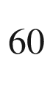

in MEH-PPV, can pin the Fermi level of the n-contact metal and leads to a change of the built-in potential [1752].

Space-charge limited currents (see Sect. [21.2.6](#u116076_4_En_21_Chapter-Sec8)) are often observed in organic semiconductors. An analysis including the effects of traps has been reported in [1755].

### 21.3 Metal-Insulator-Semiconductor Diodes

In a metal-insulator-semiconductor (MIS) diode an insulator is sandwiched between the metal and the semiconductor. Subsequently, a MIS contact has zero dc conductance. The semiconductor typically has an ohmic back contact. As insulator, often the oxide of the respective semiconductor, is used. In particular SiO



on Si has been technologically advanced (Fig. [21.29](#u116076_4_En_21_Chapter-Fig29)). In the latter case, the diode is called a MOS (metal-oxide-semiconductor) diode. This structure has great importance for the investigation of semiconductor surfaces and overwhelming importance for semiconductor technology (planar integration of electronic circuits, CMOS technology). Also, CCDs (Sect. [22.​3.​8](The_Physics_of_Semiconductors00008.docx#u116076_4_En_22_Chapter)) are based on MIS diodes.

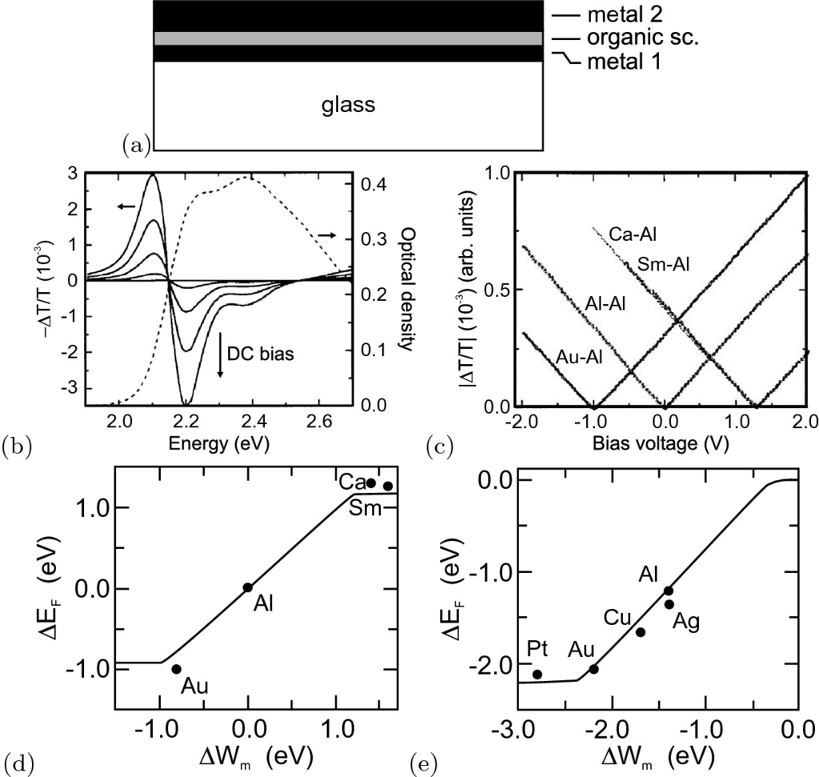

Fig. 21.28

**a** Schematic MSM structure with organic semiconductor (sc.) on transparent glass substrate. Metal 1 is thin and semitransparent. Thickness of organic semiconductor (polymer or small molecules) is about 50 nm. **b** Electroabsorption spectra of Al/MEH-PPV/Al structure at four dc bias voltages (*solid lines*) and optical density spectrum (*dashed line*). **c** Magnitude of the electroabsorption response at 2.1 eV as a function of bias for metal/MEH-PPV/Al structures. **d**, **e** Calculated (*solid lines*) and experimental (*points*) potential difference across (**d**) metal/MEH-PPV/Al structures and (**e**) metal/MEH-PPV/Ca structures as a function of the work-function difference of the contacts. Parts (**b**)–(**e**) adapted from [1753]

#### 21.3.1 Band Diagram for Ideal MIS Diode

An ideal MIS diode has to fulfill the following three conditions:

(i)

(as shown in Fig. [21.30](#u116076_4_En_21_Chapter-Fig30)) without external bias the energy difference

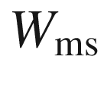

between the work function of the metal and the semiconductor

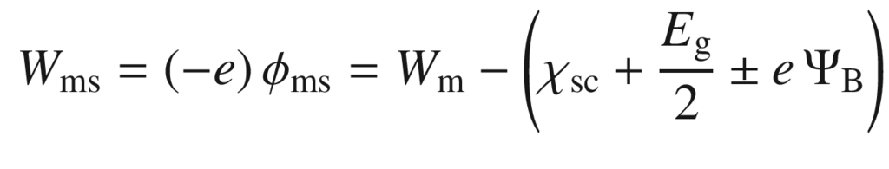

(21.77)

is zero (

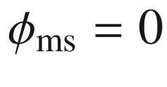

). The ‘

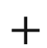

’ (‘−’) sign in ([21.77](#u116076_4_En_21_Chapter-Equ79)) applies to a p-type, Fig. [21.30](#u116076_4_En_21_Chapter-Fig30)b (n-type, Fig. [21.30](#u116076_4_En_21_Chapter-Fig30)a) semiconductor.

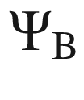

is the potential difference between the intrinsic and actual Fermi level,

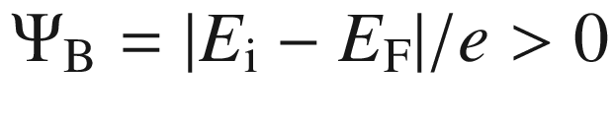

.

(ii)

The only charges present are those in the semiconductor and the opposite charge is on the metal surface close to the insulator.

(iii)

There is no dc current between the metal and the semiconductor, i.e. the conductivity of the insulator is zero.

The quantity

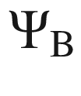

(Fig. [21.32](#u116076_4_En_21_Chapter-Fig32)) is given as (for a p-type material, using ([7.​18](The_Physics_of_Semiconductors00003.docx#u116076_4_En_7_Chapter)), the high temperature approximation ([7.​32](The_Physics_of_Semiconductors00003.docx#u116076_4_En_7_Chapter)) and ([7.​15](The_Physics_of_Semiconductors00003.docx#u116076_4_En_7_Chapter)))

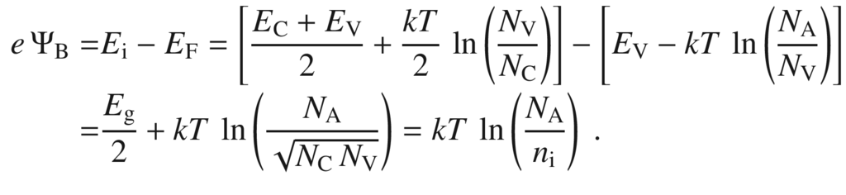

(21.78)

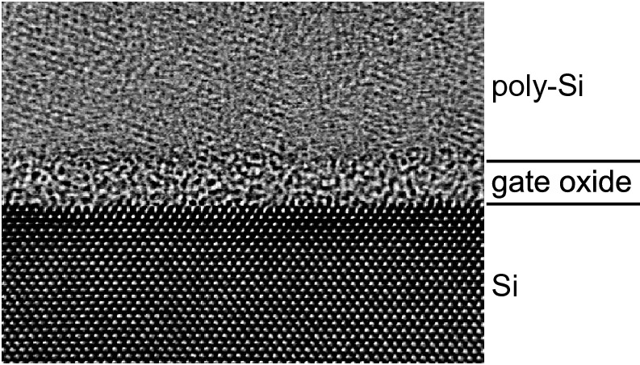

Fig. 21.29

High-resolution transmission electron microscopy image of a 1.6-nm thick gate oxide between poly-Si (cf. Sect. [24.​5.​4](The_Physics_of_Semiconductors00009.docx#u116076_4_En_24_Chapter)) and crystalline Si. From [1756]

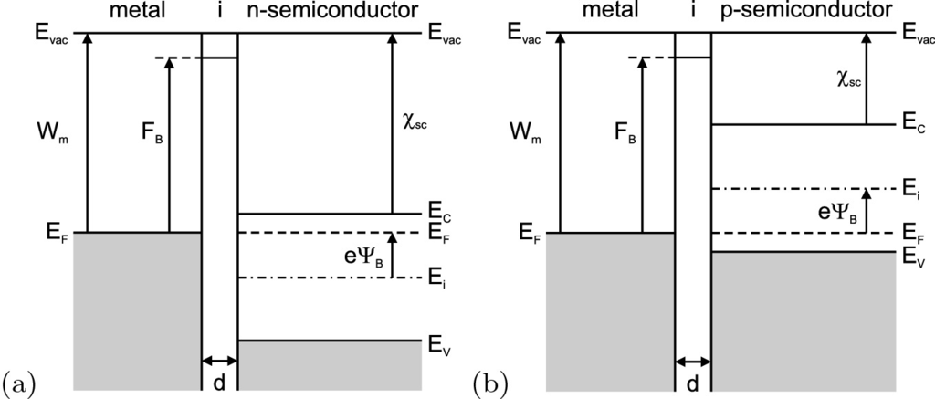

Fig. 21.30

Band diagram of an ideal MIS diode with **a** n- and **b** p-type semiconductor at external bias

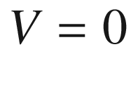

. The insulator (‘i’) thickness is *d* as labeled. The *dash-dotted line* represents the intrinsic Fermi level

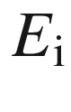

When an ideal MIS diode is biased, three general cases—accumulation, depletion and inversion—  can occur (Fig. [21.35](#u116076_4_En_21_Chapter-Fig35)). We discuss these first for the p-type semiconductor.

Figure [21.35](#u116076_4_En_21_Chapter-Fig35)d shows the accumulation case for a negative voltage at the metal.[14](The_Physics_of_Semiconductors00008.docx#u116076_4_En_21_Chapter-Fn14) Part of the voltage drops across the insulator, the rest across the semiconductor. The valence band is bent upwards towards the Fermi level. The quasi-Fermi level in the semiconductor, however, is constant since no dc current flows (Fig. [21.31](#u116076_4_En_21_Chapter-Fig31)).[15](The_Physics_of_Semiconductors00008.docx#u116076_4_En_21_Chapter-Fn15)

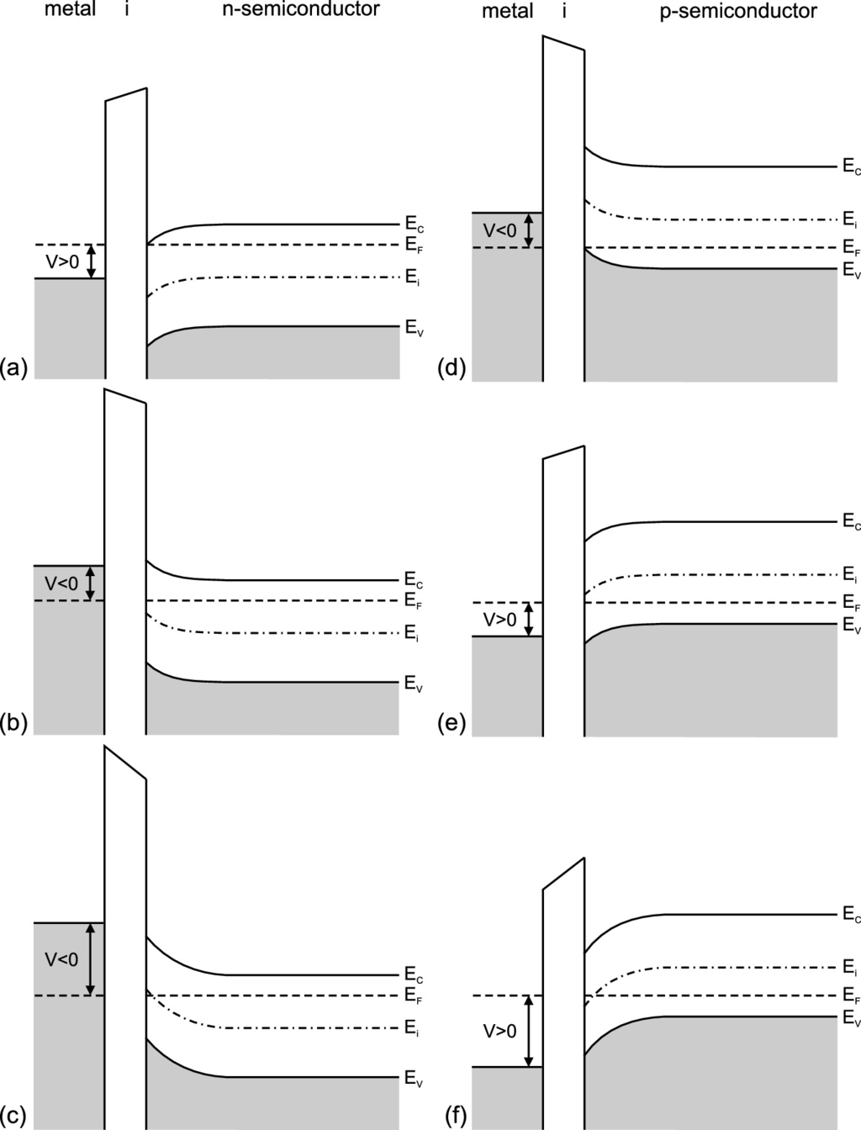

Fig. 21.31

Band diagram of ideal MIS diodes with **a**, **b**, **c** n-type and **d**, **e**, **f** p-type semiconductors for

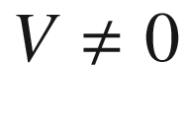

in stationary equilibrium for the cases **a**, **d** accumulation, **b**, **e** depletion and **c**, **f** inversion

Since the charge-carrier (hole) density depends exponentially on the energy separation

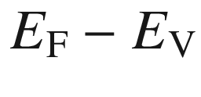

, a charge accumulation (of holes) occurs in the (p-type) semiconductor in the vicinity of the interface to the insulator.

In Fig. [21.35](#u116076_4_En_21_Chapter-Fig35)e the depletion case is shown. Now a moderate reverse voltage, i.e. a positive bias to the metal, is applied. A depletion of majority charge carriers occurs in the semiconductor close to the insulator. The quasi-Fermi level in the semiconductor remains beneath the intrinsic level (

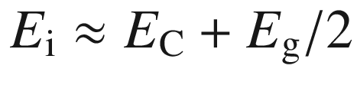

), i.e. the semiconductor remains p-type everywhere. If the voltage is increased further to large values, the quasi-Fermi level intersects the intrinsic level  and lies *above*

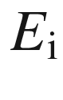

close to the insulator (Fig. [21.35](#u116076_4_En_21_Chapter-Fig35)f). In this region, the electron concentration becomes larger than the hole concentration and the inversion regime is reached. The inversion is called ‘weak’ if the Fermi level is still close to

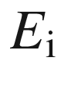

. The inversion is called ‘strong’ when the Fermi level lies close to the conduction-band edge with an accordingly large inversion charge.

The corresponding phenomena occur for n-type semiconductors for the opposite signs of the voltage with electron accumulation and depletion. In the inversion case,

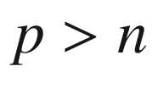

close to the insulator (Fig. [21.35](#u116076_4_En_21_Chapter-Fig35)a–c).

#### 21.3.2 Space-Charge Region

Now we calculate the charge and electric field distribution in an ideal MIS diode, following the treatment in [1757]. We introduce the potential

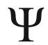

that measures the separation of the intrinsic bulk Fermi level and the actual intrinsic level

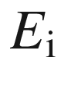

, i.e.

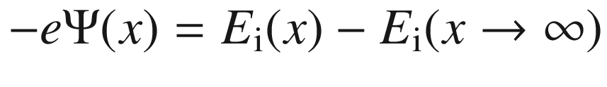

(see Fig. [21.32](#u116076_4_En_21_Chapter-Fig32)). Its value at the surface is termed

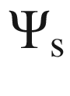

, the surface potential. The value is positive, i.e.

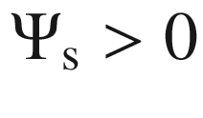

, if the intrinsic Fermi level at the surface is below the bulk Fermi level.

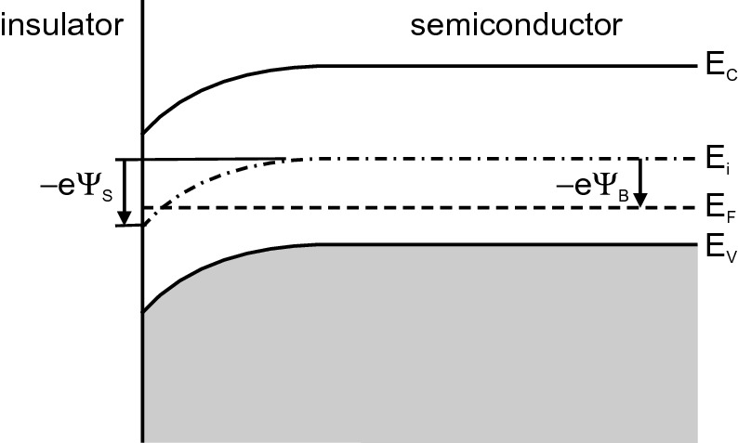

Fig. 21.32

Band diagram close to the interface of a p-type semiconductor MIS diode. Accumulation occurs for

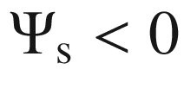

, depletion for

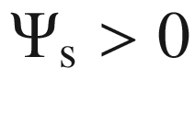

and inversion (as shown here) for

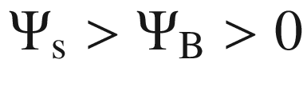

The electron and hole concentrations are given (for a p-type semiconductor) as

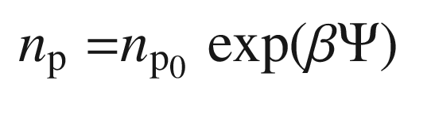

(21.79a)

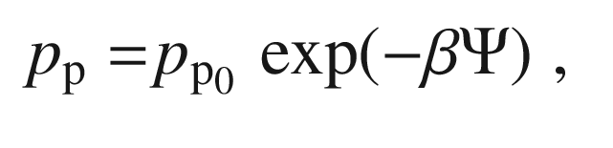

(21.79b)

where

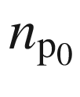

(

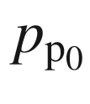

) are the bulk electron (hole) concentrations, respectively, and

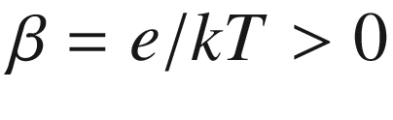

.

Therefore, the net free charge is given by

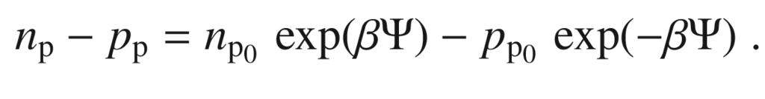

(21.80)

The electron and hole concentrations at the surface are denoted with an index ‘s’ and are given by[16](The_Physics_of_Semiconductors00008.docx#u116076_4_En_21_Chapter-Fn16)

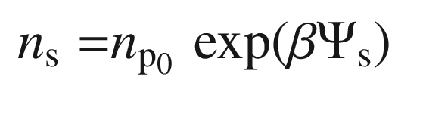

(21.81a)

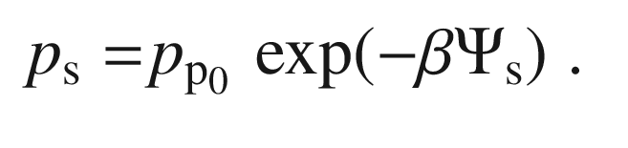

(21.81b)

We use the Poisson equation

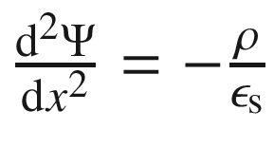

with the charge given by

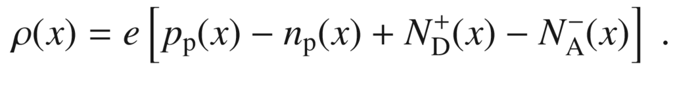

(21.82)

As boundary condition we employ that far away from the surface (for

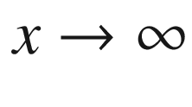

) there is charge neutrality (cf. ([7.​40](The_Physics_of_Semiconductors00003.docx#u116076_4_En_7_Chapter))), i.e.

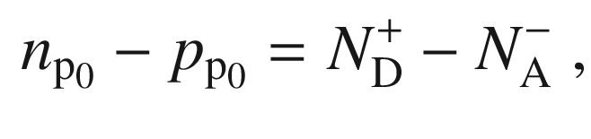

(21.83)

and that

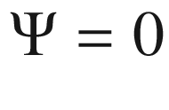

. The ionization of the dopants only depends on temperature which is everywhere the same[17](The_Physics_of_Semiconductors00008.docx#u116076_4_En_21_Chapter-Fn17); thus

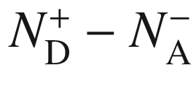

is constant throughout the homogeneous semiconductor. Therefore ([21.83](#u116076_4_En_21_Chapter-Equ87)) (but not charge neutrality) holds everywhere in the semiconductor. Using ([21.80](#u116076_4_En_21_Chapter-Equ83)) the Poisson equation reads

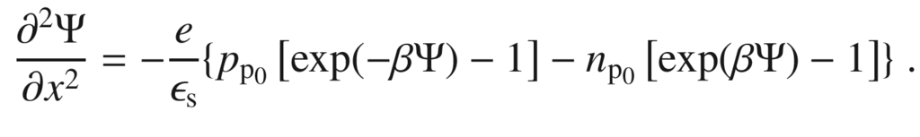

(21.84)

The Poisson equation is integrated and with the notations

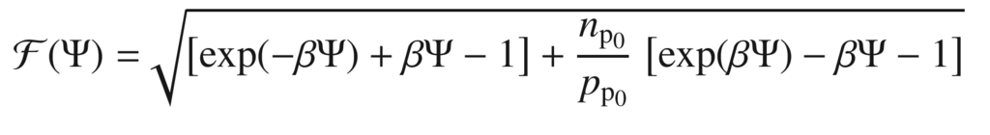

(21.85a)

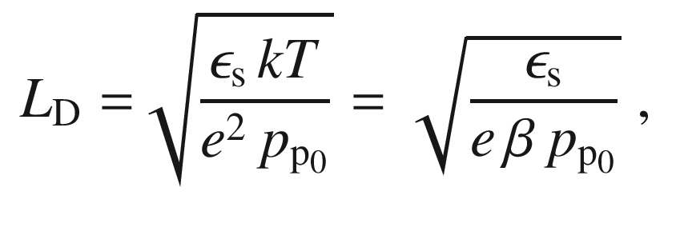

(21.85b)

with

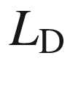

being the Debye length (screening effect) for holes, the electric field can be written as

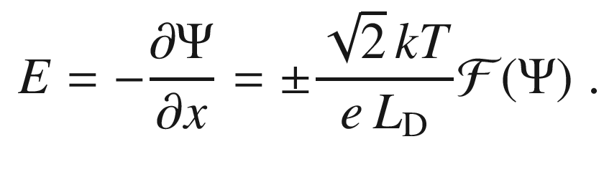

(21.86)

The positive (negative) sign is for

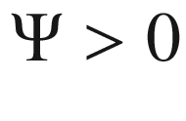

(

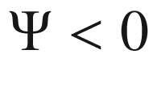

), respectively. At the surface,

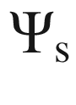

will be taken as the value for

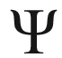

. The total charge

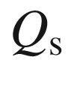

per unit area creating the surface field

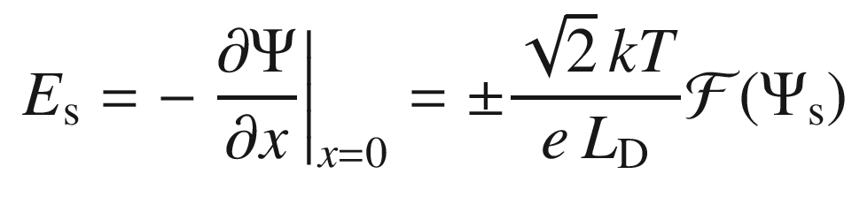

(21.87)

is given by the one-dimensional Gauss law as

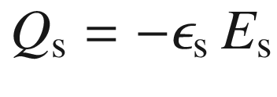

.

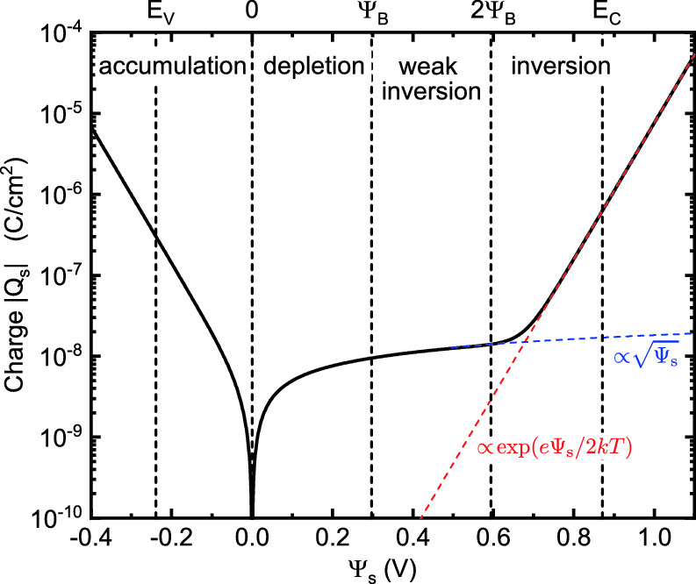

Fig. 21.33

Dependence of the space charge on the surface potential

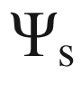

for p-type silicon with

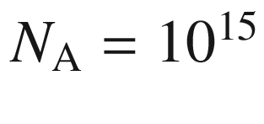

 cm

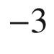

at

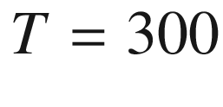

 K. The flat-band condition is present for

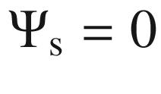

, strong inversion for

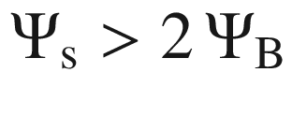

. The *dashed blue* (*red*) line is the dependence of the depletion (inversion) charge

The dependence of the space-charge density from the surface potential[18](The_Physics_of_Semiconductors00008.docx#u116076_4_En_21_Chapter-Fn18) is depicted in Fig. [21.33](#u116076_4_En_21_Chapter-Fig33). When

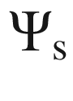

is negative,

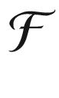

is dominated by the first term in ([21.85a](#u116076_4_En_21_Chapter-Equ89)) and the space charge is positive (accumulation) and proportional to

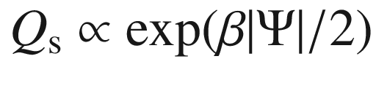

. For

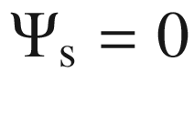

the (ideal) MIS diode is under flat-band condition and the space charge is zero. For

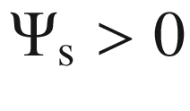

the space charge is negative. For

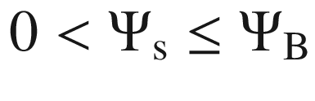

the space charge is due to ionized impurities (depletion) and

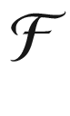

is dominated by the second term in ([21.85a](#u116076_4_En_21_Chapter-Equ89)), i.e.

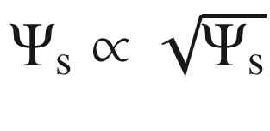

. For

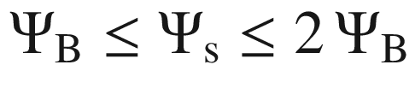

the diode is in the weak inversion regime and still

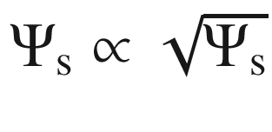

.

Eventually the dominating term of the second bracket in ([21.85a](#u116076_4_En_21_Chapter-Equ89))

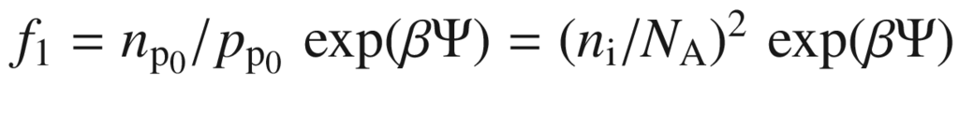

becomes comparable and exponentially larger than the dominating term of the first bracket

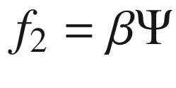

. Solving

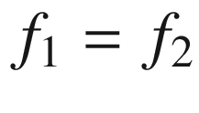

for

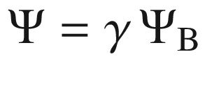

yields the equation

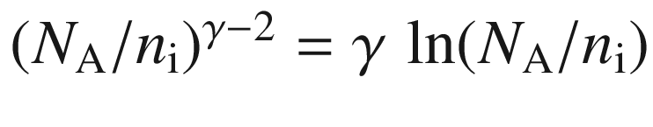

and a value

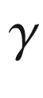

larger than and close[19](The_Physics_of_Semiconductors00008.docx#u116076_4_En_21_Chapter-Fn19) to 2. Thus for

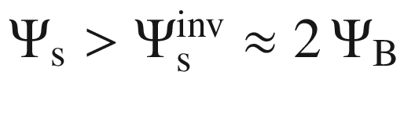

(using ([21.78](#u116076_4_En_21_Chapter-Equ80))),

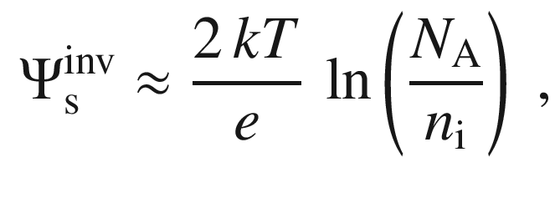

(21.88)

strong inversion starts and the space charge is given as

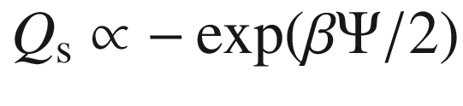

. For the case of strong inversion the band diagram is shown in Fig. [21.34](#u116076_4_En_21_Chapter-Fig34) together with the charge, field and potential.

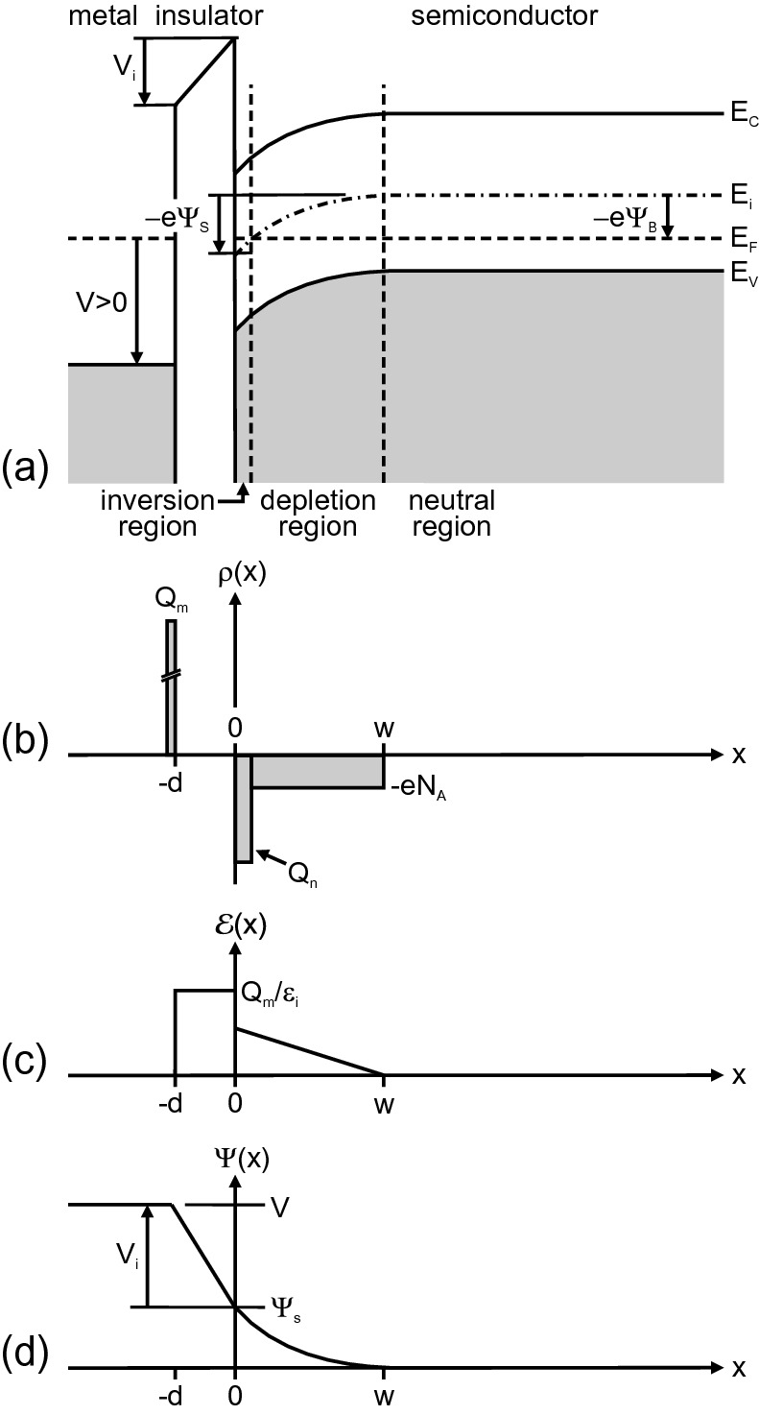

Fig. 21.34

Ideal MIS diode at inversion: **a** band diagram, **b** charge distribution, **c** electric field and **d** potential

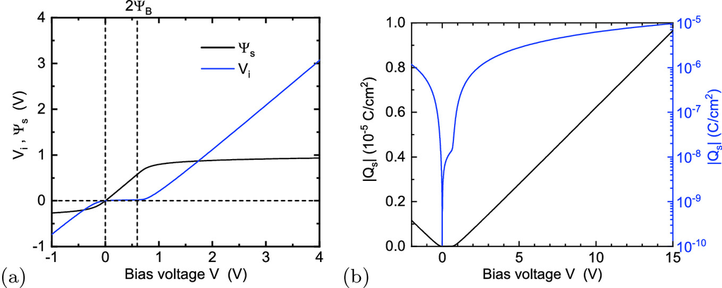

Fig. 21.35

Properties of the ideal MIS diode as a function of bias voltage *V*; same semiconductor parameters as in Fig. [21.33](#u116076_4_En_21_Chapter-Fig33) with an amorphous SiO



(

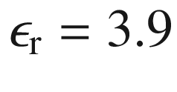

,

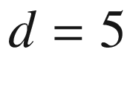

 nm) insulator (and

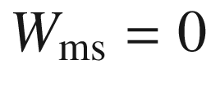

). **a** Voltage drops

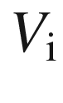

(*blue*) across the insulator and

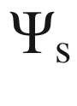

(*black*) across the semiconductor. **b** Total charge (absolute values) in the semiconductor in linear (*black*) and logarithmic (*blue*) scale

The bias voltage *V* at the MIS diode (or the total voltage drop across the MIS diode) is

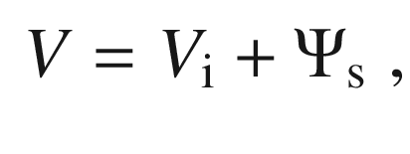

(21.89)

with

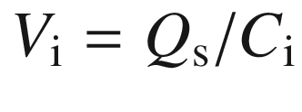

being the voltage drop across the insulator. For the insulator capacitance (per area)

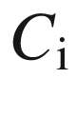

see ([21.93](#u116076_4_En_21_Chapter-Equ98)). Both partial voltages are shown in Fig. [21.35](#u116076_4_En_21_Chapter-Fig35)a as a function of the bias. The voltage drop in the insulator becomes significant for

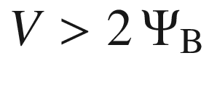

.

In the case of inversion, the charge (per unit area) in the space-charge region

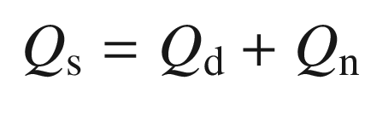

(21.90)

is composed of the depletion charge (ionized acceptors)

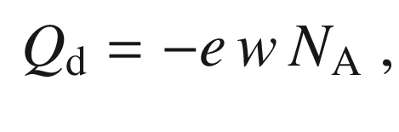

(21.91)

with *w* being the width of the depletion region, and the inversion charge

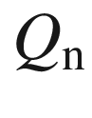

, which is present only close to the interface. The charge as a function of bias is depicted in Fig. [21.35](#u116076_4_En_21_Chapter-Fig35)b where in the semi-logarithmic plot, the depletion and inversion charges can be distinguished. The charge becomes significant for

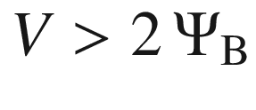

.

The metal surface carries the opposite charge

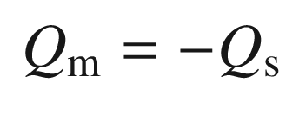

(21.92)

due to global charge neutrality. The insulator itself does not contribute charges in the case of an ideal MIS diode.

#### 21.3.3 Capacitance

The insulator represents a capacitor with the dielectric constant

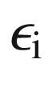

and a thickness *d*. Therefore, the capacitance is

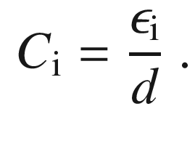

(21.93)

Between the charges

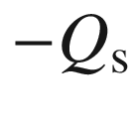

and

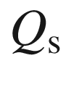

the field strength

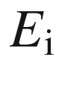

in the insulator is

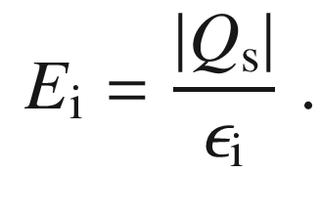

(21.94)

The voltage drop

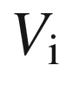

across the insulator is given by

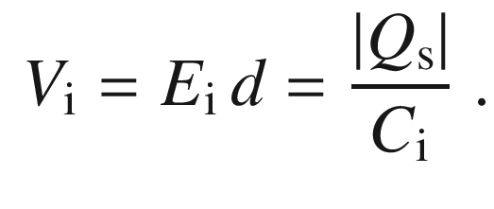

(21.95)

The total capacitance *C* of the MIS diode is given by the insulator capacitance in series with the capacitance

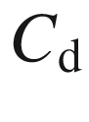

of the depletion layer

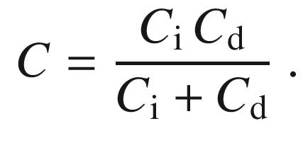

(21.96)

The capacitance of the space-charge region varies with the applied bias (Fig. [21.36](#u116076_4_En_21_Chapter-Fig36)). For forward bias (accumulation), the capacitance of the space-charge region is high. Therefore, the total capacitance of the MIS diode is given by the insulator capacitance

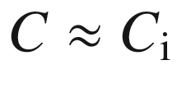

. When the voltage is reduced, the capacitance of the space-charge region drops to

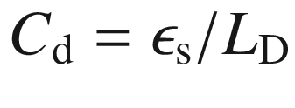

for the flat-band case (



). For a high reverse voltage, the semiconductor is inverted at the surface and the space-charge region capacitance is high again. In this case, the total capacitance is given by

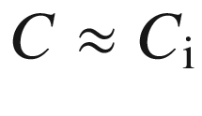

again.

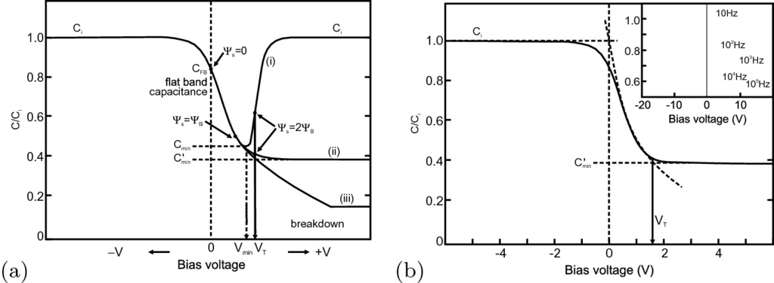

Fig. 21.36

**a** Schematic dependence of the capacitance of a MIS diode on the bias for (i) low frequencies, (ii) high frequencies and (iii) deep depletion. **b** High-frequency capacitance of a Si/SiO



diode. The *inset* shows the frequency dependence.

Adapted from [1758]

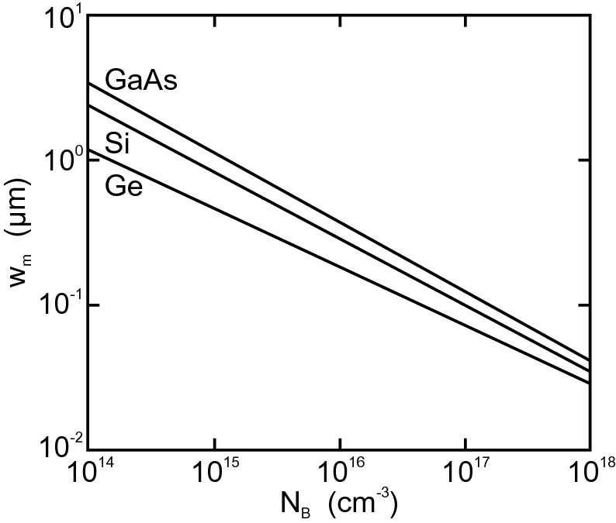

Fig. 21.37

Maximum width of the depletion layer

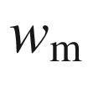

([21.97](#u116076_4_En_21_Chapter-Equ102)) at room temperature for deep depletion for GaAs, Si and Ge diodes as a function of bulk doping level

The previous consideration assumes that the charge density in the semiconductor can follow changes of the bias sufficiently fast.[20](The_Physics_of_Semiconductors00008.docx#u116076_4_En_21_Chapter-Fn20) However, the inversion charge must be built up and then also disappear via recombination that is limited by the recombination time constant



. For frequencies around

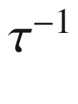

or faster, the charge in the inversion layer cannot follow and the capacitance of the semiconductor is given by the value

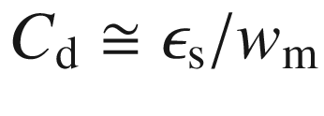

;

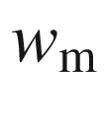

(Fig. [21.37](#u116076_4_En_21_Chapter-Fig37)) is the maximum depletion-layer width present at the beginning of inversion (cf. ([21.10](#u116076_4_En_21_Chapter-Equ10)) and ([21.88](#u116076_4_En_21_Chapter-Equ93)))

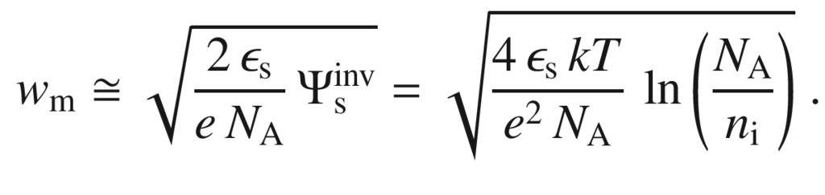

(21.97)

For further increased voltage (into the inversion regime), the electric field is screened by the inversion charge and the width of the depletion layer remains constant. Therefore, the total capacitance in the inversion regime is given by

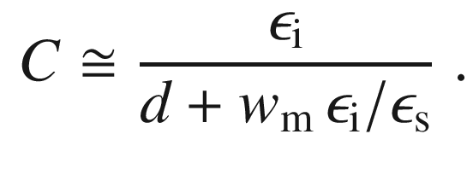

(21.98)

#### 21.3.4 Nonideal MIS Diode

In a real, i.e. nonideal, MIS diode, the difference



in the work functions of the metal and semiconductor (cf. ([21.77](#u116076_4_En_21_Chapter-Equ79))) is no longer zero. Therefore, the capacitance versus voltage relation is shifted with respect to the ideal MIS diode characteristic by the *flat-band voltage shift*

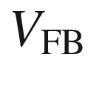

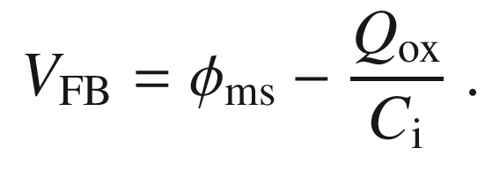

(21.99)

Additionally, the flat-band voltage can be shifted by charges

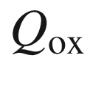

in the oxide that have been neglected so far. Such charges can be trapped, i.e. fixed with regard to their spatial position, or mobile, e.g. ionic charges such as sodium.

For Al as metal (

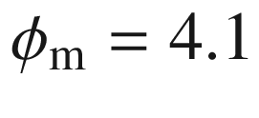

 eV) and n-type Si (

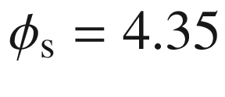

 eV), the flat-band voltage shift is

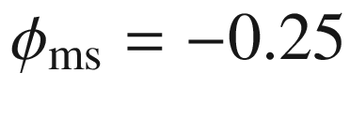

 V, as shown schematically in Fig. [21.38](#u116076_4_En_21_Chapter-Fig38)a for zero bias.



is split into 0.2 eV and 0.05 eV for the oxide and the silicon, respectively. In Fig. [21.38](#u116076_4_En_21_Chapter-Fig38)b, the dependence of



on the doping, conductivity type and metal is shown for various SiO



/Si MIS diodes. An Au-SiO



/Si diode with p-type Si and

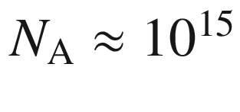

 cm

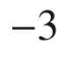

fulfills the condition of an ideal MIS diode with regard to



.

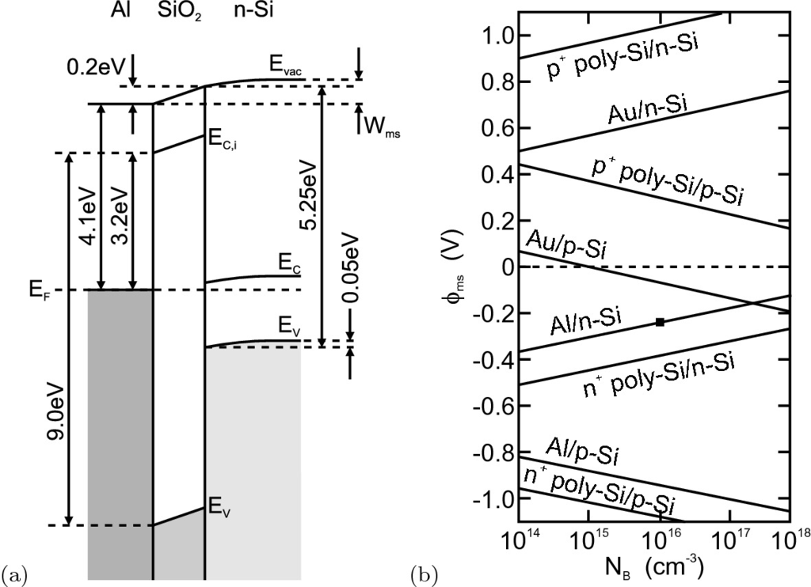

Fig. 21.38

**a** Schematic band diagram of an Al/SiO



/Si (n-type) diode with 50 nm oxide thickness and

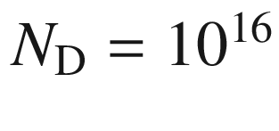

 cm



for zero bias,

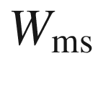

= 0.25 eV. Based on data from [1759]. **b** Difference of work functions

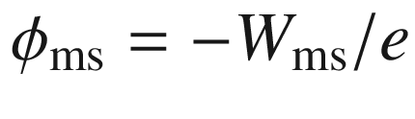

for SiO



/Si MIS diodes and various doping levels and electrode materials (Al, Au and polycrystalline Si). The *square* represents the situation depicted in panel (**a**). Based on data from [1760]

### 21.4 Bipolar Diodes

A large class of diodes is based on pn junctions. In a homo pn junction an n-doped region is next to a p-doped region of the same semiconductor. Such a device is called *bipolar*. At the junction a depletion region forms. The transport properties are determined by the minority carriers. An important variation is the pin-diode in which an intrinsic (or lowly doped) region is between the doped region (Sect. [21.5.8](The_Physics_of_Semiconductors00008.docx#u116076_4_En_21_Chapter-Sec31)). If the differently doped regions belong to different semiconductor materials, the diode is a heterostructure pn diode (Sect. [21.4.6](The_Physics_of_Semiconductors00008.docx#u116076_4_En_21_Chapter-Sec21)). Various schemes have been used to fabricate pn diodes (Fig. [21.39](#u116076_4_En_21_Chapter-Fig39)).

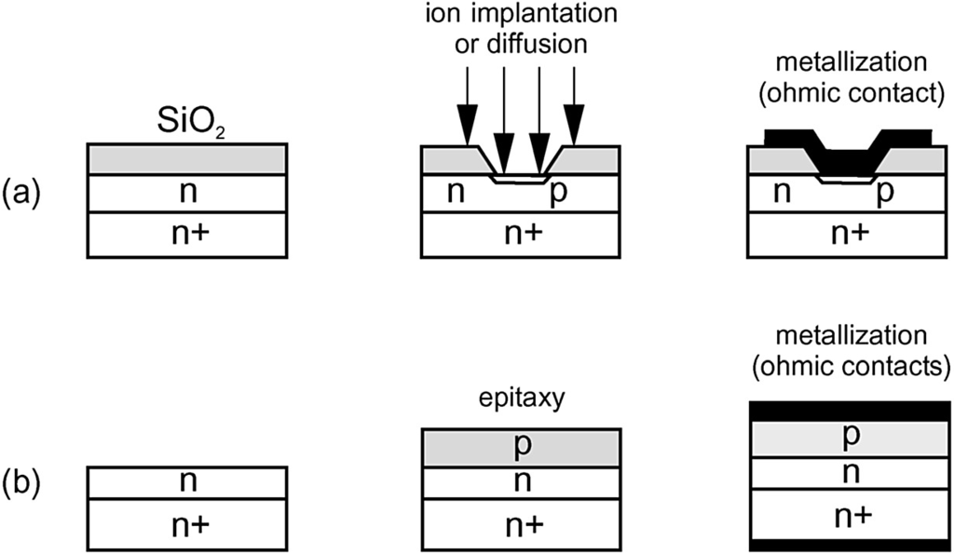

Fig. 21.39

Schematic fabrication technologies for bipolar diodes: **a** Planar junction with local impurity incorporation (diffusion from gas phase or ion implantation) through mask and contact metallization, **b** epitaxial junction

#### 21.4.1 Band Diagram

If the doping profile is arbitrarily sharp, the junction is called *abrupt*. This geometry is the case for epitaxial pn junctions where the differently doped layers are grown on top of each other.[21](The_Physics_of_Semiconductors00008.docx#u116076_4_En_21_Chapter-Fn21) For junctions that are fabricated by diffusion, the abrupt approximation is suitable for alloyed, ion-implanted and shallow-diffused junctions. For deep-diffused junctions a linearly graded approximation is better (Fig. [21.40](#u116076_4_En_21_Chapter-Fig40)), which is treated in more detail in [574]. If one doping level is much higher that the other, the junction is termed a *one-sided* (abrupt) junction. If

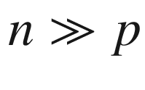

(

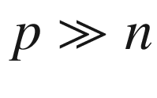

), the junction is denoted as an n

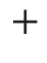

p-diode (p

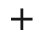

n-diode).

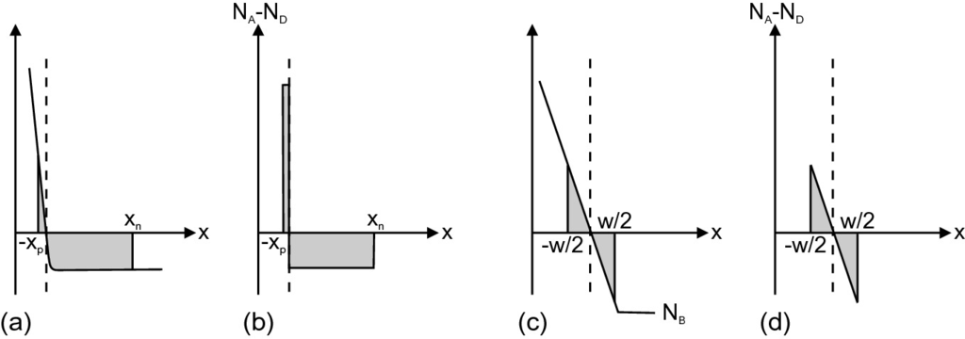

Fig. 21.40

Description of doping distribution with (**a**, **b**) abrupt approximation and with (**c**, **d**) linearly graded junction. (**a**, **c**) show real impurity concentration, (**b**, **d**) idealized doping profile

The thermodynamical equilibrium of a pn diode is considered here only for the electronic system. The thermodynamic stability of the atomic doping distribution is discussed in [1761]. Typically, thermodynamics works to randomize the chemical concentration gradient; the existence of a pn junction is due to the extremely low diffusion coefficient of dopants in the semiconductor lattice. Elevated temperatures can cause the destruction of the pn diode via enhanced dopant diffusion (Sect. [4.​2.​3](The_Physics_of_Semiconductors00002.docx#u116076_4_En_4_Chapter)). However, a thermodynamically stable concentration gradient and thus a built-in field can exist in a multi-component system [1761].

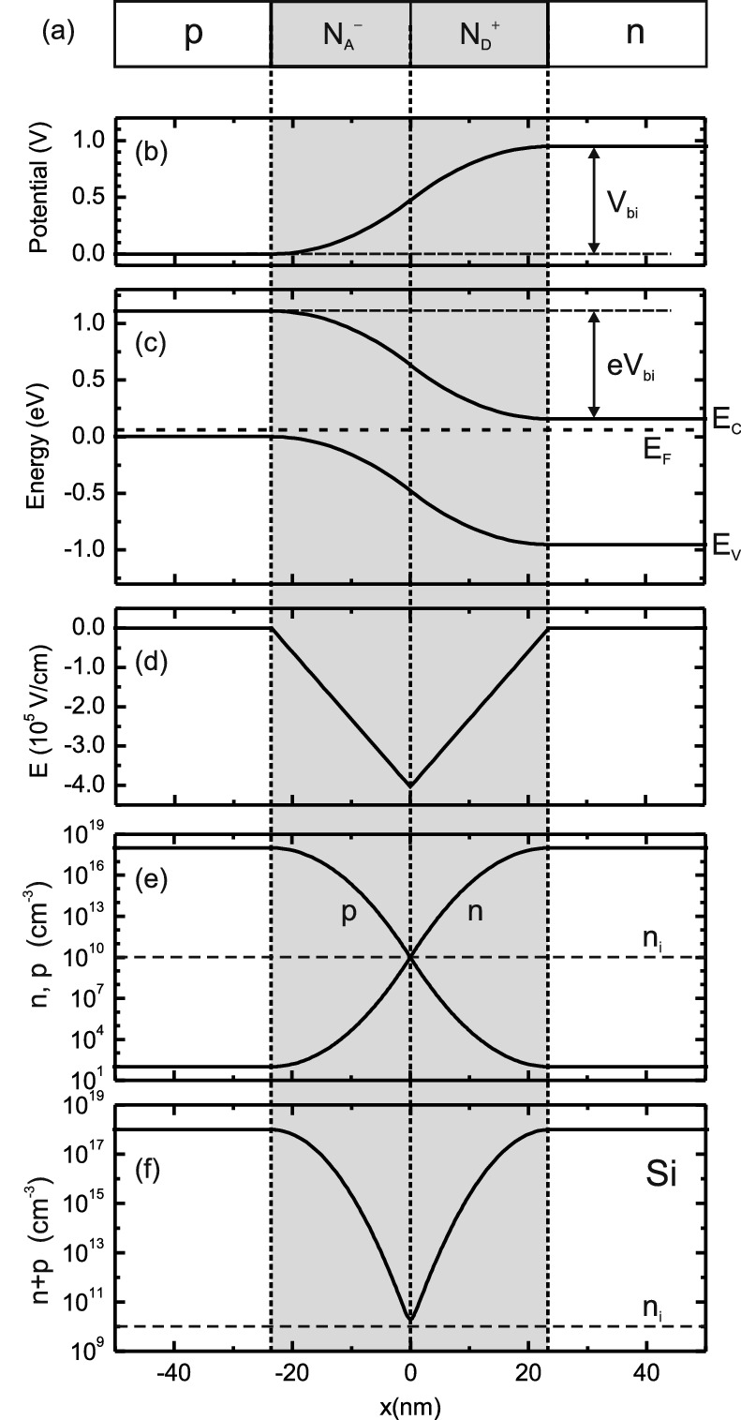

Fig. 21.41

pn junction (abrupt approximation) in thermal equilibrium (zero bias) for Si at room temperature and

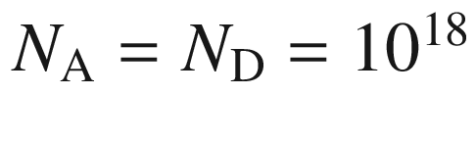

 cm



. **a** Schematic representation of p-doped and n-doped region with depletion layer (*grey area*) and fixed space charges, **b** diffusion potential, **c** band diagram with Fermi level (*dashed line*), **d** electric field, **e** free-carrier concentrations *n* and *p* and **f** total free-carrier density

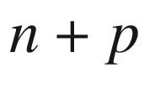

#### 21.4.2 Space-Charge Region

In thermodynamical equilibrium the Fermi level is constant (

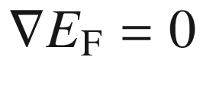

). The built-in (positive) voltage

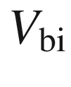

is given by (see Fig. [21.41](#u116076_4_En_21_Chapter-Fig41)c)

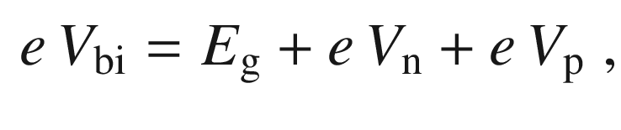

(21.100)

where

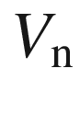

is the difference between conduction band and Fermi level on the n-side,

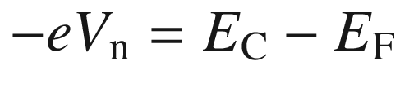

.

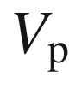

is the difference between valence band and Fermi level on the p-side,

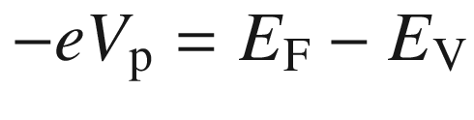

. For the nondegenerate semiconductor

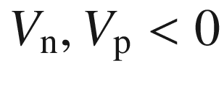

and (using ([7.​12](The_Physics_of_Semiconductors00003.docx#u116076_4_En_7_Chapter)), ([7.​10](The_Physics_of_Semiconductors00003.docx#u116076_4_En_7_Chapter)) and ([7.​11](The_Physics_of_Semiconductors00003.docx#u116076_4_En_7_Chapter)))

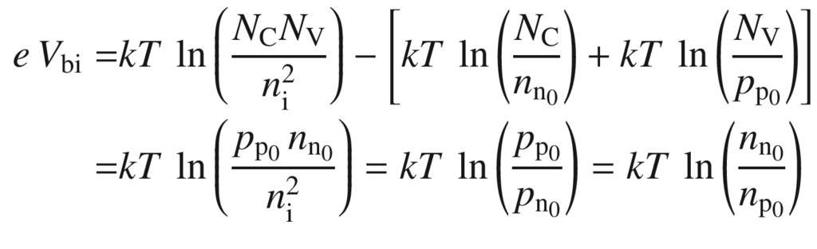

(21.101a)

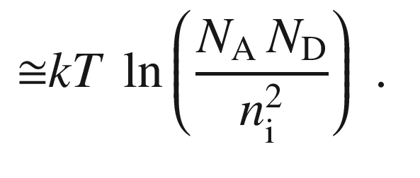

(21.101b)

The electron and hole densities on either side of the junction (

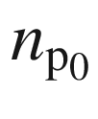

and

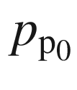

at

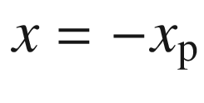

and

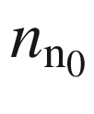

and

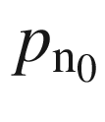

at

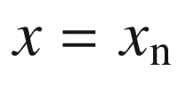

) are related to each other by (from rewriting ([21.101a](#u116076_4_En_21_Chapter-Equ106)))

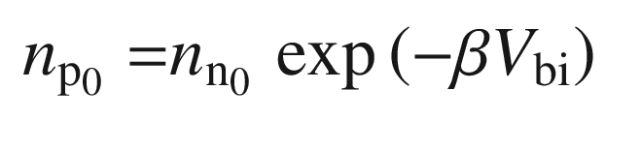

(21.102a)

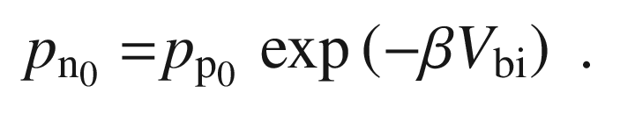

(21.102b)

Microscopically, the equilibration of the Fermi levels on the n- and p-side occurs via the diffusion of electrons and holes to the p- and n-side, respectively. The electrons and holes recombine in the depletion layer. Therefore, on the n-side the ionized donors and on the p-side the ionized acceptors remain (Fig. [21.41](#u116076_4_En_21_Chapter-Fig41)a). These charges build up an electric field (Fig. [21.41](#u116076_4_En_21_Chapter-Fig41)d) that works against the diffusion current. At thermal equilibrium the diffusion and drift currents cancel and the Fermi level is constant.

Values for the built-in potential are depicted in Fig. [21.42](#u116076_4_En_21_Chapter-Fig42) for Si and GaAs diodes. The spatial dependence of the potential in the depletion layer is determined by the Poisson equation.

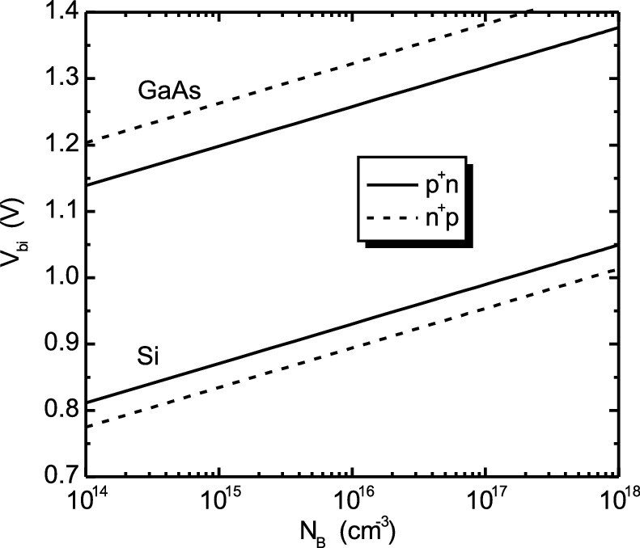

Fig. 21.42

Built-in voltage as a function of doping for one-sided Si and GaAs pn diodes

We assume here the complete ionization of the donors and acceptors. Also, we neglect at first majority carriers in the depletion layers on the n- and p-sides.[22](The_Physics_of_Semiconductors00008.docx#u116076_4_En_21_Chapter-Fn22) With these approximations, the Poisson equation in the depletion layers on the n- and p-side reads

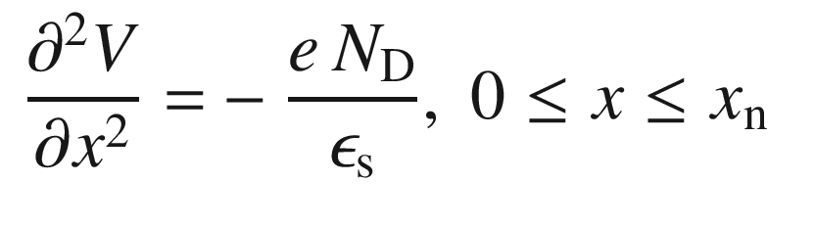

(21.103a)

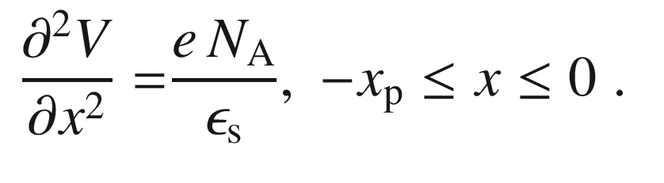

(21.103b)

One integration yields (together with the boundary conditions that the field is zero at the boundaries of the depletion layer) the electric field in the two regions

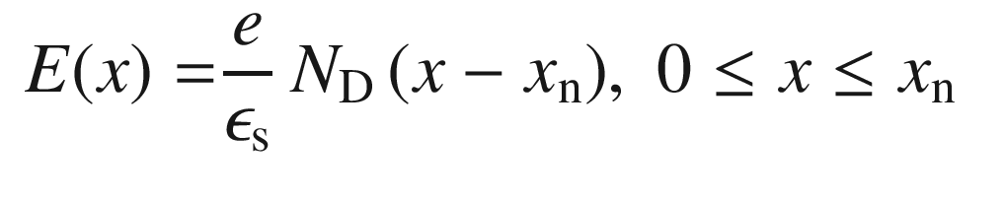

(21.104a)

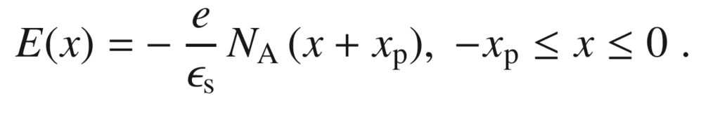

(21.104b)

The maximum field strength

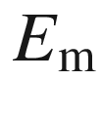

is present at

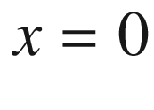

and is given by

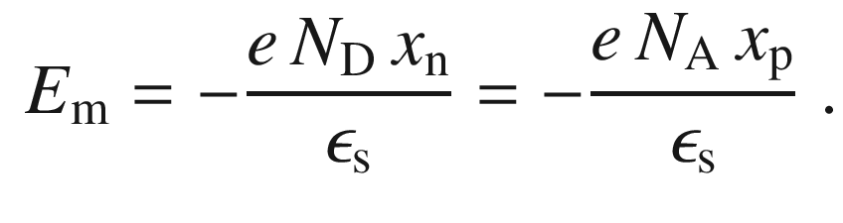

(21.105)

The continuity of the field at

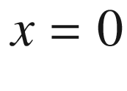

is equivalent to the overall charge neutrality

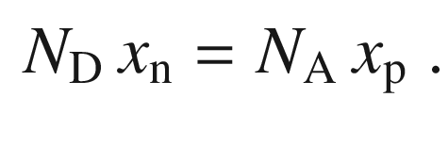

(21.106)

Another integration yields the potential (setting

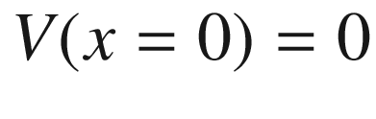

)

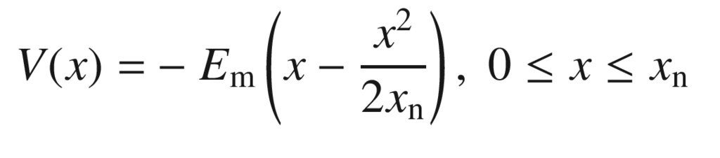

(21.107a)

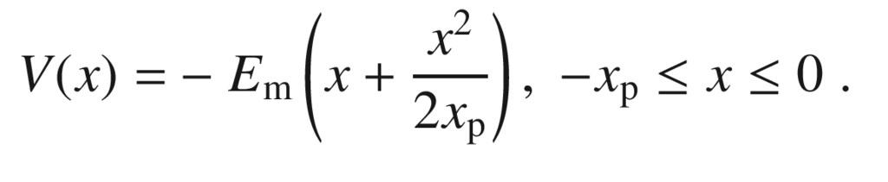

(21.107b)

The built-in potential

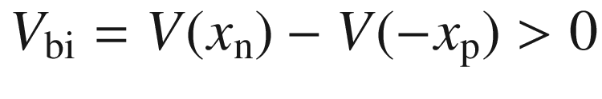

is related to the maximum field via

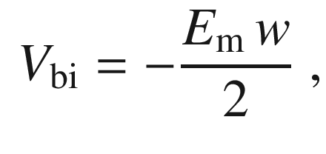

(21.108)

where

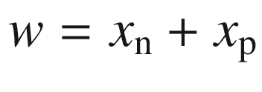

is the total width of the depletion layer. The elimination of

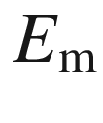

from ([21.105](#u116076_4_En_21_Chapter-Equ114)) and ([21.108](#u116076_4_En_21_Chapter-Equ118)) yields

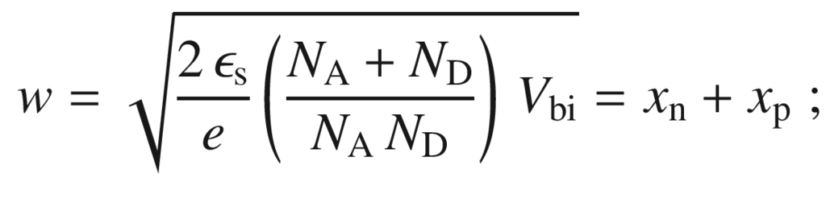

(21.109)

the two parts of the depletion layer are given by

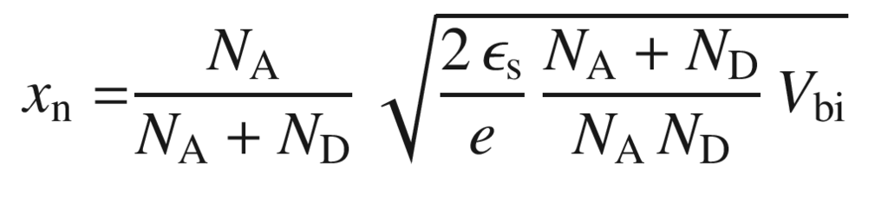

(21.110a)

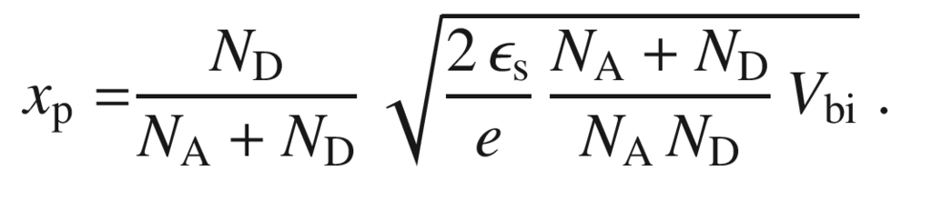

(21.110b)

For p

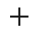

n and n



p junctions, the width of the depletion layer is determined by the lowly doped side of the junction

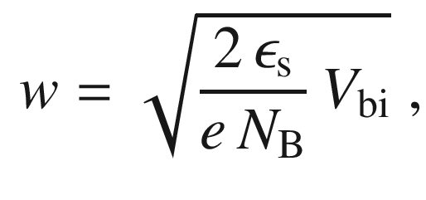

(21.111)

where

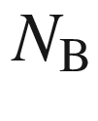

denotes the doping of the lowly doped side, i.e.

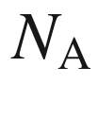

for a n

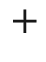

p diode and

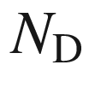

for a p



n diode.

If the spatial variation of the majority carrier density is considered in more detail (and for finite temperature, cf. ([21.13](#u116076_4_En_21_Chapter-Equ13))), an additional term

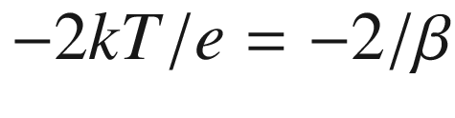

is added [1757] to

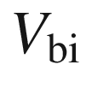

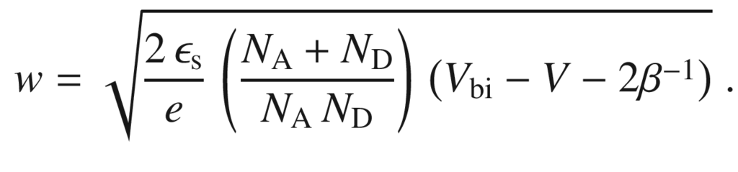

(21.112)

Also, the external bias *V* has been included in the formula. If

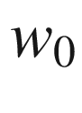

denotes the depletion layer width at zero bias, the depletion layer width for a given voltage *V* can be written as

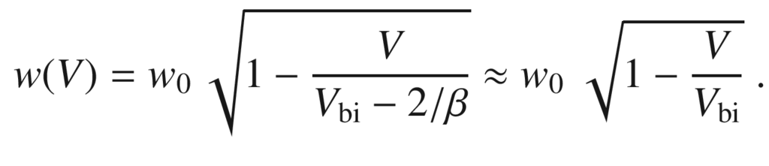

(21.113)

Using the Debye length (cf. ([21.85b](#u116076_4_En_21_Chapter-Equ90)))

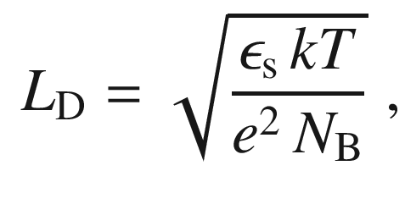

(21.114)

the depletion layer width for a one-sided diode can be written as (with

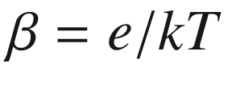

)

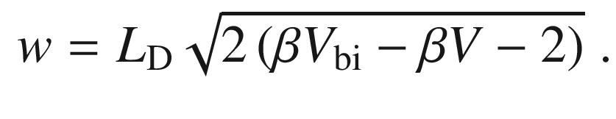

(21.115)

The Debye length is a function of the doping level and is shown for Si in Fig. [21.43](#u116076_4_En_21_Chapter-Fig43). For a doping level of 10

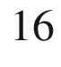

 cm

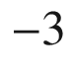

the Debye length in Si is 40 nm at room temperature. For one-sided junctions the depletion layer width is about

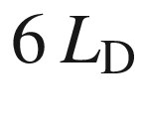

for Ge,

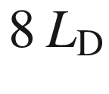

for Si and

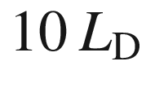

for GaAs.

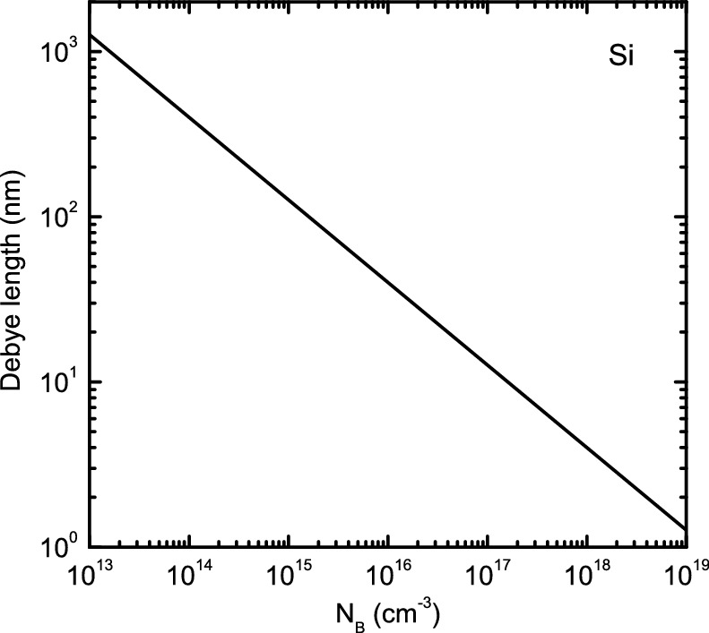

Fig. 21.43

Debye length in Si at room temperature as a function of the doping level

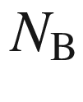

according to ([21.114](#u116076_4_En_21_Chapter-Equ125))

The external bias is counted positive if the ‘

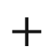

’ (‘−’) pole is at the p-side (n-side). The reverse voltage has opposite polarity. If a reverse bias is applied, the depletion layer width is increased (Fig. [21.44](#u116076_4_En_21_Chapter-Fig44)).

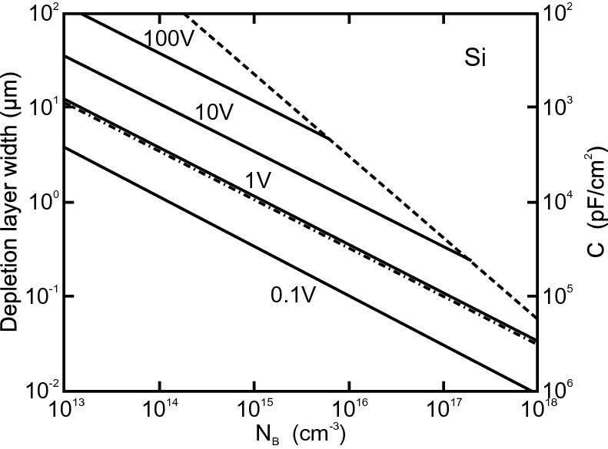

Fig. 21.44

Width of the depletion layer and capacitance per area for one-sided, abrupt Si junctions for various values of

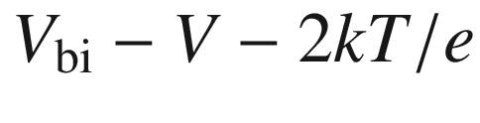

as labeled. The *dash-dotted line* is for zero bias, the *dashed line* is the limit due to avalanche breakdown.

Adapted from [574]

#### 21.4.3 Capacitance

The capacitance of the depletion layer is the charge change upon a change of the external bias. It is given as

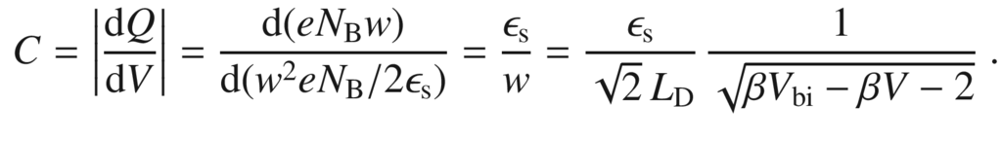

(21.116)

Therefore, the capacitance of the depletion layer is inversely proportional to the depletion-layer width (see the two scales in Fig. [21.44](#u116076_4_En_21_Chapter-Fig44)). A detailed treatment has been given in [1762].

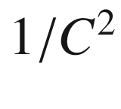

is proportional to the external bias

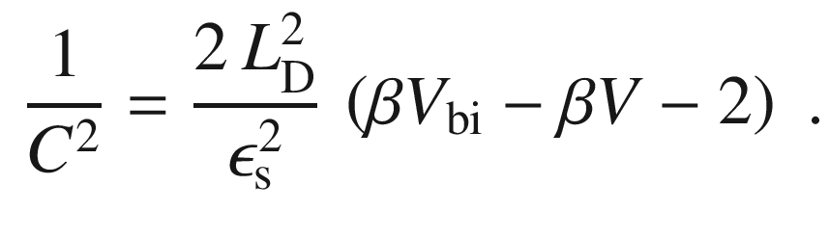

(21.117)

From *C*–*V* spectroscopy the doping level can be obtained from the slope

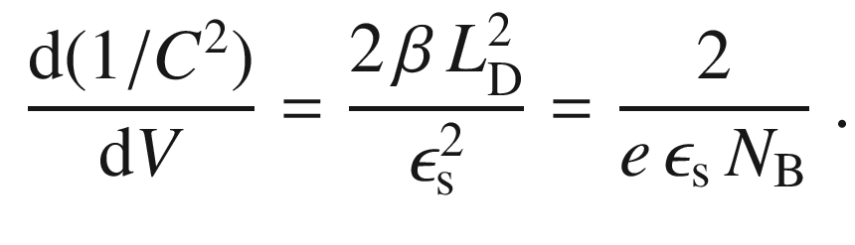

(21.118)

From the extrapolation to the voltage for which

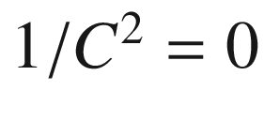

the built-in voltage can be obtained.